

**Join in the fun with your family and have a go at a variety of arts and crafts activities with a "signs of spring" theme.** **Cold drinks/snacks provided.**

**Wednesday 17th February 2016 1.30 - 4.30pm**

**Linton on Ouse Village Hall**.

**FREE HALF TERM HOLIDAY**

**FAMILY FUN ACTIVITIES**

**(for parents, grandparents and children aged 3 and above)**

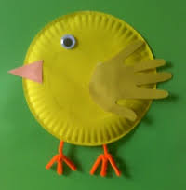

Yorkshire & Humber Region

**www.wea.org.uk/yh**

For more information about these free activities and to book free places for your family please contact:

**Diane Quinney 07824 545919 Email: dquinney@wea.org.uk**