**Crayke Chronicle**

**Friday 5th February**

**Yellow Team**

I’m sorry to have to inform you that Mr. Buttery’s recovery is taking a little longer than anticipated and he will not now return to school until after the half term holiday.

**Christingle Service**

The whole school had great fun on Wednesday making the Christingles for the service this afternoon. As Revd. Liz says, she came into school along with two governors and a member of the local community to help the children decorate their oranges with candles, tape and sweet items.

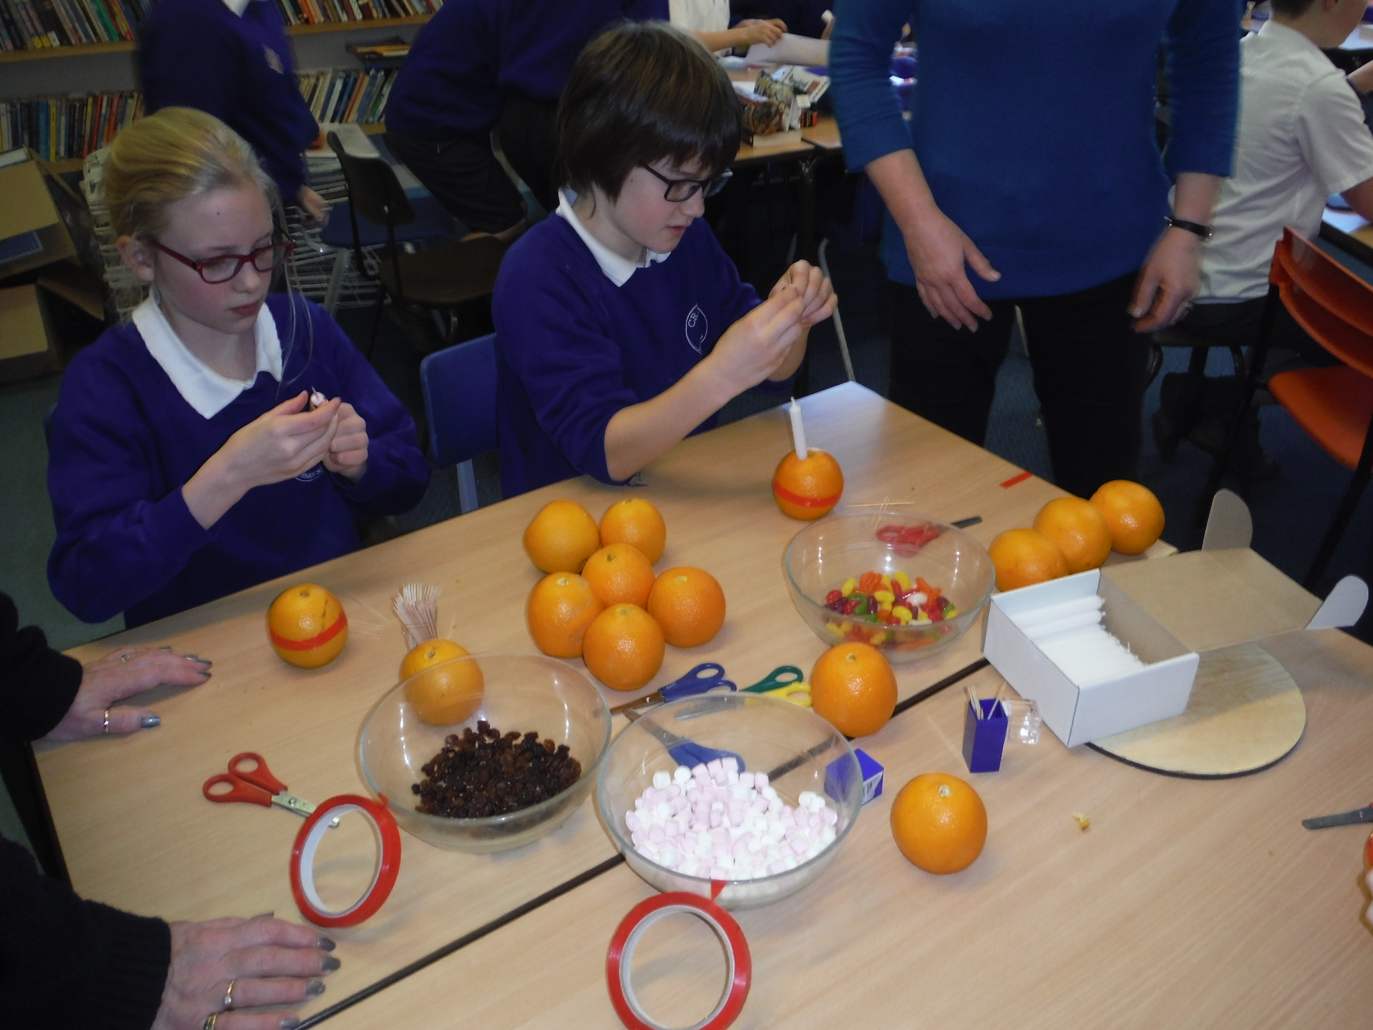

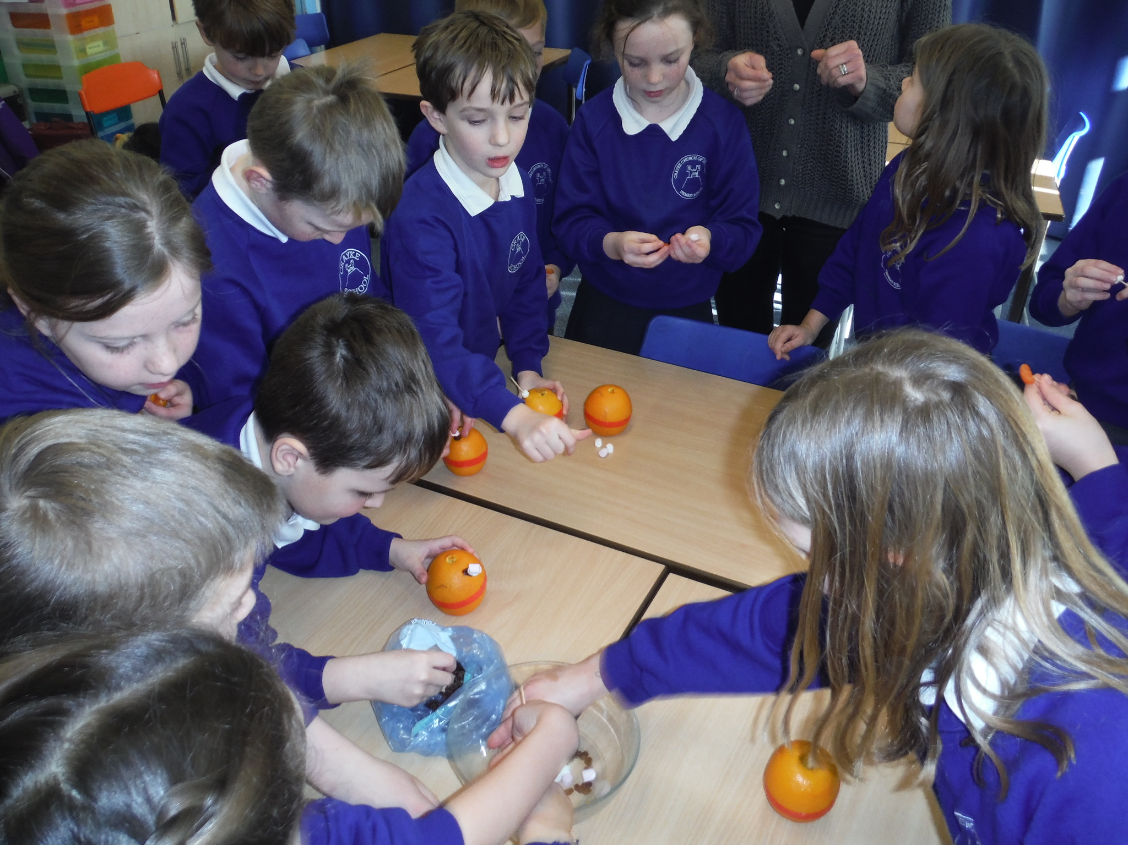**Where's Church this Week?**

Sunday 7th February - 10.30am Family Service at St Cuthbert, Crayke. 10.30am Holy Communion at All Saints, Brandsby.  
I and my team of helpers had a great time making Christingles in school on Wednesday ready for the service on Friday. If you haven't sent in your coin collecting box for the Children's Society, there's still time to bring it into school early next week. All welcome. Revd. Liz



In Class 1, the children will be able to be acknowledged as Whizz of the week...

**Whizz of the Week**

**Class 1 – Teddy Hill**

Each week a child will be selected from our classes to receive the title of *Maths Whizz* of the Week or *Wonderful Writer* of the Week. Congratulations to this week’s children...

**Maths Whizz of the Week**

**Class 2 – Ella Fenton**

**Class 3 – Gaby Hollinrake**

**Class 4 – Emily Knowlson**

**Wonderful Writer of the Week**

**Class 2 – Mani Brown**

**Class 3 – Oscar Ashworth**

**Class 4 – Leo Sharp**

**Team Points**

This week’s winners are:

