Class 4 Homework Spring Term (2nd half)

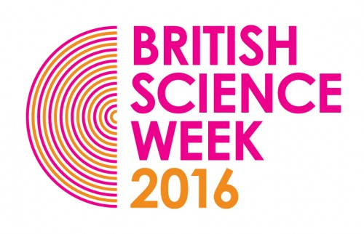  https://www.britishscienceweek.org/  It’s British Science Week 11th – 20th March 2016.  Log on to the website. You could download the Primary activity pack and do an activity, enter the poster competition or complete one of the quizzes.  (Website to have been accessed by the end of the half term and a comment added to the DB Primary blog during school time) |   Tell me about your favourite film!  Who is in it? What happens? Why do you love it? How does it make you feel? |   http://www.childrensuniversity.manchester.ac.uk/interactives/history/greece/  Visit this website for information and learning about Ancient Greece. There’s games on there too!  (Website to have been accessed by the end of the half term and a comment added to the DB Primary blog during school time)
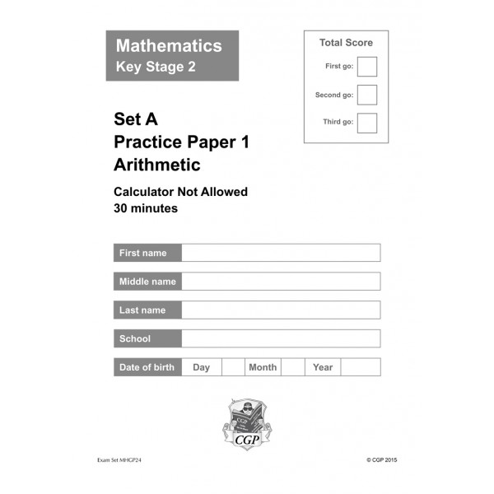Year 6: 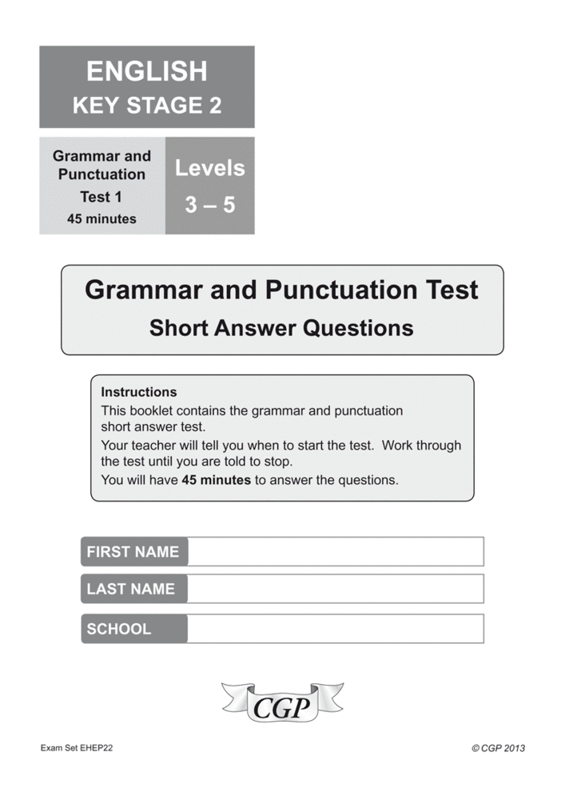  Continue to complete your CGP papers.  Class 4:  Continue to learn your spellings, practise your times tables and read regularly. I know you’re all busy but this is really important! | Family Activity:  Look for the first signs of Spring eg buds, snowdrops, crocuses.    How can you records these first signs of Spring?  Do some observational drawings?  Write some poetry?  Take some photographs?  Or maybe something different?  YOU CHOOSE! | 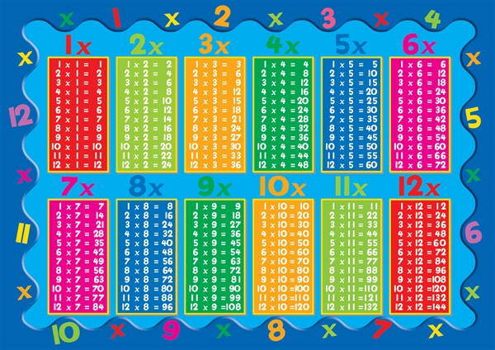  55 Club  Please see attached letter about 55 Club (times tables club)  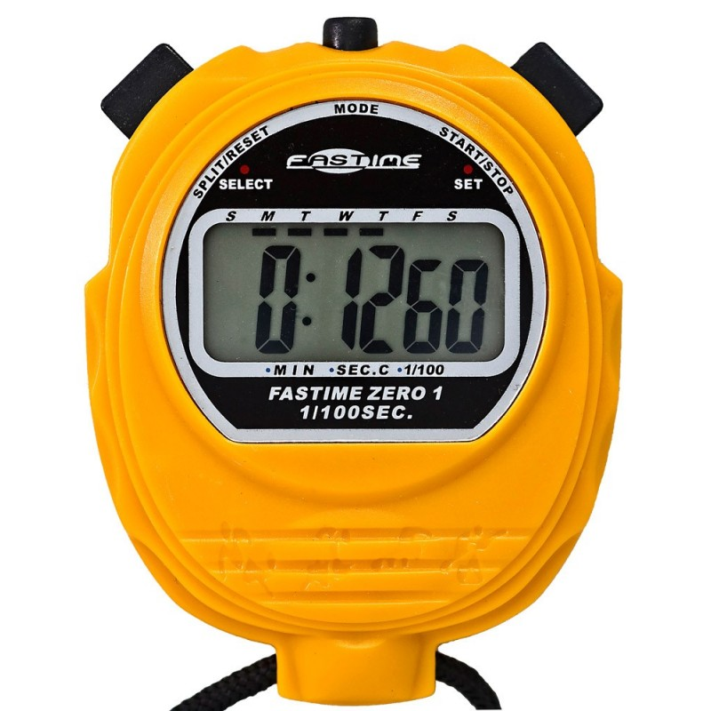
 | Weekly activities: See Curriculum Letter

