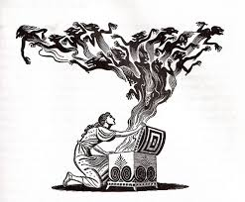
Wednesday 27th January 2016
As part of our Art/DT topic on Pandora’s Box, can you bring in a container that you keep something special in e.g. a memory box, photo file/box, jewellery box/bag for us to investigate existing products before we begin to design our own.
IT DOES NOT HAVE TO BE A BOX! Any container that you keep something special in.
You may wish to remove what you keep inside!
Mrs Chandler
Wednesday 27th January 2016
As part of our Art/DT topic on Pandora’s Box, can you bring in a container that you keep something special in e.g. a memory box, photo file/box, jewellery box/bag for us to investigate existing products before we begin to design our own.
IT DOES NOT HAVE TO BE A BOX! Any container that you keep something special in.
You may wish to remove what you keep inside!
Mrs Chandler

