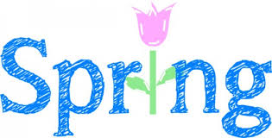
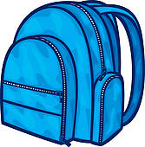
Class 4 Curriculum Letter
Spring Term
Dear Parent/Carers,  In this newsletter we hope to give you a brief outline to the content of our curriculum this term. | Homework  Children will be required to complete the following homework:  READING – Pupils should read for 25-30 minutes each day. This is important even for accomplished readers to help improve speed, accuracy and comprehension.  SPELLINGS – Pupils will be provided with spellings on a Monday and tested on a Friday.  NUMERACY – This will usually be based on the Numeracy work from either the previous or current weeks work. Numeracy homework is set on a Thursday and is due in on the following Monday.  In addition, there will be essential and optional homework choices on the homework menu. Could we also ask parents/carers to sign your child’s home/school record. Year 6 children will be provided with CGP Practice Papers (additional information to follow).  The key stage 2 national curriculum tests next year will take place in the week commencing Monday 9th May 2016. Could you please avoid any unnecessary absences, especially in the Spring Term, as this can have a detrimental effect on your child’s attainment.  Achievement Assembly  Class 4’s achievement assembly will take place on Friday 18th March 2016.  Please don’t hesitate to arrange an appointment via the schools office should you wish to discuss any aspect of your child’s education.  Mr A Buttery & Mrs L Chandler
Timetable Reminders
Games will take place on a Wednesday.
Swimming will be on a Thursday morning, for eight weeks, from Thursday 21st January.
Your child will be required to bring the appropriate kit (trainers are necessary for outdoor sessions).
Year 6 Topics this Term
During the Spring term, children will study the following topics:
Numeracy – Coverage across the year of:

- Number and Place Value
- Addition and Subtraction
- Multiplication and Division
- Fractions (including decimals and percentages)
- Measurement
- Geometry – properties of shape
- Geometry – position and direction
- Statistics
- Ratio and proportion
- Algebra
Literacy – Nonfiction (persuasion/balanced arguments), fiction (playscripts) and nonfiction (instructions).
Science – Properties & changes of materials and forces
ICT – Shape and Weather (multimedia & handling data)
Religious Studies – What matters most to Christians, Humanists and to me? What do I believe about the resurrection?
History – Ancient Greece
Art – Greek Art
P.E – Circuit Training Swimming & Gymnastics
Music – Exploring Rhythm and Pulse
PSHCE – Democracy & Rule of Law
MFL – French: Fashion and my family

