**Crayke Chronicle**

**Friday 18th December**

**Yellow Team**

**Happy Christmas**

I would like to take the opportunity to thank you for your support throughout this term. I feel that our pupils have worked really hard and made an excellent start to the academic year, both in lessons as well as in the multitude of extra-curricular clubs and activities which have taken place.

I would like to wish all of our pupils, parents, carers and community a restful and happy Christmas, as well as a prosperous New Year.



We look forward to starting a successful 2016 when we return for the new term on the 5th January.

**Mrs Manfield**

As you are all aware, today was Mrs Manfield’s last day at Crayke. Mrs Manfield will be missed by all those associated with our school and I am sure you will join me in wishing her a long and happy retirement.

**Riding Lights**

I would like to thank CHASA for allowing the whole school to be treated to a performance from Riding Lights.

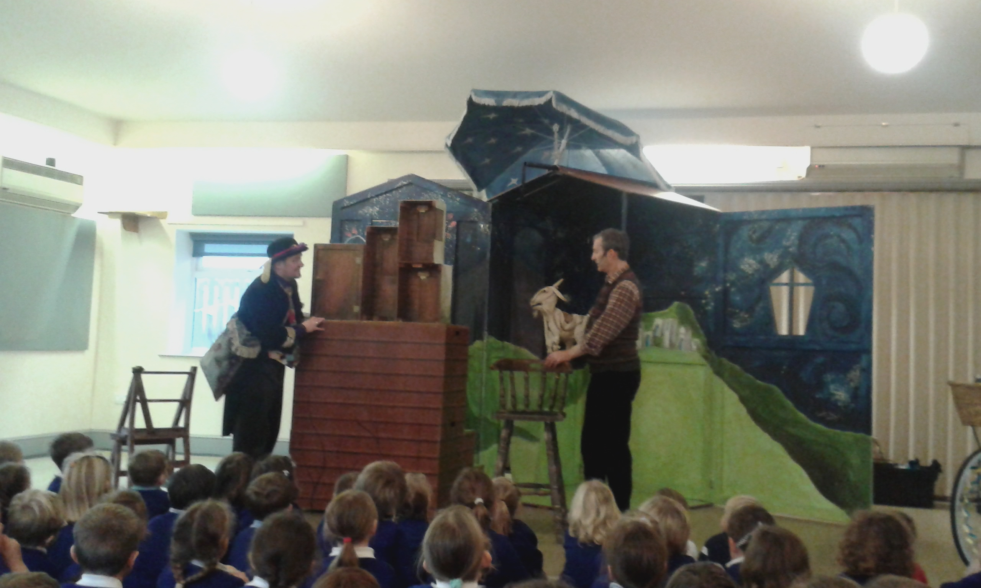

The children (and staff) thoroughly enjoyed watching *Nearly the Goat* – if you ask your child they will explain the title…

**Carol Service**

Thank you to all of those who attended our Carol Service at the Church of St Cuthbert. The children really enjoyed singing carols and reading a range of poetry.

**Where's Church this Christmas?**

If you would like to rediscover the original meaning of the Christmas story, we would love to see you at one or more of the church services over the holidays. New people, children and babies, visitors and occasional attenders are all hugely welcome at any service.

Sunday December 20th 10.30am Holy Communion at Crayke and 4pm Carol Service at Brandsby.

Christmas Eve

4pm Nativity and Carols at Crayke - if you have a nativity costume, please wear it. We have spares available if needed! 11.30pm Midnight Holy Communion

Christmas Day

9am Family Communion at Yearsley and 10.30am Family Communion at Brandsby

Sunday December 27th

10.30am Holy Communion at Husthwaite

Sunday January 3rd

10.30am Holy Communion at Brandsby

10.30am Family Service at Crayke

With best wishes for a Happy Christmas

Revd Liz

**Team Points**

This half term’s winners are:

