**Crayke Chronicle**

**Friday 3rd July**

**East Barnby**

The Year 6’s had a wonderful time at East Barnby last week and had the opportunity to experience a range of activities, from bodyboarding (in sleet) to rock climbing.

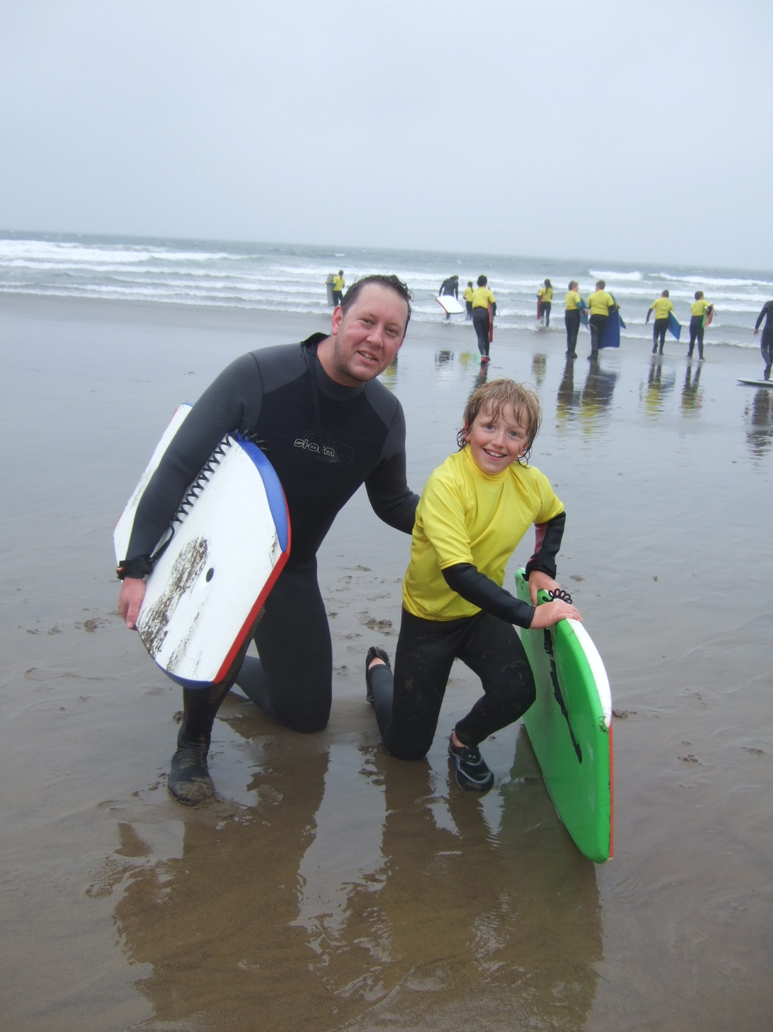

**Sporting Success**

Congratulations to all the children who successfully represented our school and contributed to Crayke winning the annual Cluster Athletics Competition on Monday. The following day, the whole school enjoyed a rather warm Sports Day. It was great to see the effort and sportsmanship the children displayed, despite the soaring temperatures.

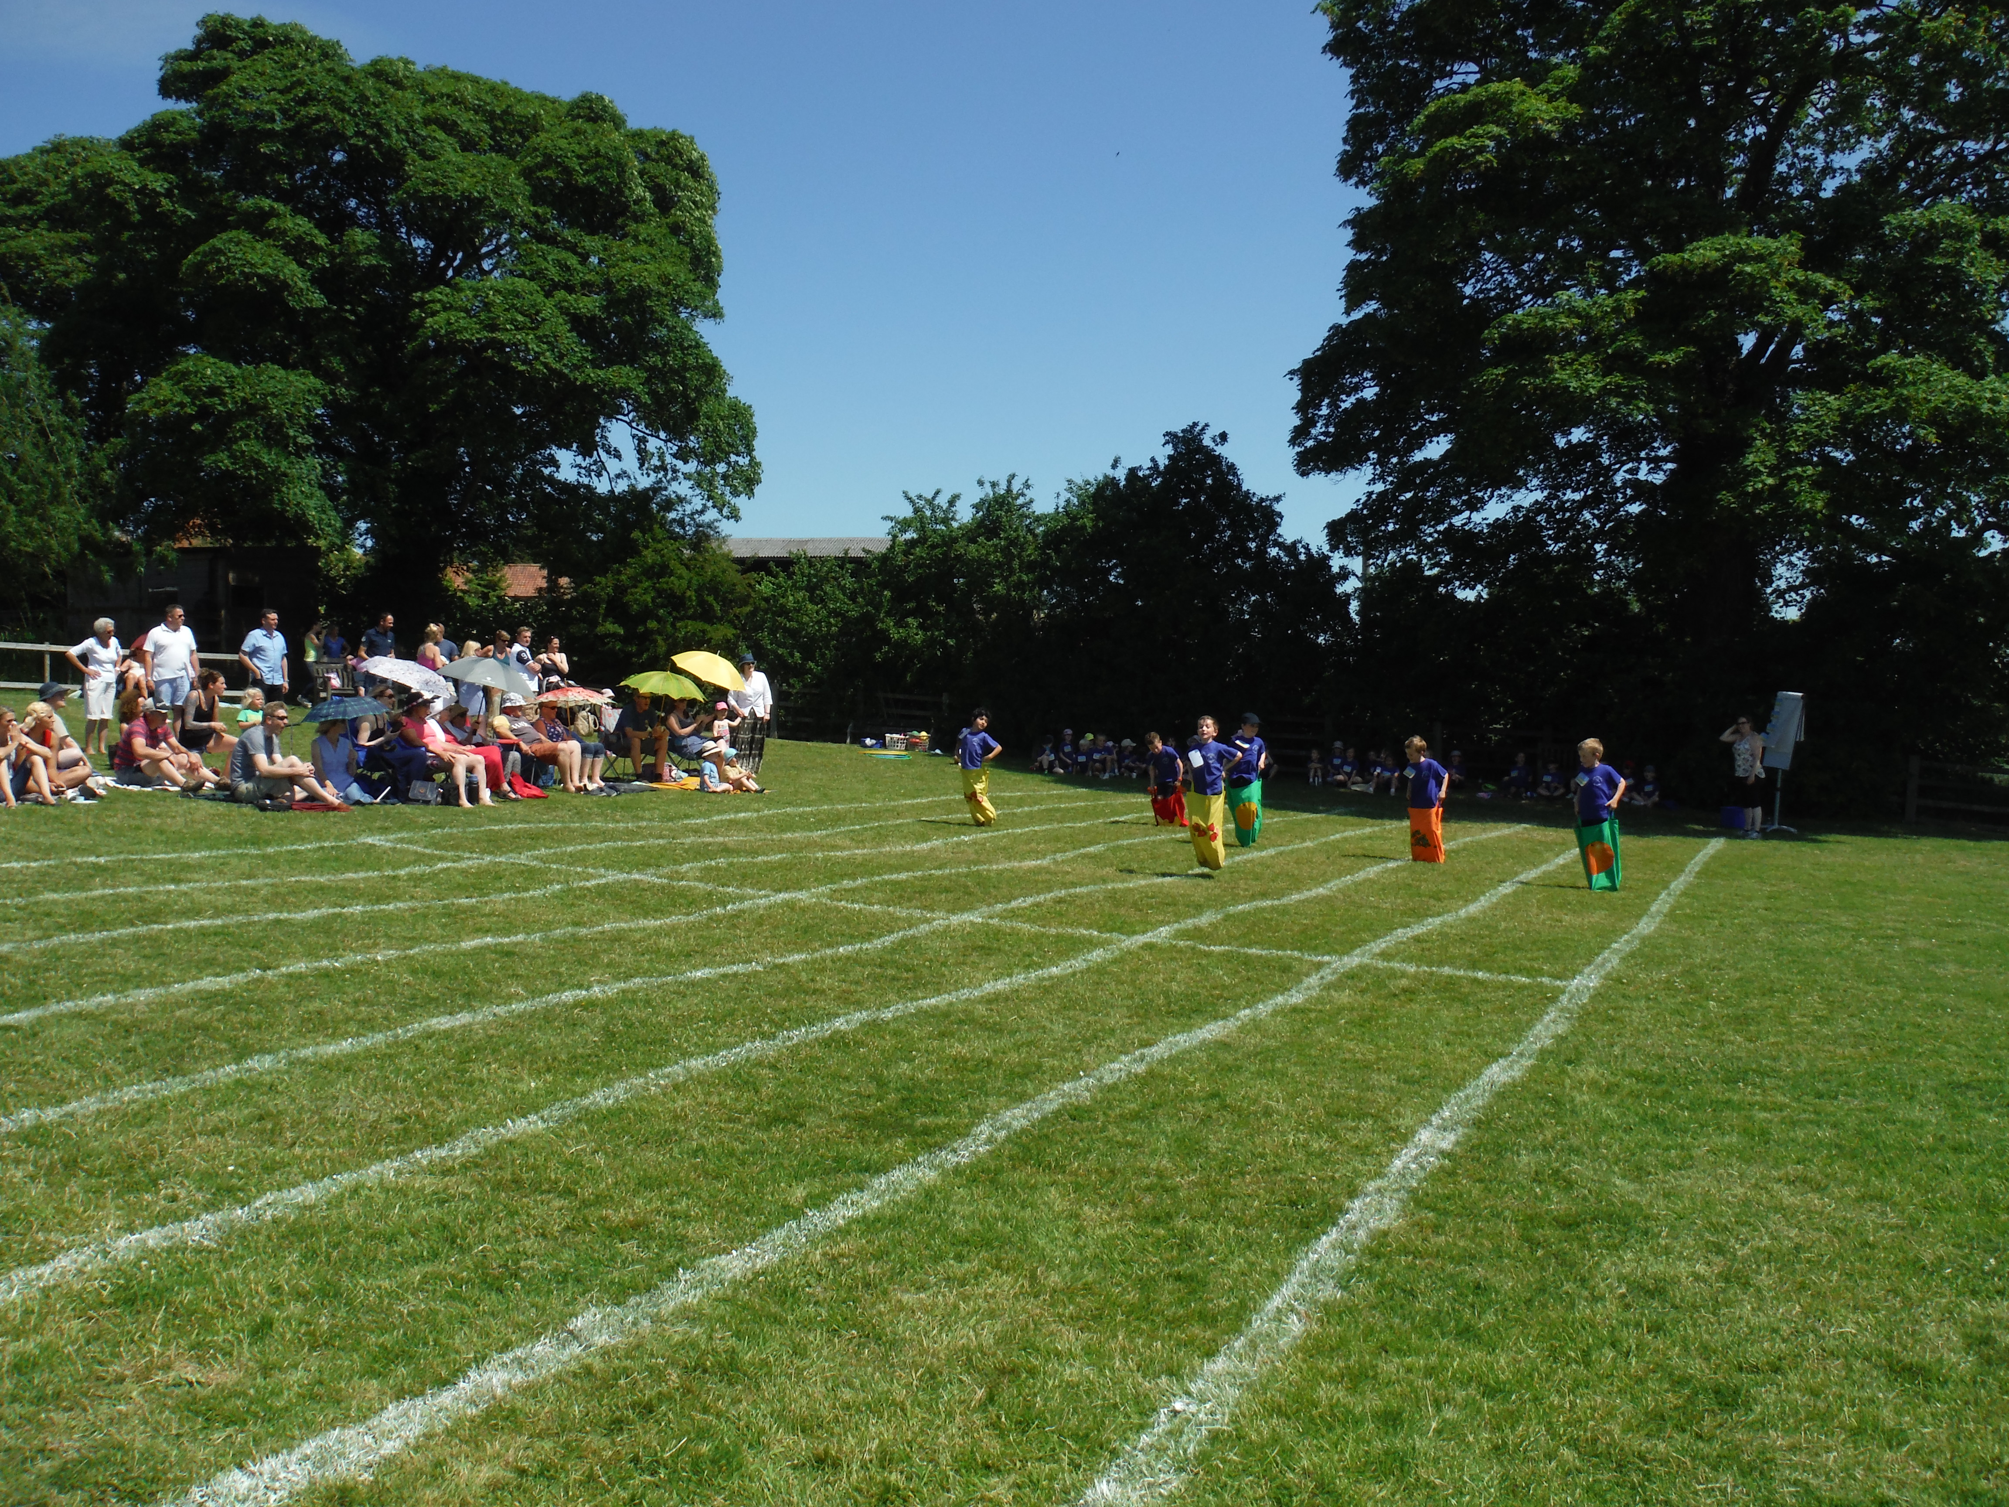

I would like to thank the parents/carers who gave up their time to support both the aforementioned events.

**Where's Church this week?** by Rev. Liz

Sunday July 5th  
All welcome, especially new people. Do come and join us.  
Family Service at St Cuthbert's, Crayke with refreshments from 10.30 am. Holy Communion at All Saints', Brandsby at 10.30am  
Date for your diary:  
Church picnic and walk - Sunday July 12th. All welcome to our picnic and walk. Join us for any or all of the afternoon. We'll meet after the 10.30am service of Holy Communion, have   
a picnic lunch together, then walk to the Dutch House, returning to church for a glass of wine later in the afternoon.  
Please let Fiona Warriner know if you are coming on 823131.

Many thanks,

Revd Liz



In Class 1, the children will be able to be acknowledged as either *Thinker* or *Friend* of the Week. Congratulations to this week’s children...

**Thinker of the Week**

**Class 1 – Reo Tweddle**

**Friend of the Week**

**Class 1 – Ella Fenton**

Each week a child will be selected from our classes to receive the title of *Maths Whizz* of the Week or *Wonderful Writer* of the Week. Congratulations to this week’s children...

**Maths Whizz of the Week**

**Class 2 – Oliver Lawery**

**Class 3 – Olivia Piercy**

**Class 4 – Jack Wainwright**

**Wonderful Writer of the Week**

**Class 2 – Gracie Bramwell**

**Class 3 – Teegan Duffield**

**Class 4 – Finlay Thorne**