Writing programs – what is debugging?
Programmers write computer programs in a language we call code. However, because no one is perfect, computer programmers sometimes make mistakes when writing their code. These mistakes are known as ‘bugs’.
A complex program can be made up of lots of lines of code and it is normal for new programs to have some bugs.
An important part of programming is testing your program and 'debugging' (which means removing the bugs).
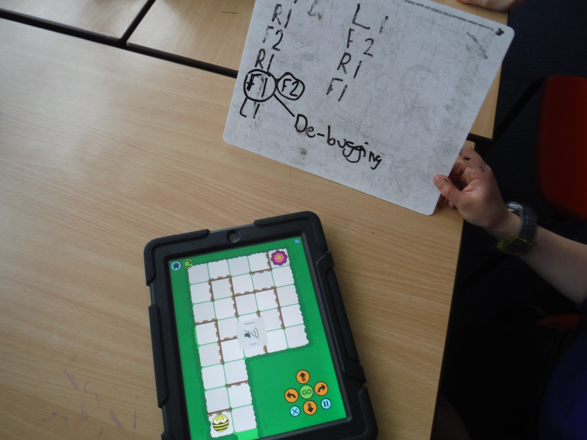
Class 4 identified and corrected lines in code (debugging)

