**Crayke Chronicle**

**Friday 24th April**

**Science Boffins**

On Monday 20th May the school was visited by Science Boffin Harry. The children had a wonderful time learning all about gases and watched/participated in some great experiments.

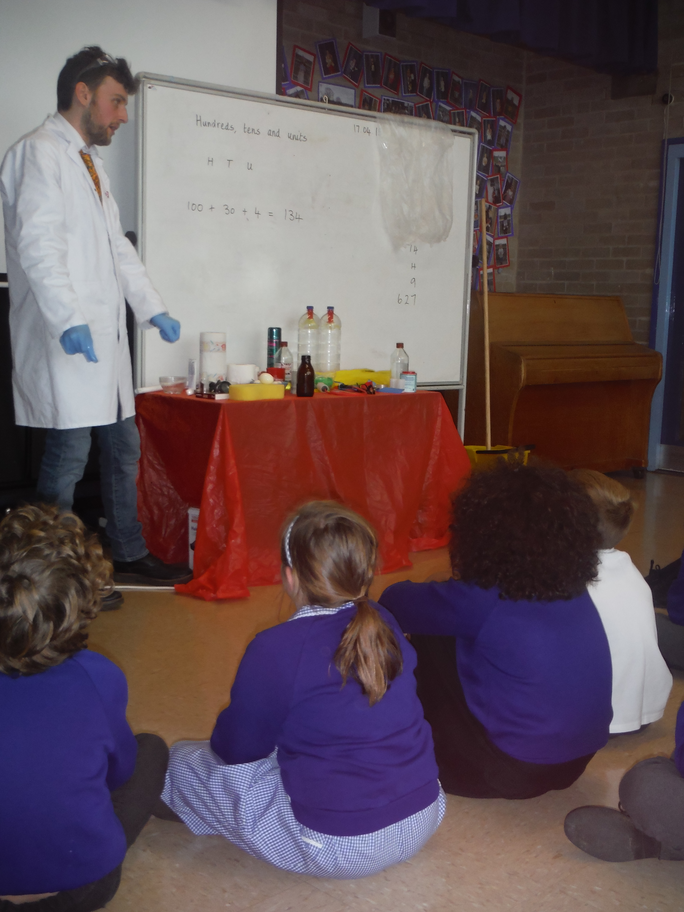

Here’s what Oliver Lawery in Class 2 had to say “my favourite experiment was the volcano because it exploded a lot more than he wanted!”

Thank you to CHASA for organising and funding the event.

**STEM Mega Jam**

The National STEM Centre is hosting a family friendly mega jam on Saturday 6th June 2015. Take part in presentations, hands on workshops and exhibitions of technology and science. For further information please clink the link [STEM mega jam](http://info.nationalstemcentre.org.uk/heatedlz/lz.aspx?p1=05047961S9372&CC=&w=5103&cID=0&cValue=1).

**Where's Church this week?**

Sunday, 26th April at 10.30 a.m. Holy Communion at Yearsley, 6.30 p.m. Evensong at Crayke.

Don't forget the new family service at Crayke begins on May 3rd at 10.30am.

Many thanks,

Revd Liz



In Class 1, the children will be able to be acknowledged as either *Thinker* or *Friend* of the Week. Congratulations to this week’s children...

**Thinker of the Week**

**Class 1 – Alfie Pinchon-Watson**

**Friend of the Week**

**Class 1 – Sam Noy Scott**

Each week a child will be selected from our classes to receive the title of *Maths Whizz* of the Week or *Wonderful Writer* of the Week. Congratulations to this week’s children...

**Maths Whizz of the Week**

**Class 2 – Olivia Tweddle**

**Class 3 – Pia Emsley**

**Class 4 – Amara Dobson**

**Wonderful Writer of the Week**

**Class 2 – Ellayana Roberts**

**Class 3 – Eliza Fielding**

**Class 4 – Charlie Wright**