**Crayke Chronicle**

**Friday 27th March**

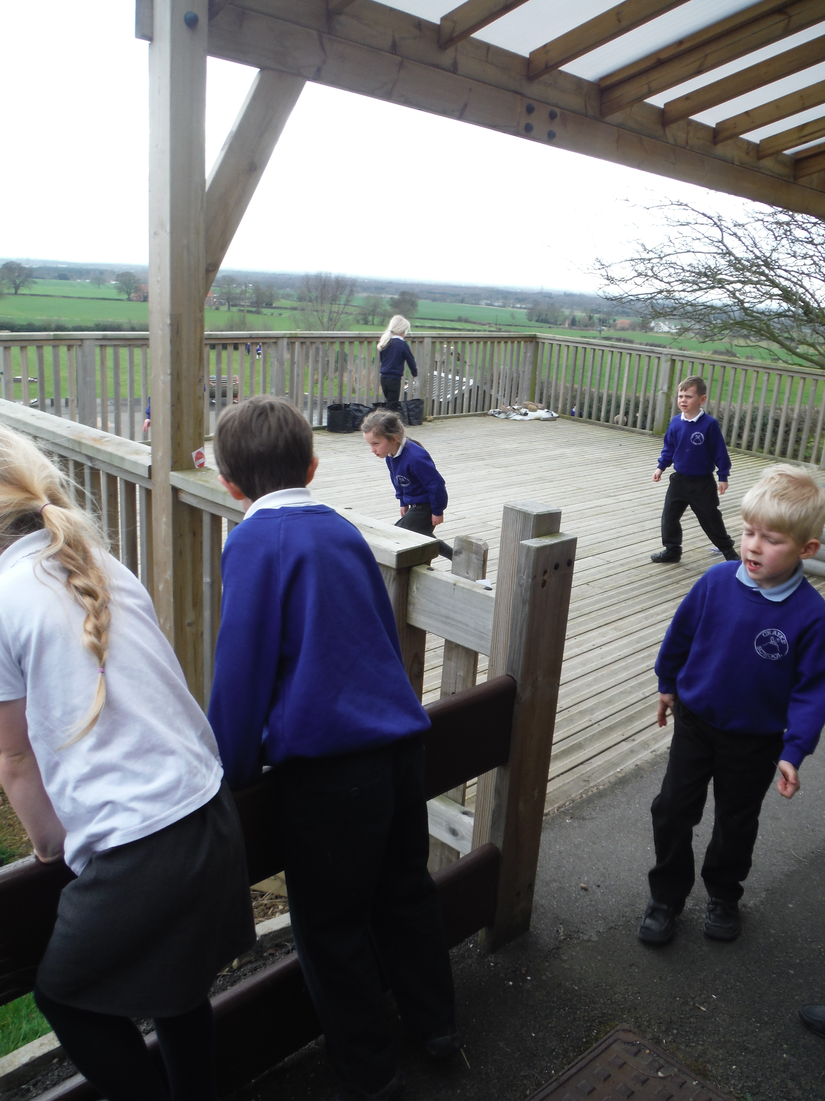

**Happy Easter**

On behalf of all the staff at Crayke, I would like to take this opportunity to wish all the children, parents and carers a happy Easter! There have been some wonderful Easter activities taking place at both the Church and the school this week. I was very impressed by the standard and variety of decorated eggs on show today. I think it would be fair to say that the children really enjoyed the Easter egg hunt…

We look forward to a successful summer term when the children return on Tuesday 14th April.

**Goodbye Miss Henn**

I would like to wish Miss Henn all the best in her new job and thank her for her invaluable contribution at Crayke. I know the whole school community will really miss her.

**Where's Church over Easter?**

Donkey Service on Palm Sunday (29th March) - Don't forget to change your clocks forward an hour!

A little further afield this week, you will find our family service with donkey at Carlton Husthwaite. Meet at the village hall at 10.15am to walk with the donkey, or at the Church at 10.30am.

At St Cuthbert's, Crayke we have a Holy Communion service at 10.30am with the dramatised gospel: come and be part of the story.

In Holy Week there are lots of services, mostly in the evenings. Details in the parish magazine, or on www.achurchnearyou.com

On Easter Sunday (5th April) there are family communion services at:

10.30am Crayke

10.30am Brandsby

On the 12th of April we have a joint service in Coxwold at 10.30am. Our tradition here is to continue the celebration of Easter by calling it Colourful Sunday and all wearing our brightest colours.

Wishing you a very happy Easter.

**Head Lice**



Unfortunately there are several cases of head lice in school.  Please could all parents check their children and if necessary, take remedial action with the whole family.

***Remember once a week, take a peek.***

[Click here](http://www.nhs.uk/Livewell/childhealth6-15/Pages/Nits.aspx) to open the NHS website with information regarding how to treat head lice.