**Crayke Chronicle**

**Friday 5th December**

**Where's Church this week?**

**Sunday 7th December**

10.30am Holy Communion at Brandsby

4.00pm Advent Christingle Service at Crayke - a great family event. Come and make your Christingle and celebrate Advent.

**Wednesday 10th December** at 7.30pm - Yearsley Carol Service

The church's travelling Mary and Joseph set out from Brandsby last Sunday, visited school on Monday and then went on their way. If you want to follow their progress, click on this link <https://twitter.com/search?q=%23craykeposada&src=typd> or just search #craykeposada on twitter.

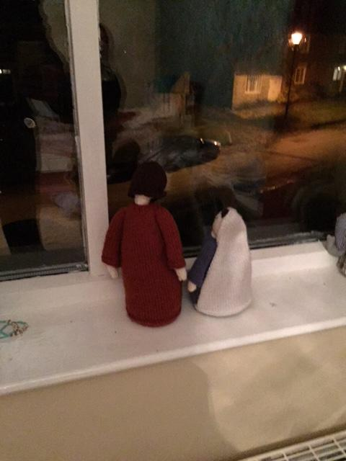

Please remember that if Mary and Joseph come to visit your house, they need to be passed on to someone else after one night!

There's still time to sign up to be in the Christmas Eve nativity at Crayke church. See Rev Liz for details, or text/call Victoria on 07793 962784.

Revd Liz

**Class Three’s Stone Age Museum Workshop**

Class Three really enjoyed their visit on Thursday. The workshop explored how we know and find out about the past before written history. The children handled prehistoric objects from the Stone Age, Bronze Age and Iron Age and discussed what life was like in each period. It goes without saying that red face paint was also involved!

**Road Safety Slap-wrap Armbands**

Following generous support from CHASA, the School Council will be selling high visibility slap-wraps next week.

The wraps will be priced at £1.50, with all profits going to support Suamy. Representatives from the School Council will sell the wraps at first break.

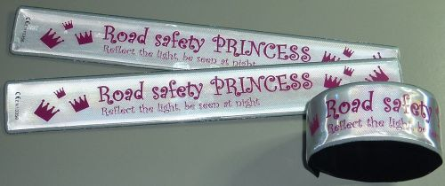

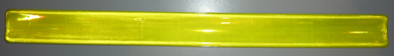

**Christmas Cards**

Children wishing to send Christmas cards can now do so. A snowman post box is situated in the hall and will be opened daily (up to the 19th December). Could I please ask that the child’s name and class is included on the envelope.



In Class 1, the children will be able to be acknowledged as either *Thinker* or *Friend* of the Week. Congratulations to this week’s children...

**Thinker of the Week**

**Class 1 – Evie Marwood**

**Friend of the Week**

**Class 1 – Edward Lowther**

Each week a child will be selected from our classes to receive the title of *Maths Whizz* of the Week or *Wonderful Writer* of the Week. Congratulations to this week’s children...

**Maths Whizz of the Week**

**Class 2 – Abigail Walsh**

**Class 3 – Lipxin Tang**

**Class 4 – Robert Featherstone**

**Wonderful Writer of the Week**

**Class 2 – Gaby Hollinrake**

**Class 3 – Hattie Alexander**

**Class 4 – Emily Brown**

**Durham Ox Competition Winners**

Congratulations to the following children:   
**Reception**  
Alfie Pinchon       
Florence Ritchie (Children in Reception will receive a certificate)    
**Class 2**   
Winner: Ellenor Atkinson     
Runner-up: Nancy Bramall-Smith    
Commended:  Toby Helfferich  & Emilia Tankard     
**Class 3**  
Winner:  Lipxin Tang      
Runner-up: Annabel Ritchie     
Commended:  Astara Carleton-Musker & Tom Ellerker     
**Class 4**   
Joint Winners: Ben Forshaw & Oliver Levin       
Commended: Charlie Wright & Josh Stojkovic

To mark the occasion The Durham Ox would also like to offer all Crayke School children a free ice cream for pudding the next time they come in for Magnificent 7 (early bird menu) at The Durham Ox. Their Magnificent 7 Menu is available Monday - Friday 5.30pm - 6.45pm.

A calendar has been made to mark the occasion and these will be for sale in The Ox shop for £5.99

**Achievement Assembly**

Congratulations to all the children in Class One for their wonderful assembly this morning. It was great to see their artwork and hear about all the exciting activities they have been doing during Forest Schools.