**Crayke Chronicle**

**Friday 28th November**

**Tag Rugby Success**

I was immensely proud of the boys and girls, who represented the school, in this week’s Tag Rugby Tournament. It was wonderful to see such high levels of commitment on display; despite the fact that most of the team had limited prior experience. Crayke won seven out of eight games (one draw) and finished the tournament as winners! The children will represent the school again in the North Yorkshire finals (Summer 2015).

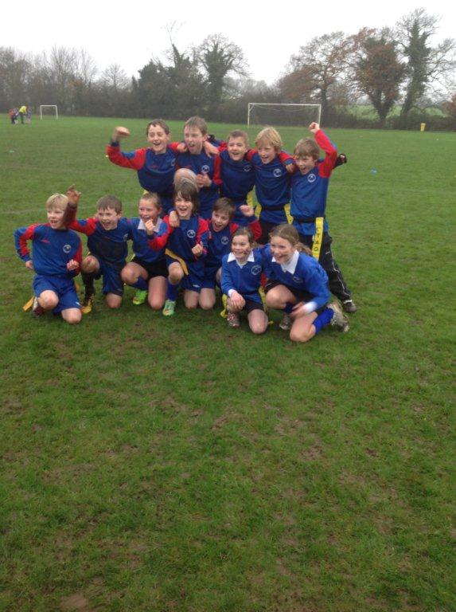

**Where's Church this week?**

30th November is the First Sunday of Advent. Join us at 10:30am in All Saints Church, Brandsby.



In Class 1, the children will be able to be acknowledged as either *Thinker* or *Friend* of the Week. Congratulations to this week’s children...

**Thinker of the Week**

**Class 1 – Daniel Wilson**

**Friend of the Week**

**Class 1 – Florence Ritchie**

Each week a child will be selected from our classes to receive the title of *Maths Whizz* of the Week or *Wonderful Writer* of the Week. Congratulations to this week’s children...

**Maths Whizz of the Week**

**Class 2 – Olivia Waite**

**Class 3 – Laura Mears**

**Class 4 – Oliver Levin**

**Wonderful Writer of the Week**

**Class 2 – Henry Ellerker**

**Class 3 – James Ritchie**

**Class 4 – Hannah Reid**