**Crayke Chronicle**

**Friday 5th September**

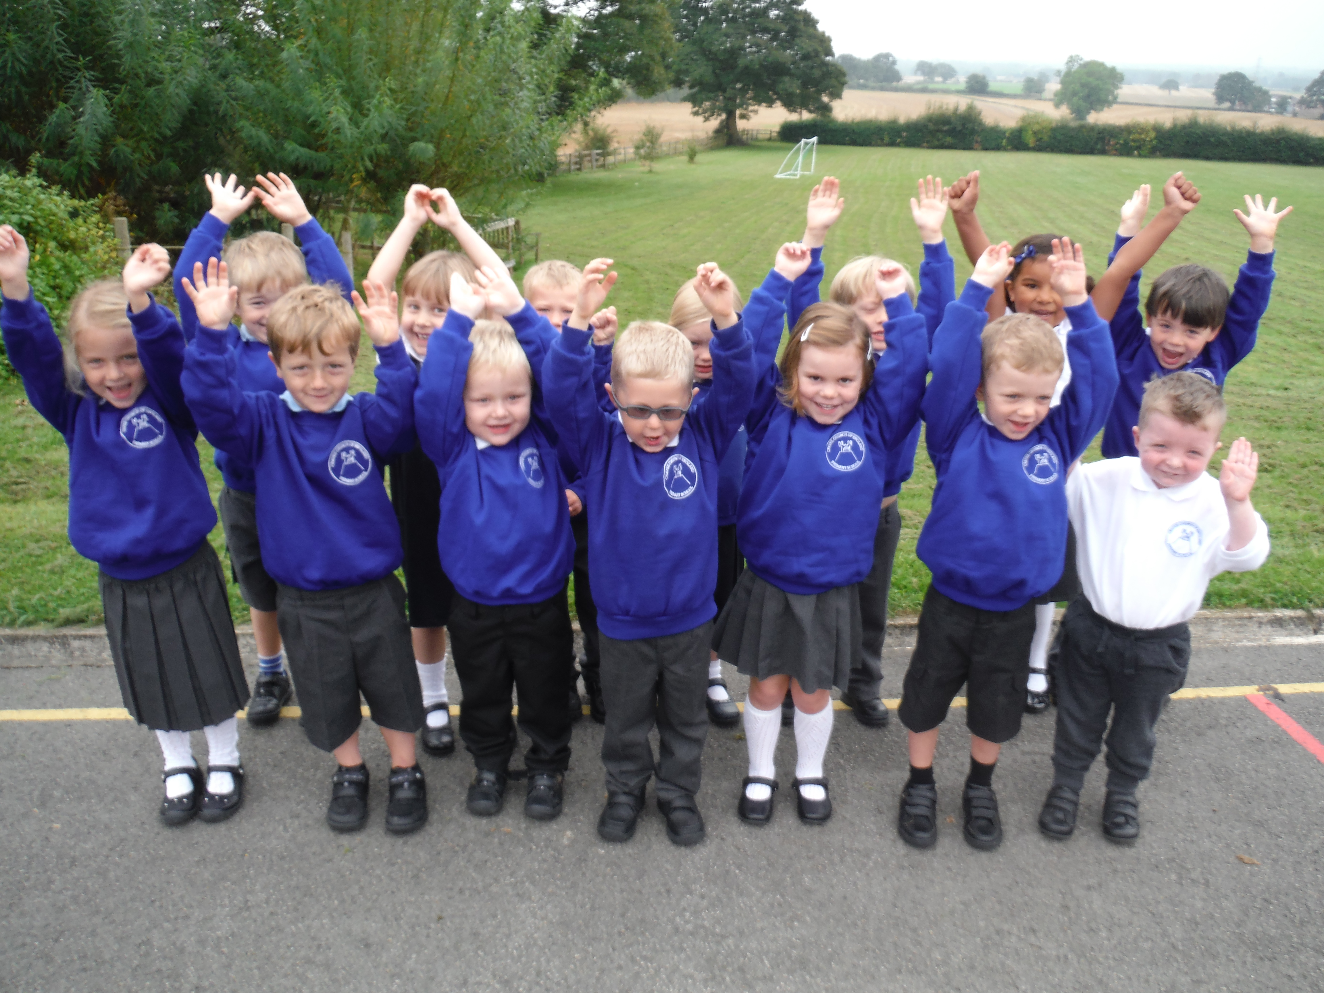

**New starters**

**Autumn Term**

Firstly, I would like to welcome the students and staff back for the new academic year. I hope that you have all had restful and enjoyable holidays and are looking forward to another school year which I am sure will be successful and exciting for all. We also give a warm welcome to our 15 pupils joining us in Class One.

**Newsletters**

Weekly newsletters (Crayke Chronicle) will be added to the school website to keep parents informed about what is going on at school. Newsletters will come out on a Friday so don’t forget to check the website.

**School Contact Details**

If you need to contact the school office Mrs Cotterill is available on 01347 821767. The office can also be reached by email on [admin@crayke.n-yorks.sch.uk](mailto:admin@crayke.n-yorks.sch.uk).

**Pupil Absence**

If your child is unable to come into school please can you contact the school office, either by telephone, letter or in person on the first day of absence. Registers are checked twice a day and the school office will contact any parent where there is an unexplained absence for a pupil. If you know your child will be absent at a future date e.g. hospital appointment, please can the request for absence be given to the school office and not to the class teacher.

**Parent Helpers**

We actively welcome parent helpers into school and we know you have lots of skills to share with us! If you have time to help in a classroom e.g. hear readers, supervise art projects or are willing to help with gardening or other special events please can you see Mr Buttery.

**CHASA**

Our Friends association (CHASA) do a wonderful job of providing a range of enjoyable social events throughout the year as well as providing valuable additional funds that are spent on resources for your children. Please continue to support CHASA this year and it would be lovely to have a large turnout at their meeting on Monday 8th September at 8.00pm. The meeting will be held at Rachael Pears house (Crayke Lodge, Daffy Lane, Crayke, YO61 4TH). If you have never been to a meeting please consider coming along.

**Welcome to my first Headteacher’s Newsletter**

I’ve had a really enjoyable first week at Crayke and would like to thank the children, parents and staff for such a warm welcome. If you would like to contact me directly, my non-teaching days are Wednesday, Thursday & Friday. Alternatively, I can be reached by email on [headteacher@crayke.n-yorks.sch.uk](mailto:headteacher@crayke.n-yorks.sch.uk).

Thank you Mr. A Buttery

**The 2014 National Curriculum: what Crayke parents need to know**

The National Curriculum in England is currently in a process of transition. The obligation to teach programmes of study from the existing national curriculum will be disapplied and new programmes of study and attainment targets will eventually completely replace the existing national curriculum.

**Why the big curriculum change?**

The main aim is to raise standards. Although the new curriculum is intended to be more challenging, the content is actually slimmer than the current curriculum, focusing on essential core subject knowledge and skills such as extended writing and computer programming.

**The main changes…**

The information below summarises the main changes in the core subjects.

**English**

Stronger emphasis on vocabulary development, grammar, punctuation and spelling (for example, the use of commas and apostrophes will be taught in KS1). Handwriting (not currently assessed under the national curriculum) is expected to be fluent, legible and speedy. Spoken English has a greater emphasis, with children to be taught debating and presenting skills.

**Maths**

Five-year-olds will be expected to learn to count up to 100 (compared to 20 under the current curriculum) and learn number bonds to 20 (currently up to 10). Simple fractions (1/4 and 1/2) will be taught from KS1, and by the end of primary school, children should be able to convert decimal fractions to simple fractions (e.g. 0.375 = 3/8). By the age of nine, children will be expected to know times tables up to 12×12 (currently 10×10 by the end of primary school). Calculators will not be introduced until near the end of KS2, to encourage mental arithmetic.

**Science**

Strong focus on scientific knowledge and language, rather than understanding the nature and methods of science in abstract terms. Evolution will be taught in primary schools for the first time. Non-core subjects like caring for animals will be replaced by topics like the human circulatory system.

**Design & technology**

Design and Technology has become more important in the new curriculum, setting children on the path to becoming the designers and engineers of the future. More sophisticated use of design equipment such as electronics and robotics. In KS2, children will learn about how key events and individuals in design and technology have shaped the world.

**ICT**

Computing replaces Information and Communication Technology (ICT), with a greater focus on programming rather than on operating programs. From age five, children will learn to write and test simple programs, and to organise, store and retrieve data. From seven, they will be taught to understand computer networks, including the internet. Internet safety – currently only taught from 11-16 – will be taught in primary schools

**Languages**

Currently not statutory, a modern foreign language or ancient language (Latin or Greek) will be mandatory in KS2. Children will be expected to master basic grammar and accurate pronunciation and to converse, present, read and write in the language.