Enrichment Week in Class 4
Our first visitor of the week was an artist called Peter Swidrak. Around the hall were various well known pictures by different artists and we had to really study these pictures very carefully to be able to answer the quiz questions he gave us. For our own artwork, our chosen medium was artists’ modelling clay, which we used to create an image of famous landmarks to great effect.
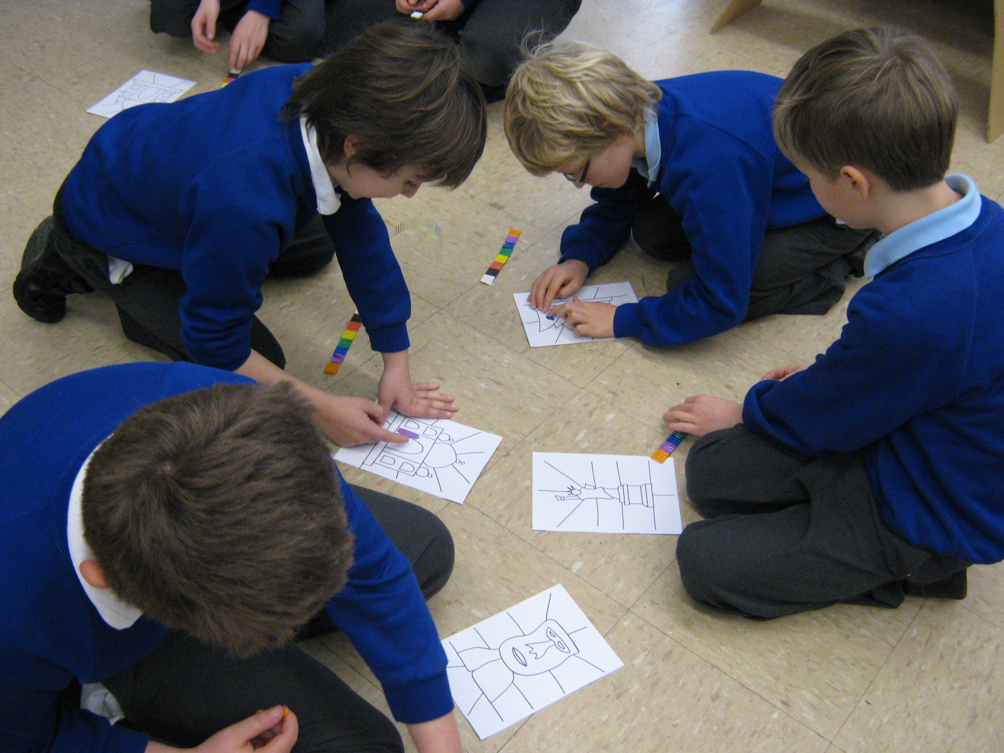

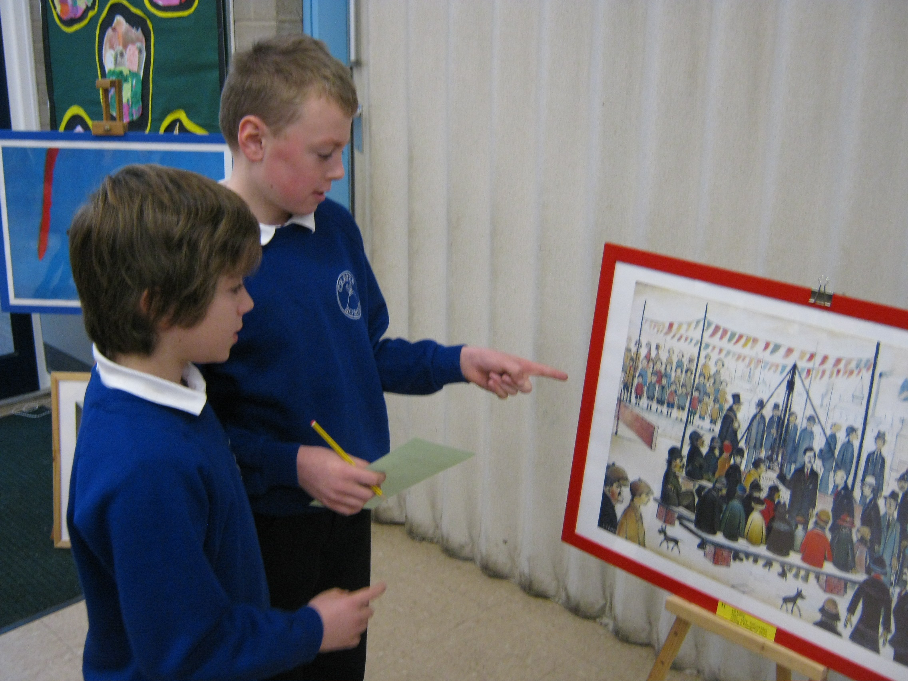

Tuesday saw us all learning a new form of dance with Pete Francis (a member of the original cast of the production Stomp), which was a mixture of street, ballet and ‘Stomp’ style! We all chose groups and made up our own dances, including stamping, clapping and body movements. At the end of the day, we “busted some moves” for the younger children to show them our techniques.
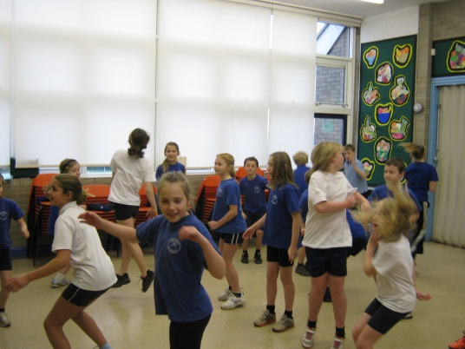

Information on other events on another post!

