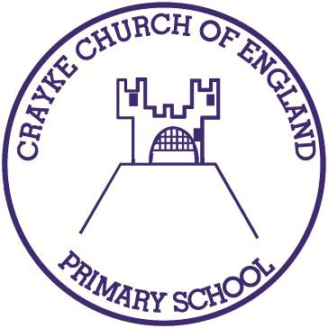

**Crayke Church of England Primary School**

**Easingwold Road**

**Crayke**

**North Yorkshire YO61 4TZ**

Tel/Fax: 01347 821767

E.mail: [admin@crayke.n-yorks.sch.uk](mailto:admin@crayke.n-yorks.sch.uk)

Website: craykeschool.org

**Headteacher – Mr. Andrew Buttery** BA (HONS), PGCE, NPQH

**Dinner Money Increase**

16/05/19

Dear Parents and Carers, as you are already aware, our school subsidised the cost of school dinners for a number of years (this resulted in no increases for eight years). Following updated costings from North Yorkshire County Caterers, the school will be charged the equivalent of £2.65 per meal from September.

This financial year, due to rising costs, our budget is tighter and we are unable to offset the aforementioned increase in costs. As a result, from September 2019 school dinners will cost £2.65 per day or £13.25 per week.

Please note that all universal free school meals will be unaffected, however, Key Stage 2 children will be charged at the new rate from the start of next academic year.

We apologise for the increase in costs, however, we have no alternative.

Thank you for your continued support.

Yours sincerely,



Andrew Buttery

Headteacher