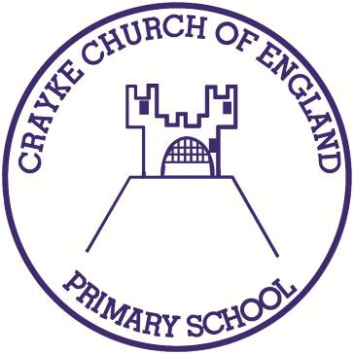

**Crayke Church of England Primary School**

**Easingwold Road**

**Crayke**

**North Yorkshire YO61 4TZ**

Tel/Fax: 01347 821767

E.mail: [admin@crayke.n-yorks.sch.uk](mailto:admin@crayke.n-yorks.sch.uk)

Website: craykeschool.org

**Headteacher – Mr. Andrew Buttery** BA (HONS), PGCE, NPQH

15th March 2019

Dear Parents/Carers,

I am writing to inform you of a new program that children in Years 2-6 have started using in school this week ‘Times Table Rockstars’. With times tables being a vital part of the curriculum and with the new Year 4 end of year testing beginning in 2020, we hope this program will support the learning of times tables in a fun and innovative way.

Participating children have completed their baseline assessments for Times Table Rockstars this week. This will allow children to login to the program, which will be tailored to their needs and ability. The children will work though levels, collecting coins, which in turn allow them to buy new accessories for their ‘Avatar’. Over time the year groups and classes will have the opportunity to battle against each other too!

Login details will be sent home this afternoon, so that children can keep practising at home.

The children are already having great fun using ‘Times Table Rockstars’. If you have any further questions, please do not hesitate to contact me…

Yours sincerely,



Mrs L Dobson

