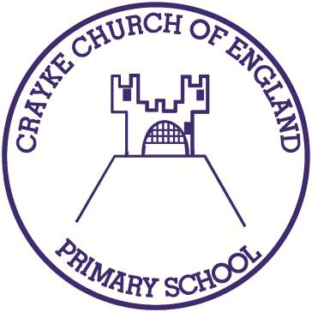

Crayke Church of England Primary School
Easingwold Road
Crayke
North Yorkshire YO61 4TZ
Tel/Fax: 01347 821767
E.mail: admin@crayke.n-yorks.sch.uk
Website: craykeschool.org

Headteacher – Mr. Andrew Buttery BA (HONS), PGCE, NPQH

Crayke Spelling Bee Competition
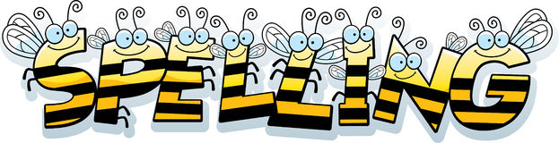
We will be holding a spelling bee event for Years 1 to 6 on
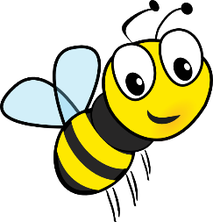
Tuesday 9th April. Reception will take part in spelling games and activities on the same day.
Why have a spelling bee competition?
This year we are trying to raise the profile of spelling across the school. We are working hard to teach the children the value of learning to spell, and to develop their knowledge of different spelling patterns.
Just as we celebrate sports at Sports Day, we want to celebrate the efforts that children are making with their spelling!

How will spellings be tested?
In the morning, all children will be tested much like a normal weekly spelling test. These will be based on the spelling list you are provided with for children to learn at home. For any children who get them all correct, they will then be tested separately by a teaching assistant on some of the other words from their year group NC list. No scores will be shared, but the three finalists will be announced.

For the spelling bee itself, in the afternoon the three finalists from each year group will write their spellings on a whiteboard and show them to our panel of ‘judges.’ The rest of the school won’t be able to see what they have written, and no scores will be shared. These words will also be based upon the NC lists, although there may be some additional ‘challenge’ words if required in the event of a tie.

There will be stickers and certificates for all who take part as well as certificates awarded for effort and improvement.
The finalists will receive either a bronze, silver or gold medal and certificate.
The winner from each year group will also receive a prize.

Try using different ways of practising spellings with your children, to make it fun.
Can they write the word in flour or write it in chalk outside? Could they make up mnemonics or draw pictures to help them remember?

Please find the attached spelling lists for each year group. The reduced lists are the words that all children will be tested on. Further spellings will be selected at random from the full age-appropriate list for any children competing in further heats after the whole-class challenge. Children have between now and the Spelling Bee on Tuesday 9th April.
Have fun learning your spellings!
What if my child finds spelling challenging?
Our spelling bee is designed for all children to be able to enjoy spellings and develop their knowledge of different spelling patterns as well as help them to spell more of the words on the National Curriculum word list. We want to make the event as fun and exciting as possible. We want to recognise children’s efforts and personal improvements, much like we would do in Sports Day for any children who find those types of activities a challenge. This is also a wonderful opportunity to help build all children’s confidence with spelling, whilst having fun!

Yours sincerely,

Louise Rayner
English Co-ordinator

