**Crayke Chronicle**

**Friday 23rd November**

**Red Team**

**Children in Need**

A grand total of £257.70 was raised for Children in Need. Thank you for your generous support.



**Nativity**

The children and staff are busily rehearsing for our Nativity. This year we are performing ‘Born in a Barn’.

In order that all parents will be able to attend the children will perform on two occasions:

Wednesday 12th December 2.30pm and Thursday 13th December 6.00pm.

Information relating to the performances will be distributed next week.

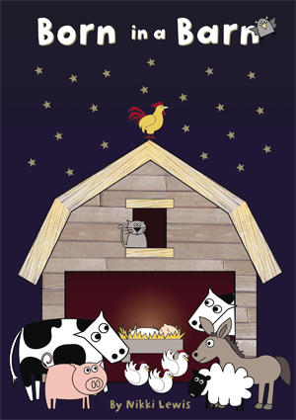

**Colder Weather**

Please can you ensure that your child comes into school every day with a coat.

We will continue with Run a Mile and relevant outdoor PE sessions; please ensure your child has suitable clothing and a bag to place their trainers in.

**Where's Church this Week?**

**Sunday November 25th**

10.30am Holy Communion at Yearsley  
6.30pm Evening Prayer at Crayke

Best wishes

Revd Liz



In Class 1, the children will be able to be acknowledged as Whizz of the week...

**Whizz of the Week**

**Class 1 – William Swan**

Each week a child will be selected from our classes to receive the title of *Maths Whizz* of the Week or *English Expert* of the Week. Congratulations to this week’s children...

**Maths Whizz of the Week**

**Class 2 – Leonard Liddell**

**Class 3 – Evie Marwood**

**Class 4 – Tamzin Harrison**

**English Expert of the Week**

**Class 2 – Maisy Emsley**

**Class 3 – Emily Sharp**

**Class 4 – Emily Walsh**

**Team Points**

This week’s winners are:



**GIANT Microbes**

The children in Class 4 have really enjoyed learning about both helpful and harmful microorganisms as part of their science topic.

Annabel explained; “our giant microbes are stuffed toys that look like tiny microbes — only a million times their actual size! They're humorous, educational, and fun! Each of the giant microbes comes with an image and information about the real microbe it represents. We really enjoyed making them!”

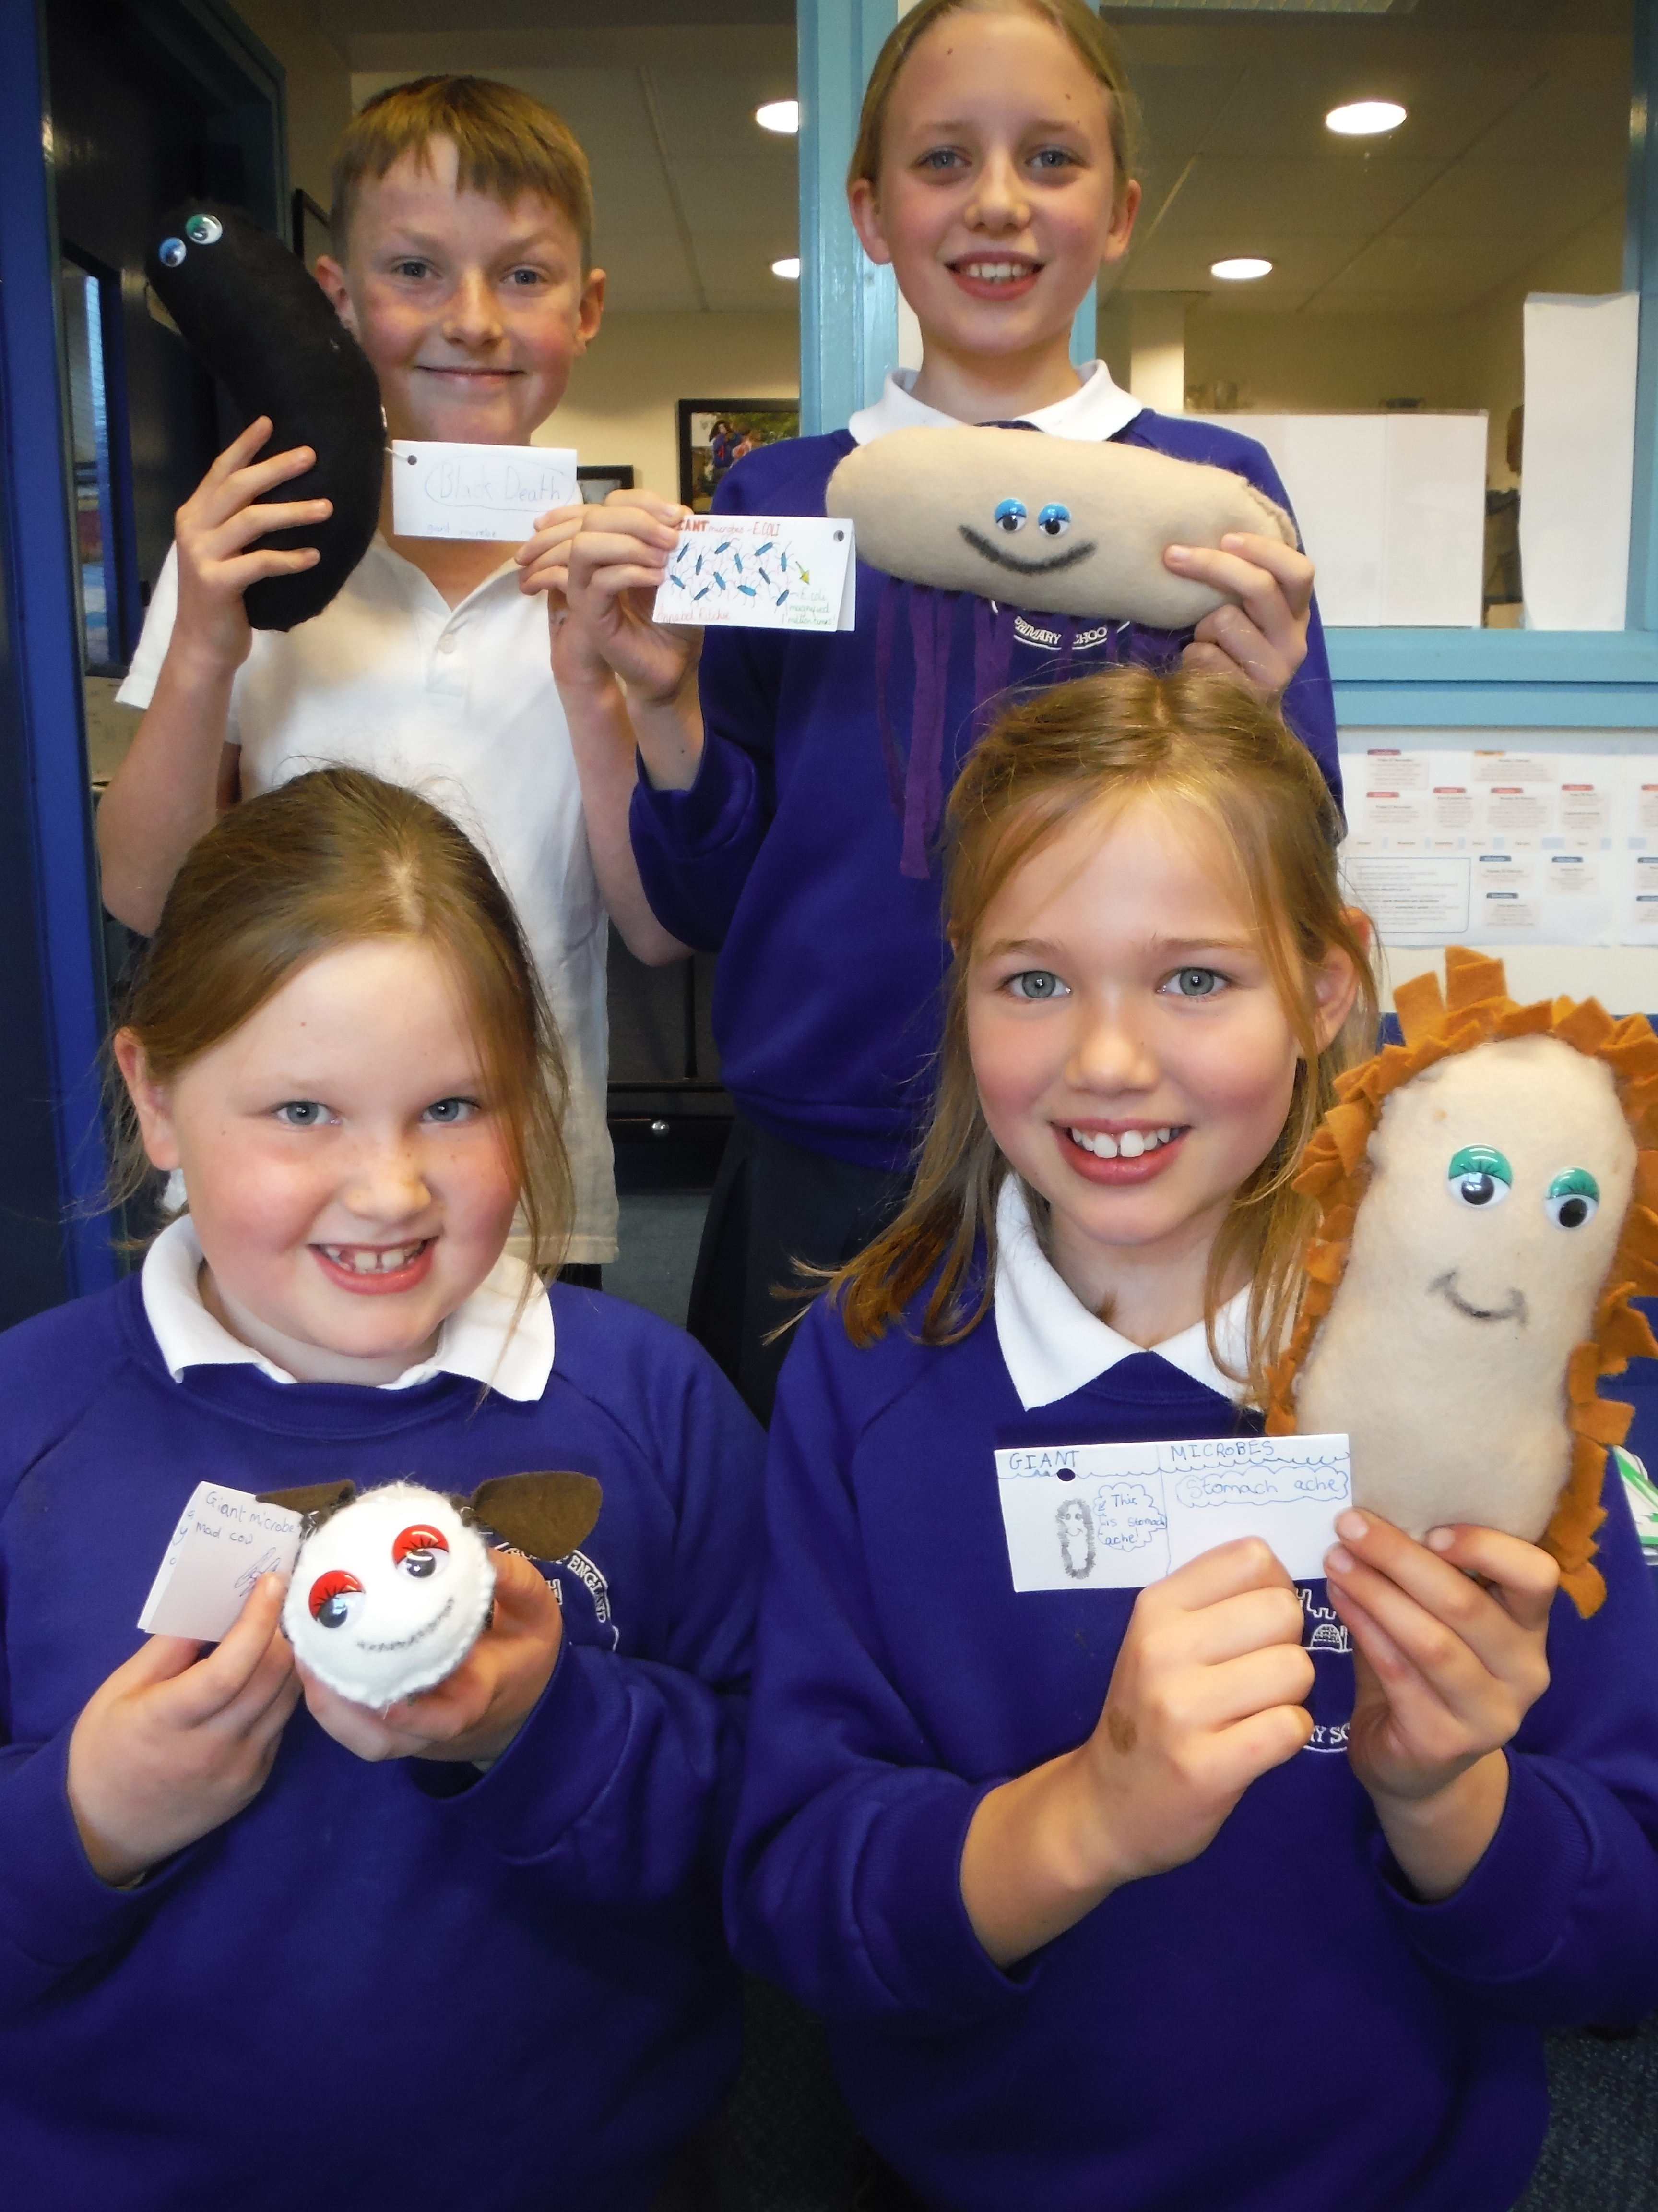

**NSPCC**

Thank you so much to the parents, carers, relatives and friends of the children who donated to the recent NSPCC sponsorship event.

Any remaining sponsorship money can still be brought into school up to Tuesday 13th December.

The current total is a hugely impressive £265.34!

Best wishes,

Revd Liz

**Colder Weather**

Please can you ensure that your child comes into school every day with a coat.

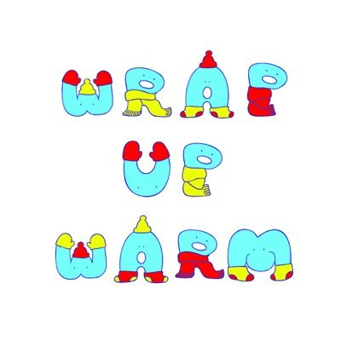



*At Crayke Church of England Primary School, we have our own news team, 'The Roving Reporters.' The team is made up of children from School Council. The Roving Reporter’s articles will be included in the Crayke Chronicle.*

**Roving Reporters**

This is Christopher, your Crayke School’s roving reporter for this week. Highlights of the week, class by class include:

Class 1 are getting ready for the nativity play which will be performed soon and they are really enjoying their new dark tent.

Class 2 are learning how to be great pirates and are working on amazing pirate sliders.

Class 3 are learning about electricity and how it works, they are working on amazing games with circuits and wires.

Class 4 are learning all about World War II.

Look out for our next Roving Report to find out more.

