**Crayke Chronicle**

**Friday 26th October**

**Parents’ Evening**

Thank you to all the parents and carers who attended Parents’ Evening. I hope this provided you with an opportunity to discuss your child’s initial progress this academic year. Following your appointment, if there is anything you would like to discuss with me, please call the school, or alternatively I can be reached by email on [headteacher@crayke.n-yorks.sch.uk](mailto:headteacher@crayke.n-yorks.sch.uk).

**York City Knights**

After half term tag/touch rugby will be available as an after school club on both a Monday & Tuesday (3.30-4.15pm).

York City Knights will be in school for six weeks working with children in Classes 1 & 2, before running an after school club for pupils in Years 3, 4, 5 and 6. The aforementioned sessions will take place from Tuesday 6th November to Tuesday 11th December. If you would like your child to part in the Tuesday sessions, please send a confirmation email to [admin@crayke.n-yorks.sch.uk](mailto:admin@crayke.n-yorks.sch.uk) - places will be allocated on a first come first served basis…

**Half Term**

The staff at Crayke Church of England Primary School would like to thank you for all your support this half term. School will reopen on Monday 5th November. I hope you all have an enjoyable half term.

**Where's Church this half-term?**

Don't miss our next family service at the end of half term. If you haven't been before, we would love to welcome you. We start with drinks and snacks, then a short service with activities for the children.

**Sunday 28th October** - 10.30am Holy Communion at Yearsley  
6.30pm Evening Prayer at Crayke

**Sunday 4th November** - 10.30am Holy Communion at Brandsby and 10.30am Family Service at Crayke

Have a lovely half term!

Revd Liz

**Planned Road Closure**

Further to the post we sent out on Tuesday, we can now provide you with additional information about the planned road closure.

Easingwold Road (outside school) will be closed for 2 weeks from 29th October.  The contractors are planning to do as much work as possible during half-term, in order to now open up access to the Sports Hall car park when we return to school on 5th November.

From 5th November the recommended access route to school will be via Easingwold Road and parents/carers will need to park their vehicle at Crayke Sports Hall and walk their child/ren up to school.  You will not be able to drive up to school and drive through/park in the lay-by as normal.  The only vehicles that will be permitted entry into the lay-by are staff vehicles, delivery vehicles, buses and emergency services.  In the interest of health and safety and giving thought to local residents, we would respectfully ask that you do not drive right up to the road closure signs and drop off/park. Potentially it could become quite congested at the Sports Hall, so we would ask that you car share wherever possible during this week.

We appreciate that this situation is not ideal, however this work is totally out of our control and what we have managed to negotiate is far better than was originally proposed.  If there is any change to the above arrangements once the work has begun, we will put a further post out during the half-term break.

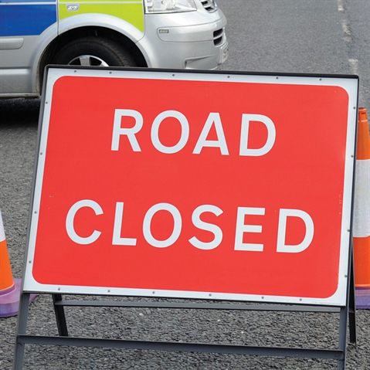



In Class 1, the children will be able to be acknowledged as Whizz of the week...

**Whizz of the Week**

**Class 1 – Florence Hindley**

Each week a child will be selected from our classes to receive the title of *Maths Whizz* of the Week or *English Expert* of the Week. Congratulations to this week’s children...

**Maths Whizz of the Week**

**Class 2 – Ernie Cater**

**Class 3 – Daniel Wilson**

**Class 4 – Jack Bain**

**English Expert of the Week**

**Class 2 – Toby Seligman**

**Class 3 – Daisy Ritchie**

**Class 4 – Macy Taylor**

**Team Points**

This week’s winners are:

**Yellow Team**





*At Crayke Church of England Primary School, we have our own news team, 'The Roving Reporters.' The team is made up of children from School Council. The Roving Reporter’s articles will be included in the Crayke Chronicle.*

**Roving Reporters**

Hello, this is Georgia and Gaby, we are here to inform you about the latest news on our Poppy Appeal - we have had an amazing time raising money for the charity poppy appeal. We are selling rubbers, rulers, pencils, pencil sharpeners, stick on poppies, poppy stickers and reflective poppy charms.

Over the last couple of days we have raised lots of money - we are going to carry on after the half term, so don’t worry if you haven’t got anything yet!

