

**Crayke Church of England Primary School**

**Easingwold Road**

**Crayke**

**North Yorkshire YO61 4TZ**

Tel/Fax: 01347 821767

E.mail: [admin@crayke.n-yorks.sch.uk](mailto:admin@crayke.n-yorks.sch.uk)

Website: craykeschool.org

**Headteacher – Mr. Andrew Buttery** BA (HONS), PGCE, NPQH

Dear Parents, Carers and Pupils,

**Welcome to Crayke C.E. Primary School!**

It gives me great pleasure to welcome and introduce you to Crayke Church of England Primary School. We are situated in very rural surroundings on the outskirts of Easingwold, 12 miles north of the historic city of York. Crayke is a small village set on a hill and the school enjoys spectacular views across the Vale of York.

With our four classrooms and school hall, the children also enjoy the benefits of a large playing field, two playgrounds (including a recently improved adventure play area) and a garden area. In 2013, we introduced our brand new outdoor classroom, including raised beds and garden area.

There are 98 pupils on roll and we have a full complement of teaching and associate staff, all of whom are energetic, dedicated and enjoy being and working with children. We form a much larger team of Governors and parents who work together in ensuring the best education for the children at Crayke School, in a caring and secure environment.

I hope that this prospectus will give you an insight into what life is like at our school, and help you to decide if Crayke School is the right one for your child or children to attend. We can assure you that your child’s arrival will be the beginning of a strong and fruitful partnership between home and school. The relationship will profoundly influence the progress every child makes during these formative years.

We look forward to seeing you.

Yours sincerely,



Andrew Buttery

Headteacher

*Please note that the information in this prospectus is updated each year but occasionally minor changes are made throughout the year.*

**Vision and Aims**

Crayke Church of England Primary School works in partnership with parents, children, church and community to provide a first-class education and start in life. We aim to inspire and equip children to learn throughout life and to strive for excellence in their work and relationships.

We promote the personal growth and development of all children, teaching and practising acceptance and inclusion for those of all backgrounds, abilities and beliefs.

We are a Christian foundation serving the whole community, embodying our school values of Respect, Determination, Friendship and Forgiveness in our nurture and encouragement of all.

**Respect** Our school is a community which values and respects each member equally. We pay attention to each other’s ideas, feelings and possessions, and take care of our school environment.

**Friendship** Everyone needs friends. We encourage children to extend their friendship to all school members, showing support, generosity and love to each other.

**Forgiveness** Forgiveness is at the heart of the Christian faith andwe acknowledge that every member of the school community – children and staff – needs a fresh start from time to time. We aim to wipe the slate clean each day and not to hold grudges.

**Determination** We know that life and learning are sometimes difficult and painful and

that it is important to have courage and not to give up. We are

committed to the achievement of our community, and of ourselves, for

the benefit of us all. We are inspired by God’s endless love and

forgiveness for us, so that as members of Crayke School we promise to

try our best in everything we do.

**ADMISSION POLICY**

All governing bodies are required by law to admit to the school a child with a statement of special needs (SEN) or education health and care plan (EHCP) that names the school. This is not an oversubscription criterion. This relates only to children who have undergone statutory assessment or education health and care assessment and for whom a final statement of special educational needs or education health and care plan has been issued.

If the number of applications exceeds the published admission number, after the admission of children where the school is named in the statement of special educational needs (SEN) or education health and care plan (EHCP) the following oversubscription criteria will apply.

Children in higher numbered priority groups will be offered places ahead of those in lower numbered priority groups. All applications within each priority group will be considered equally (i.e. **all** applications, regardless of order of preference).

At Crayke Church of England Primary School we offer all new starters into Reception a full time place in September. The new starters will have three half day afternoon visits during the term prior to their entry to school, in order to familiarise themselves with school life in general.

|  |
| --- |
| **Priority Group One** |
| Children and young people in public care for whom the school has been expressed as a preference and previously looked after children, that is children who were adopted (or subject to residence orders or special guardianship orders) immediately following having been looked after. This applies to all looked-after children, including those who are in the care of another local authority. In the case of previously looked after children, proof that the child was previously in the care of a local authority will be required to support the application. |
| **Priority Group Two** |
| Children the authority believes have exceptional social or medical reasons for admission to the highest preference school. We will only consider applications on social or medical grounds if they are supported by a professional recommendation from a doctor, social worker, or other appropriate professional. The supporting evidence should set out the particular social or medical reason(s) why the school in question is the **only** school that can meet your child's needs and the difficulties that would be caused if the child had to attend another school. Panels of professionally qualified people will consider all applications made under priority group two. Unsupported applications will **not** be considered under the social / medical criterion. |
| **Priority Group Three** |
| Children living within the normal area of the school. |
| **Priority Group Four** |
| Children living outside the normal area of the school. |

Children in higher numbered priority groups will be offered places ahead of those in lower numbered priority groups. All applications within each priority group will be considered equally (i.e. all applications, regardless of order of preference).

**Tie Break**

If there are not enough places for all the children in one of these priority groups, we will give priority first to those with a sibling at the school in September 2015 (in all cases sibling refers to brother or sister, half brother or sister, adopted brother or sister, step brother or sister, or the child of the parent/carer's partner where the child for whom the school place is sought is living in the same family unit at the same address as that sibling) and then to those living nearest the school.

If within a priority group there are not enough places for all those with a sibling at the school in September, we will give priority to those children with a sibling living nearest the school.

For further information please visit [www.northyorks.gov.uk/article/26372/Admissions-policies](http://www.northyorks.gov.uk/article/26372/Admissions-policies)

**CRAYKE C.E. PRIMARY SCHOOL – ADMISSION FORM**

If your child/ren have been accepted to attend Crayke School, please complete this form and return it to school as soon as possible (block capitals).

**FULL NAME OF CHILD**

**DATE OF BIRTH POSITION IN FAMILY ETHNICITY RELIGION**

(please circle)

White – British Church of England

Other Other (please state)

**FULL NAME OF PARENTS / GUARDIAN**

**ADDRESS**

**POST CODE TELEPHONE NUMBER**

**EMAIL**

**NAME AND ADDRESS OF ANY PARENT/GUARDIAN IF DIFFERENT FROM ABOVE**

**PREVIOUS SCHOOLS - IF APPLICABLE**

**EMERGENCY CONTACTS**

**Please provide the following information should we need to contact you in an emergency. Telephone number/s for use in an emergency (other than above).**

**Name Name**

**Number Number**

**Relationship Relationship**

**MEDICAL INFORMATION**

**Are there any special medical conditions that you think we should know about?**

**Please state these below or speak to the Headteacher in confidence. Include any medication taken such as an inhaler.**

**(Please note that it is the school's policy not to administer medication to pupils – see page 10)**

**NAME AND ADDRESS OF FAMILY DOCTOR TELEPHONE NUMBER**

**SCHOOL MEALS**

Please list any special dietary information that the school should know about.

Please list all other siblings under 5 with their dates of birth.

**NAME OF CHILD DATE OF BIRTH POSITION IN FAMILY**

***Visits Within Crayke Village***

On occasion, children will be taken around the village and church in connection with project work or topics. To minimise the number of permission slips to be filled in during the time your child attends the school, could all parents please complete the permission slip below.

I give permission for …………………………. to take part in educational visits within Crayke village during the time they are attending this school.

Signed …………………………………… Date ………………………….

**GENERAL INFORMATION**

**ARRANGEMENTS FOR PARENTS WHO WISH TO VISIT THE SCHOOL**

Parents who may be considering sending their child to Crayke School are most welcome to visit and are kindly asked to make an appointment. The Headteacher will be pleased to show prospective parents the school at work, and will endeavour to answer any questions.

**SCHOOL SESSIONS**

**School starts at 9.00 a.m. and finishes at 3.30 p.m.**

**Break times are: 10.40 a.m. - 10.55 a.m.**

**2.15 p.m. – 2.35 p.m. (KS1)**

**2.25 p.m. – 2.35 p.m. (KS2)**

**Lunch time is from 12.00 noon - 1.00 p.m.**

Please could parents ensure that they bring children to school on time and collect them promptly at the end of the school day.

**Please do not send children to school before 8.45 a.m. unless they arrive**

**by school transport, as there is no direct supervision in the playground until**

**8.50 a.m.**

**Teaching times:** 9.10 a.m. - 10.40 a.m. (10 minutes are allowed for

10.55 a.m. - 12 noon registration)

1.00 p.m. - 2.15 p.m. (2.25 p.m. for KS2 children)

2.35 p.m. - 3.30 p.m.

Assembly time lasts approximately 20 minutes and consists of Collective Worship time, as well as teaching time. The hours available for teaching are 22 hours and 30 minutes at KS1 and 23 hours and 20 minutes for KS2.

**SCHOOL UNIFORM**

We expect all our pupils to wear school uniform. This consists of a royal blue school sweatshirt or cardigan which can be ordered online through The School Shop [www.school-shop.co.uk](http://www.school-shop.co.uk). The sweatshirt/cardigan can be worn with grey, black or navy trousers or skirts in the school colours and white shirts or polo shirts. Mini-skirts and ‘designer’ type clothing are not acceptable please. Apart from the school sweatshirt and cardigan which have the school logo printed on, all other items listed for school uniform should be plain**.** However, white polo shirts with the school logo on can be purchased online from The School Shop if desired. Dresses using school colours can be worn in fine weather. Tights and socks should be black, grey or dark blue.

Please note that children should wear sensible shoes (for girls these should be flat with no open toes or heel straps as these can be dangerous in the playground).

For physical education the children will require shorts and t-shirts. Shorts should be plain **and** **be in the school colours.** Navy blue PE t-shirts with the school logo on should be worn and can again be purchased online from The School Shop. Plimsolls or trainers are also required for P.E. sessions. Trainers need to be ‘traditional’ in style and colour please. No “designer” type/colour shoes, trainers (including flashing trainers or fluorescent laces).

For football sessions, (or other outdoor sessions in damp conditions), all children will need appropriate footwear. These can be in the form of sturdy trainers which may get very muddy or football boots, and should be kept separate from other P.E. kit.

P.E./book bags can again be purchased online from The School Shop. We encourage the use of these P.E. bags because cloakroom space is very limited and if pupils have large holdalls then coats usually end up on the floor.

Please could parents ensure that **all** clothing is named. Much time and sometimes tears are spent when clothing goes missing, or children are unable to identify items.

We strongly encourage the wearing of school uniform in school and on all educational visits. Many people compliment us on the smart appearance of the pupils and we hope very much to have your support in this area.

Nail varnish should not be worn.

**JEWELLERY**

For health and safety reasons jewellery must not be worn at school. This includes bracelets, necklaces, earrings etc. The wearing of jewellery may cause injury to the wearer or to other pupils and that this also applies to the wearing of studs. If studs must be worn then these need to be removed for P.E. sessions. Friendship bracelets or anklelets should not be worn. Charity bracelets that are linked to charities supported by the school may be worn, but individually, not in multiples.

These rules are set for the safety of all pupils.

**DINNER MONEY**

School dinners are a special time here at Crayke School. Dinner is served as family service, whereby the oldest children in school help serve the meals and all children sit together in mixed age groups. The vast majority of our pupils stay for school lunch, which is made on the premises. Children need to choose between having a dinner or bringing in a packed lunch on a half termly basis and we are unable to offer a mixture of the two. Dinners need to be paid for at the start of each half term via ParentPay. The cost of one week’s dinner money is £12.50 (£2.50 per day). Reimbursements are made if meals have not been taken up due to absences.

The school cook needs to have the dinner numbers by 10.00 a.m. each day, so if your child is absent for any reason or for part of the morning, you must inform the secretary if he or she is having a meal. The cook has to weigh out ingredients to very specific amounts and it may be difficult for extra meals to be provided if numbers are changed after 10.00 a.m. Vegetarian meals are available and specific dietary requirements should be discussed with the school.

Packed lunches are an option at lunch times and where this is taken up we encourage a healthy balance of food in these. Only cold drinks should be provided. Hot drinks or soup in a flask is **not** an option.

Supervising assistants take care of the welfare of the children during lunchtime, closely monitored by a member of the teaching staff.

**FREE SCHOOL MEALS**

Families may be eligible for free school meals, details of which may be obtained from the Secretary. This is an entirely confidential process and children receiving free meals cannot be distinguished from those who pay.

**GOING HOME FOR LUNCH**

Parents who would like their child to have lunch at home should collect their child at 12 noon and return them for 1.00 p.m.

**BREAK TIME**

As part of our Healthy Schools policy, we have a long established routine whereby children bring a healthy snack for morning break, e.g. a piece of fruit, vegetable or dried fruit. Crisps, biscuits or sweets are not permitted. In Class 1 and 2, children are provided with a piece of fruit.

**WATER**

It is important for children to drink water during the day at school. We, therefore, allow all children to bring bottles of water to school. These need only be small and can be refilled when required. We have our own Water Cooler and children have free access to this to refill their bottles.

**ABSENCES**

If children are absent from school for any reason the school must be informed on the day of the child’s absence. All absences need to be logged as being authorised or unauthorised, and these figures are sent to the Secretary of State for Education. It is, therefore, important that a letter is sent to school explaining why your child was absent. I am pleased to say that in the academic year 2017/2018 there was 0.4% unauthorised absence and only 3.7% of the total number of pupil sessions (two sessions make up one school day) were lost due to authorised absences.

We ask to be informed of absence by 9.30 a.m. on the first day of absence. When this is not received, we will follow up absences on the first day and I know you will appreciate the necessity of this if we are to fulfil our duty in ensuring the care and safety of children.

Any parent wishing to apply for leave of absence for their child is required to make an appointment with the Headteacher. After discussion, a form should be completed by the parents and returned to the school as far in advance as possible and at least 7 days before the first date of the period of absence being requested. Parents must obtain the school’s permission before making any bookings for holidays in term time.

No parent can demand leave of absence for the purposes of a holiday as of right. The law says that schools have a discretionary power to grant up to 10 days authorised absence in a school year. Each application is considered individually by the school.

Taking a holiday during term time means that children miss important school time – both educationally and for other school activities. Before requesting leave of absence parents are asked to consider the effect on their child’s continuity of education.

**MEDICAL MATTERS**

Hearing and eyesight tests are carried out in school by the Healthy Child Team for Reception age children. Parents are not normally informed in advance and only afterwards if treatment is necessary.

Currently, Flu Vaccines are offered in school by the Healthy Child Team for children in Reception and Years 1, 2, 3 and 4.

In the event of a child becoming ill or having an accident at school, the Headteacher/School Secretary will need to contact a parent quickly. Please fill in the admissions form at the front of this prospectus, which gives details of emergency contact numbers. Please bear in mind that these contact numbers must be ones on which parents can be contacted immediately.

Please ensure that somebody will always be available to take responsibility for your child should the need arise. In exceptional circumstances, where this may not be possible, the school will act in loco parentis.

**ADMINISTERING OF MEDICINES IN SCHOOL**

Medicines will only be administered by staff of the school when it is essential; that is where it would be detrimental to a child’s health if the medicine were not administered during the school ‘day’. The school is only able to accept medicines that have been prescribed by a doctor, dentist, nurse prescriber, or pharmacist prescriber.

Under no circumstances will the school accept medicines that have been taken out of the container as originally dispensed or make changes to dosages on parental instructions.

It is helpful, where clinically appropriate, if medicines are prescribed in dose frequencies that enable it to be taken outside of school hours. Medicines that need to be taken three times a day for example, could be taken in the morning, after school and at bedtime.

It is the policy of the school **not to administer non-prescribed medicine or to allow children to take responsibility for their own medicine.** This specifically includes medication such as Calpol, unless it has been specifically prescribed.Medicated sweets and lozenges such as Strepsils, Lockets, Tunes etc. must not be brought to school.

A full copy of the school policy may be requested from the secretary. Please remember that staff are not required to medicate children, it is a voluntary activity for each member of staff to make a decision upon. It is essential; therefore, that school is informed immediately if any child needs medication, so that staff may be made aware.

**SCHOOL TRANSPORT**

Depending upon where you live you may qualify for free school transport. If you think this is the case then parents should contact the Transport Officer at NYCC (telephone 01609 785785).

If your child usually uses the school bus but for some reason is not using it on a particular afternoon, please inform the class teacher in writing, otherwise the child will be placed on the bus. Verbal messages via the child are not sufficient as mistakes can be made.

**ROAD SAFETY**

To ensure that the highest levels of road safety are in operation, please will you follow the rules below.

1. A one-way system for all traffic outside the school in the lay-by operates at the start and end of each day. **All** cars from both the Easingwold and Crayke directions are to enter the lay-by from the Easingwold entrance of the lay-by.

2. All children should be collected **from the playground** at the end of each

day and walked back through the school gates, thereby easing congestion and giving better visibility at the school gate.

1. Three rows of cars are able to park in the lay-by. Those cars which are first

in the queue are to park right up to, but not blocking, the school car park.

4. No parking is allowed in the bus space until the bus has arrived and collected the bus children. There should also be no parking in the space beyond the area near to the Stillington Road junction. It is

important that friends and relatives who may be collecting children for

parents know these arrangements.

Any parent who wishes their child to walk to or from school unaccompanied by an adult should inform the school in writing.

**SCHOOL CLUBS (EXTRA CURRICULAR ACTIVITIES)**

Extra-curricular activities may vary according to the time of year as well as from year to year. These may be organised by staff, parents or visiting teachers and whilst we endeavour to make as many activities as possible free, there are inevitably charges for some. The majority of our activities take place out of school hours.

At present the following clubs take place at school.

|  |  |  |  |
| --- | --- | --- | --- |
| **Club** | **Year Group** | **Day/Time** | **Provider/Teacher** |
| Young Voices | 5/6 | Monday  3.00 – 3.40 p.m. | Mrs. Shirley and Mrs. Halliday |
| Tag Rugby | 5/6 | Monday  3.30 – 4.15 p.m. | Mr. Buttery |
| Forest Schools | 3/4 | Tuesday  3.30 – 4.15 p.m. | Mrs. Helfferich |
| Multi-sports | 1/2/3/4 | Tuesday  3.30 – 4.45 p.m. | Outside provider  Fee payable |
| Netball | 4/5/6 | Wednesday  3.30 – 4.15p.m. | Mrs. Dobson/Mrs. Jackson |
| Football  (Autumn term only) | 4/5/6 | Wednesday  3.30 – 4.15p.m. | Mr. Warriner |
| Recorder Club | 2/3/4 | Thursday  3.30 – 4.15p.m. | Mrs. Sheppard |
| School Council | Representatives from each year group | Thursday  3.30 – 4.15 p.m. | Mrs. Rayner / Mrs. Bower |
| Homework | 5/6 | Thursday  3.30 – 4.15 p.m. | Mrs. Chandler |
| Run a Mile Club | All Years | Tuesday and Thursday  8.30a.m. – 8.45a.m. | Mr. Buttery |

Clubs last for between half and a full hour and it is essential that children are collected promptly at the agreed time. Staff give freely of their own time for clubs and may have other jobs to do before leaving school and are unable to start them until children have left the premises.

Please note that siblings of children attending a club should still be collected from school at 3.30 p.m. The reason for this is that there is no extra supervision available.

**PRIVATE MUSIC LESSONS**

Peripatetic music lessons take place in brass, woodwind and string instruments during and after the school day. There is a charge for these lessons. If you are interested in your child taking part in these sessions, please speak to the office.

**FIRE SAFETY PROCEDURES DURING SCHOOL EVENTS**

Although fires are thankfully a very rare occurrence in schools, everyone needs to be aware of what to do in an emergency situation. This section is to inform you of what to do in the event of a fire or power cut during a school event such as the Christmas performance or a parents’ evening.

If everyone is in the school hall for an event and there is an emergency, then the two hall doors that lead on to the playground are for parents to use to exit the building.

If you are in a classroom, then please exit by the nearest exit point, which will be one of the following:

Main entrance

Hall doors

Class 1’s cloakroom exit

Junior cloakroom exit

The assembly point for the children is the bottom school playground. Children will be evacuated from the school by the school staff and leave via the emergency exits around school. The children **must** assemble outside on the bottom playground in their class lines, so that they can all be accounted for. Parents should go to the school field. I must stress the importance of keeping children in their class lines, so that staff can do a head count.

There will be torches sited at various points in the hall for staff and Fire Stewards to use in the event of a power cut. These will be used to guide people to the exits and to the assembly point. Torches will be sited on the windowsills by each of the hall doors that lead onto the playground so that they are easily available.

Various parents kindly volunteer to be Stewards at evening events and position themselves by one of the exit doors.

Whenever you do come into school, please will you make a point of noting where the fire exits are and point these out to any relatives or friends who may be with you. The children are very familiar with procedures concerned with evacuating the school in an emergency and frequent fire practice sessions take place.

I’m sorry that this may sound rather alarming, but everyone needs to be aware of what to do in the event of an emergency.

**SCHOOL ORGANISATION**

There are 96 pupils on roll who are organised into four classes. I have listed below the description and age in end year groups.

**AGE DESCRIPTION ABBREVIATION**

4 -5 Reception R

5 -6 Year 1 Y1

6 -7 Year 2 Y2

7 -8 Year 3 Y3

8 -9 Year 4 Y4

9 -10 Year 5 Y5

10 -11 Year 6 Y6

Mrs. Sheppard teaches the Reception (Class 1).

Mrs. Dobson teaches the Y1 and Y2 children (Class 2).

Mrs. Rayner teaches the Y3 and Y4 children 4 days per week and Mr. Buttery 1 day per week. (Class 3).

Mrs. Chandler teaches the Y5 and Y6 children and Mr. Buttery 1 day per week. (Class 4).

As the school is a small school, parents should note that the above year groupings may change from year to year, depending on how many children are on roll. Sometimes it may be necessary to split a year group in order to balance out the numbers in each class. All the class teachers are very competent and experienced in teaching mixed age groups.

Reception is part of ‘the Foundation Stage’, the infant years are known as Key Stage 1 (KS1) and includes Y1 and Y2 pupils. At the end of Key Stage 1 the Y2 pupils will be assessed in English grammar, punctuation, spelling and reading, together with mathematics.

The phonics screening check, which is administered towards the end of Year 1, is designed to confirm whether pupils have learnt phonic decoding to an appropriate standard. It will identify pupils who need extra help to improve their decoding skills (these pupils will be re-assessed in Year 2). The check consists of 20 real words and 20 pseudo-words that a pupil reads aloud to the teacher.

You can use the [sample materials](https://www.gov.uk/government/publications/phonics-screening-check-sample-materials-and-training-video) to familiarise yourself with the check.

As part of the national curriculum review, levels have been abolished. The Government are changing the ways tests are reported. From 2016, scaled scores will be used to report national curriculum test outcomes.

The junior years are known as Key Stage 2 (KS2) and includes Y3, Y4, Y5 and Y6 pupils. At the end of Key Stage 2, the Y6 pupils are statutorily assessed during the Summer term. It is expected that most children will reach age related expectations by the end of KS2.

**CHARGING POLICY**

All schools are strictly controlled by law with respect to charging for activities or equipment. Under the terms of the Education Reform Act 1988 the school is not allowed to request a charge for educational visits, equipment or residential visits. We are however allowed to ask for voluntary contributions. Where the school seeks a contribution towards an activity, it is sought on a voluntary basis. We are fortunate to have parents and friends of the school who ensure that our children enjoy a rich variety of curriculum enrichment through diverse activities.

The school arranges many educational visits and Y5 and Y6 pupils usually participate in a residential visit whilst at primary school. Y5 attend a two day visit whilst for the Y6 it is particularly important, as the visit is organised with other small schools in the area, and offers opportunities for the Y6 pupils of all these schools to make friends in preparation for their entry to secondary school. All visits are seen as being of great educational value. Other activities involving the local small schools are organised on a regular basis.

**TRANSFER TO SECONDARY SCHOOL**

Children from the school transfer to various secondary schools at the age of eleven. Considerable efforts are made by all schools to make the transfer a pleasant and stimulating experience. This is achieved by members of staff from the secondary schools visiting Crayke School to meet the transferring pupils. These meetings also serve to provide information to the pupils about the facilities, organisation and practices at their new school. In turn, the pupils visit their chosen school, are taken on a guided tour of the buildings and their facilities, and meet other members of staff. Parents are also invited to these schools to meet staff, examine the facilities and discuss any potential problems before the transfer takes place. Last year, children from Crayke School moved up to Outwood Academy Easingwold and Ryedale School. Year 6 pupils attend various transition days and events during the summer term of their final year at Crayke School. Every effort is made to ensure a smooth transfer to these secondary schools.

The work we do as a Primary Cluster of Schools to prepare pupils for transfer to secondary school is very effective.

**DISCLAIMER**

From time to time, the school acts as a posting service for a variety of different bodies that offer either free or paid services to parents, e.g. football coaching or other sports training, or events in the wider community. These services normally take place at weekends, holidays or after school hours.

The school distributes these leaflets as a gesture of goodwill, but this does not mean that the school endorses these services. It is the responsibility of parents to check the quality of provision given and to seek clarification from the operators that persons running these activities are appropriately qualified to work with children and do not have a criminal record.

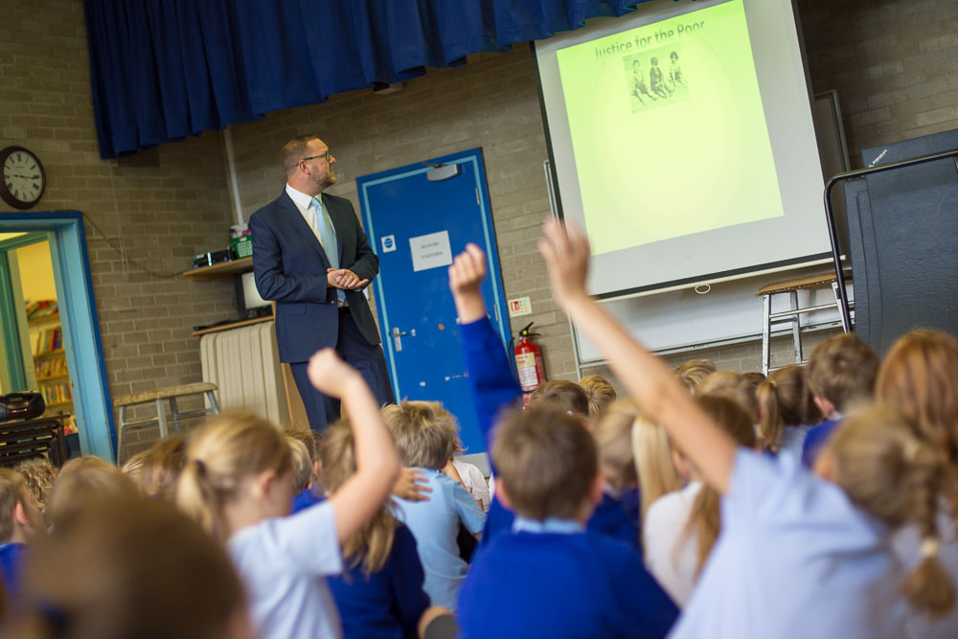

**STAFF RESPONSIBILITIES**

TEACHING STAFF Curriculum Responsibilities

|  |  |  |
| --- | --- | --- |
|  | CLASS TAUGHT | LEADERSHIP |
| Andrew Buttery |  | EVC, PE, history, child protection & assessment |
| Lauren Chandler | Class 4 | AGT, art/DT, music & PHSCE |
| Louise Rayner | Class 3 | English KS2, computing & geography |
| Lois Dobson | Class 2 | Maths, MFL & science |
| Aniko Sheppard | Class 1 | English KS1, RE, SENCO, KS1 coordinator & Church schools |

ASSOCIATE STAFF

Secretary Mrs. H. Bacon

Teaching Assistants Mrs. C. Helfferich Mrs. W. Pegram

Mrs. J. Shirley Mrs. S. Bramall-Smith

Mrs. J. Hetherington Mrs. C. Walsh

Cook Mrs. C. Yates

Kitchen Assistant Ms. K Hewitt

Mid-day Supervisory Assistants Mrs. C. Walsh

Mrs. W. Pegram

Mrs. S. Bramall-Smith

Mrs. J. Hetherington

Cleaner/

Caretaker North Yorkshire County Council

**GOVERNORS**

CHAIR Mr. H. Porter (2019)

OTHER GOVERNORS Mr. D. Curtois – Vice chair (2019)

Rev. E. Hassall - Foundation Governor (Ex-officio)

Mrs. A. Chappell – Foundation Governor (2021)

Mr. N. Jackson - Crayke Parish Council (2019)

Mrs. F. Stasiak – L.A. Governor (2021)

Mrs. B. Lunn – Associate Governor (2021)

Mr. P. Wilson – Parent Governor (2019)

Mr. A. Buttery – Headteacher (Ex-officio)

Mrs. A. Sheppard – Teacher Governor

Year in brackets indicates date of termination of appointment.

The Chair of governors – Hugh Porter - can be contacted via the school office.

**THE NATIONAL CURRICULUM**

**For specific information please view our long term plans -** [**www.craykeschool.org/?s=Long+Term+Planning**](http://www.craykeschool.org/?s=Long+Term+Planning)

**Early Years Foundation Stage**

The new Early Years Foundation Stage takes effect as from September 2012. The Reception year forms the final year of the five year EYFS framework with a real focus on childhood development and areas of learning. The areas of learning as from September 2012 will consist of three prime areas and four specific areas. The prime areas cover the knowledge and skills which are the foundations for children’s school readiness and future progress and which are applied and reinforced by the specific areas – particularly literacy and maths.

Prime areas are fundamental, work together, and move through to support development in all other areas.

* Personal, Social and Emotional Development
* Communication and Language
* Physical Development

Specific areas include essential skills and knowledge for children to participate successfully in society.

* Literacy
* Mathematics
* Understand The World
* Expressive Arts and Design

At the end of the Reception year, there will now be 17 Early Learning Goals. For each of the 17 judgements, teachers will determine whether children are meeting expected levels, exceeding them or are below the expected level (‘emerging’). This will be shared with parents and will provide a clear baseline for the Year 1 teacher.

**English/Literacy**

The acquisition of effective language skills is a fundamental aim of the school. Pupils are given opportunities to become the most competent readers, writes, speakers and listeners that they might possibly be. The curriculum guidance for the Foundation Stage, the programmes of study in the National Curriculum and the National Literacy Strategy provide the framework for the planning of English teaching throughout the school. Each class has a daily literacy lesson and many other opportunities for the development of language across the curriculum, giving each child a broad and balanced range of experiences and ensuring continuity, progression and differentiation.



**Phonics**

Phonics is taught everyday in EYFS and Key Stage 1 within a twenty minutes session first thing every morning. Letters and Sounds are used as a basis to ensure a progression of systematic synthetic phonics. They are taught to associate sounds with the corresponding letters of the alphabet and then to use this knowledge to blend sounds together to read simple words.

**Reading**

Children start to learn to read in the Early Years Foundation Stage. Rigby Star is the main scheme used. Reading activities are part of each day’s learning and reading is taught and practised across the school in three ways:

**Shared reading** - the whole class read a big book, or new vocabulary together with

the teacher.

**Guided reading** – a group of children of similar ability read a book with the teacher

and explore the meaning of the text.

**Individual reading –** the teacher listens to a child read a book that he/she is about

to take home or has already read at home.

The most effective teaching takes place during shared reading and guided reading sessions and children’s individual reading books, which are taken home, are to practice what has been learnt in school. These books are changed twice a week in order for children to share with their parents what they are learning in school and to encourage parents to be active participants in their children’s learning.

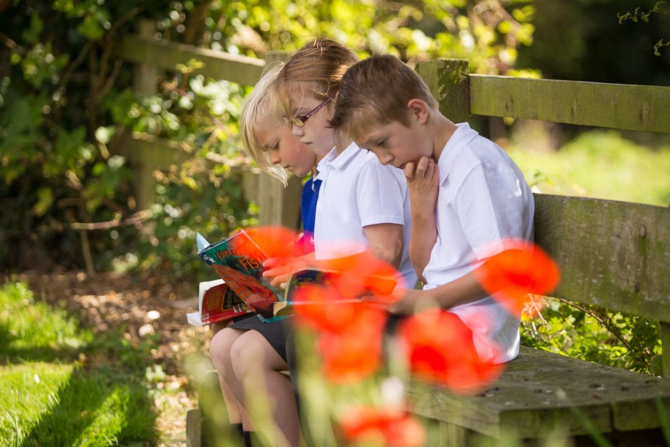

In Key Stage Two children continue to read in school, focusing on reading for meaning and developing their understanding of plot, characterisation and how texts work. Pupils are able to change their individual reading books as and when appropriate.

**Writing**

Children are taught the tools of writing; spelling, handwriting, sentence structure, grammar and punctuation systematically through the school. They apply these skills in writing for different purposes, for a variety of audiences and in different styles. Children from Year One upwards are given weekly spellings to take home and learn. Children begin to join their handwriting in Year Two. Opportunities for writing are planned both within and outside the literacy hour. ICT is also used to support the development of written work.

**Mathematics/Numeracy**

Our work in maths is based on the National Numeracy Strategy.

Mental maths agility and investigative work feature highly as we develop children in using and applying their skills in a growing number of contexts. Children are taught how to use a wide range of mathematical equipment, as well as using ICT. We encourage children to learn their tables and this is work that children are able to do as homework.

We are keen for children to enjoy their maths work and to be able to see a clear purpose for it in everyday life.

**Religious Education**

Crayke Church of England Primary School, in accordance with the 1988 Education Reform Act, provides Religious Education for all pupils registered at the school. Religious Education has the same status and importance as any other subject and the same high standards are applied to its teaching and learning as to all other subjects. We teach Religious Education according to the aims of the North Yorkshire Agreed Syllabus for Voluntary Controlled schools, which clearly states that Religious Education should not seek to urge religious beliefs on children nor to compromise the integrity of their own beliefs.

Through their work in RE children explore, analyse and reflect on a range of religious and non-religious responses to basic human questions of meaning and purpose. In particular Religious Education:

* helps children to know about and understand the religious beliefs, values, experiences, practices and traditions by which people live and make sense of their shared human experience;
* enables children to examine and draw upon their own experience through reflection and response.

Religious Education, therefore, has an important contribution to make to children’s personal and social development and especially to their spiritual, moral and cultural development.

**Parents may, if they wish, withdraw their child(ren) from RE lessons, but they must inform the school of their intention in writing.**

**Science**

We aim to encourage children to develop a lively, enquiring mind through the study of our world and man’s understanding of it. Children will study a variety of topics, according to age and ability, which include Health, Light, Sound, Electricity, Materials and their properties, Forces, Animals, Earth and Space, Plants and the Environment. Through the study of Science, we stimulate curiosity, independence and the development of the scientific skills of observing, classifying, measuring, recording, making and testing hypotheses, designing and carrying out experiments and fair tests and drawing conclusions from the evidence collected. A highly practical approach is used throughout and children will be taught to consider safety and to be sensitive to the needs of living organisms and their environment.

**Computing**

Key stage 1

Pupils are taught to:

* understand what algorithms are; how they are implemented as programs on digital devices; and that programs execute by following precise and unambiguous instructions
* create and debug simple programs
* use logical reasoning to predict the behaviour of simple programs
* use technology purposefully to create, organise, store, manipulate and retrieve digital content
* recognise common uses of information technology beyond school
* use technology safely and respectfully, keeping personal information private; identify where to go for help and support when they have concerns about content or contact on the internet or other online technologies.

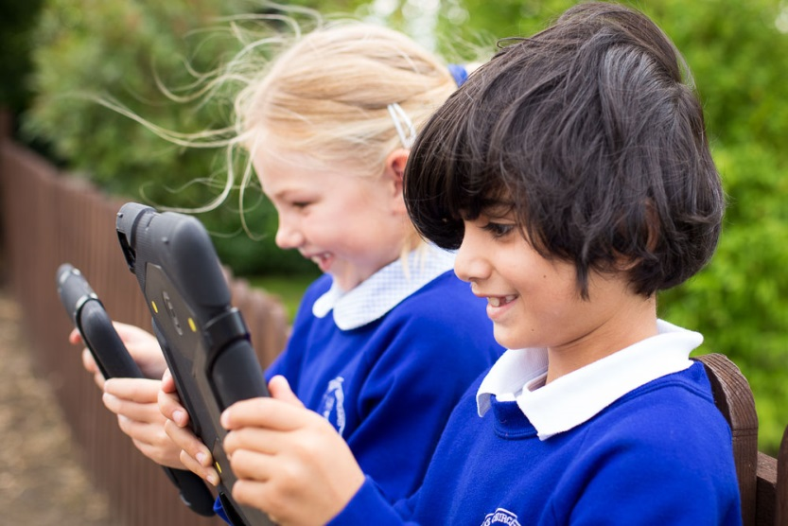

Key stage 2

Pupils are taught to:

* design, write and debug programs that accomplish specific goals, including controlling or simulating physical systems; solve problems by decomposing them into smaller parts
* use sequence, selection, and repetition in programs; work with variables and various forms of input and output
* use logical reasoning to explain how some simple algorithms work and to detect and correct errors in algorithms and programs
* understand computer networks including the internet; how they can provide multiple services, such as the world wide web; and the opportunities they offer for communication and collaboration
* use search technologies effectively, appreciate how results are selected and ranked, and be discerning in evaluating digital content
* select, use and combine a variety of software (including internet services) on a range of digital devices to design and create a range of programs, systems and content that accomplish given goals, including collecting, analysing, evaluating and presenting data and information
* use technology safely, respectfully and responsibly; recognise acceptable/unacceptable behaviour; identify a range of ways to report concerns about content and contact.

**Internet**

We will make every possible effort to ensure that your child does not access undesirable material whilst using the Internet. We have discussed with the children the procedure they should take if they accidentally come across unsuitable material. Children will usually only use sites that have been vetted by the teacher.

**History**

Key stage 1

Pupils develop an awareness of the past, using common words and phrases relating to the passing of time. They know where the people and events they study fit within a chronological framework and identify similarities and differences between ways of life in different periods. They develop a wide vocabulary of everyday historical terms.

The children are given the opportunity to ask and answer questions, choosing and using parts of stories and other sources to show that they know and understand key features of events. They understand some of the ways in which we find out about the past and identify different ways in which it is represented.

Key stage 2

Pupils continue to develop a chronologically secure knowledge and understanding of British, local and world history, establishing clear narratives within and across the periods they study. They note connections, contrasts and trends over time and develop the appropriate use of historical terms. They should regularly address and sometimes devise historically valid questions about change, cause, similarity and difference, and significance. They should construct informed responses that involve thoughtful selection and organisation of relevant historical information. They should understand how our knowledge of the past is constructed from a range of sources.

**Geography**

Key stage 1

Children will understand basic subject-specific vocabulary relating to human and physical geography and begin to use geographical skills, including first-hand observation, to enhance their locational awareness.

Key stage 2

Pupils extend their knowledge and understanding beyond the local area to include the United Kingdom and Europe, North and South America. This includes the location and characteristics of a range of the world’s most significant human and physical features.

They develop their use of geographical knowledge, understanding and skills to enhance their locational and place knowledge.

**Educational Visits**

We enhance our curriculum through a series of specific visits linked to topics covered in school. These range from enrichment activities, such as visits to the Yorkshire Wildlife Park, to topic based visits, such as Yorkshire Museum.

In addition, pupils in Years 5 and 6 experience residential visits to Carlton Lodge and East Barnby respectively. This is also part of the Year 6 transition process.

All of the aforementioned provide our pupils with valuable experiences that can’t always be replicated in the classroom.

**Physical Education**

At Crayke School, the physical health and well being of our children is promoted as a high priority. All children have access to two hours of taught P.E. every week and there are a variety of additional after school clubs available.

The children are encouraged and challenged to develop their abilities, skills and levels of confidence through a mixture of gym, athletics, games, dance and swimming. These are taught through a mixture of individual, small group and team activities. The children are encouraged to participate to the best of their abilities and help each other to develop further, helping to promote a high level of self-esteem.

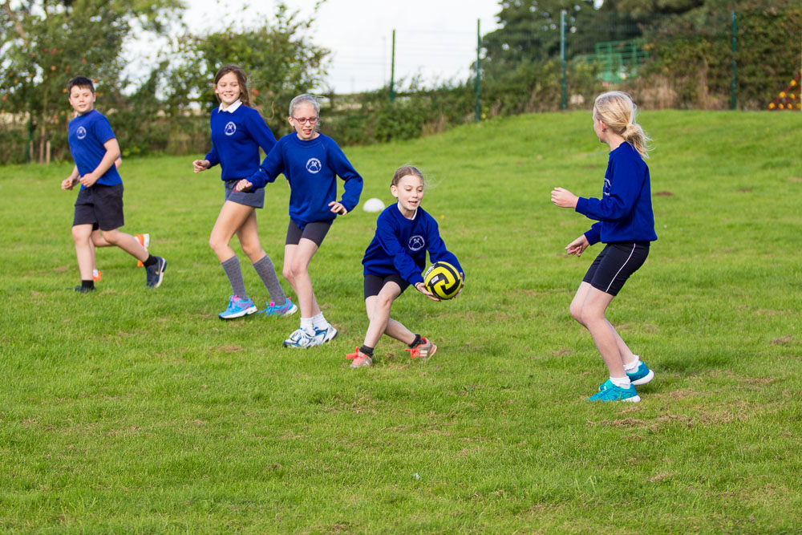

We have strong links with Easingwold School and other outside agencies, which allows us to participate in many intra and inter school activities. Crayke has a long and well-established history of success in a wide variety of sport and competitions. These develop the children’s competitive skills in a positive way and help our children to learn the importance of being a good sports person.

**Music**

Music is regarded as an important aspect of the children’s education at Crayke School. Opportunities are provided to awaken and develop their musical imagination, skills and enjoyment in a variety of ways that meet the requirements of the National Curriculum.

As part of Collective Worship, all the children sing each day and listen to, and discuss, music from a variety of periods, cultures and composers.

For the Reception children, classroom singing and music making takes place in some form most days and is often linked to other activities. Years 1-6 have a weekly lesson, where they sing and compose music using a range of tuned and un-tuned percussion instruments.

There is an option for children to pursue private music lessons, given by peripatetic teachers, usually during school hours, for guitar, violin, brass and woodwind instruments. Parents pay for these lessons.

In addition, a recorder club is held after school each week. The whole school takes part

in musical performances throughout the year. Annual visits by Music for Life enable children right throughout the school to experience through workshops a range of musical genres and instruments. There is also the opportunity to listen to inspirational visiting musicians, sometimes from other cultures, and to participate where appropriate.

**Art**

Through Art, Craft and Design, the children are given opportunities to develop their observational and imaginative skills in a creative and practical way, enabling them to explore the world around them visually and aesthetically.

The children use a variety of medium, materials and methods to produce both two and three-dimensional work. They explore techniques using computing and have opportunities to work individually or as part of a group.

Through class activities and visiting artists, they become familiar with, and respond to a range of styles, images and artefacts, as well as producing and developing their own ideas. Their work is often linked to other areas of the curriculum, enhancing specific topics.

Much of the children’s’ work is used to create visually stimulating displays around the school – fostering a sense of confidence and pride in their creative achievements.

**Design and Technology**

This is a subject which stimulates the creative and imaginative minds of our children and provides many exciting opportunities to enhance learning. Through a wide variety of real life topics, children identify problems, recognise and explore people’s needs, design, make and test products. As a result, children become increasingly able to work with a wide variety of tools and materials.

**Collective Worship**

As a Church of England School, collective worship is an integral and valued part of our daily routine. We have strong links with the local church, St Cuthbert’s and with the Diocese of York. Services are held at the church throughout the year, including a beginning of the year service, a carol service, an Easter celebration and a leavers’ service. Collective worship is led by teaching staff and local clergy, the purpose being to give children a quiet space within the day to reflect on people’s religious practices, values and beliefs and relate these to their own experiences and to consider the unanswerable questions of everyday life.

As above, parents may, if they wish, withdraw their child(ren) from collective worship, but they must inform the school of their intention in writing.

**Sex Education**

From Reception to Y5, no formal sex education is taught, although as part of Health Education and the Science curriculum, the children are taught:-

At Key Stage 1

Pupils are taught that animals, including humans, move, feed, grow, use their senses and reproduce and that humans can produce babies and these babies grow into children and then adults.

At Key Stage 2

Pupils are taught that there are life processes including nutrition, movement, growth and reproduction common to animals, including humans, as well as the main stages of the human life cycle.

At Y6 (with parental permission), the pupils receive specific sex education from the class teacher and school nurse during their final term at Primary school. Prior to this, parents are given the opportunity to view the materials used and discuss with the Headteacher any queries they may have. Questions which arise spontaneously from all age groups will be answered honestly and sensitively at the discretion of the teacher. The Y6 boys and girls are given a puberty talk together by the school nurse during the Summer term of their last year in school. In addition to this, the Y5 and Y6 girls are given an additional talk during the same term. Again this is with parental permission.

**Healthy Schools**

The school promotes healthy lifestyles through many aspects of school life and provision. As part of this, we are keen to listen to the views of the children in school and consult with you, as parents, on all matters of health education policy.

**Personal, social & health education and citizenship**

Personal, social and health education (PSHCE) and citizenship help to give children the knowledge, skills and understanding they need to lead confident, healthy, independent lives, and to become informed, active, tolerant and responsible citizens. PSHCE and citizenship is fully integrated into our curriculum planning from the earliest days. We now work on one of the national strategies to implement an ongoing programme focused on children’s social and emotional development.

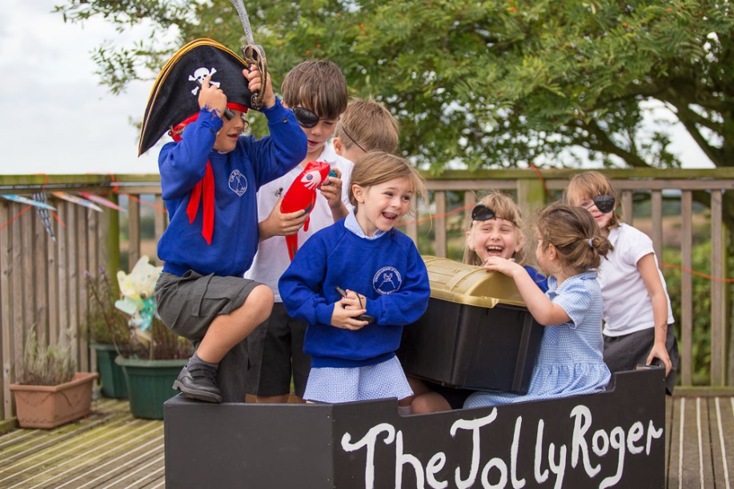

**Equal Opportunities**

All children have the right to be treated equally in accessing education, irrespective of gender, disability, ethnic difference or social disadvantage. Our expectation of pupils is not influenced by any of these factors. We will recognise and value different cultures and religious traditions amongst them.

In response to the MacPherson report, the school has in place racial incident monitoring procedures.

**ARRANGEMENTS FOR PASTORAL CARE**

The headteacher and staff welcome and encourage contact with parents to discuss the welfare of their child. Parents’ evenings are held in the Autumn and Spring terms and parents are welcome to follow up their child’s annual report in the Summer if they feel it is necessary. The strength of our pastoral care is in our ongoing relationships with families and we encourage all parents to come in and see us, without delay, should any issue arise.

Crayke C.E. School is committed to ensuring the welfare and safety of all children in school. All North Yorkshire schools, including Crayke C.E. School, follow the North Yorkshire Safeguarding Children Board procedures. The school will, in most circumstances, endeavour to discuss all concerns with parents about their child/ren. However, there may be exceptional circumstances when the school will discuss concerns with Social Care and/or the Police without parental knowledge (in accordance with Child Protection procedures). The school will, of course, always aim to maintain a positive relationship with all parents. The school’s child protection policy is available publicly.

Child abuse is defined by North Yorkshire Area Child Protection Committee as:

‘An abused child is a boy or girl under the age of 18 who has suffered from physical injury, physical neglect, a failure to thrive, emotional or sexual abuse, which the person or persons who had parental responsibility, charge or care of the child either caused or knowingly failed to prevent’.

Where the well-being and safety of a child is considered to be at risk, action must be taken by the school. Depending upon the circumstances, this does not necessarily mean that parents will be informed in the first instance. If examples of changes in behaviour or untoward incidents have occurred with the child within school, parents may have already been consulted in the normal way.

**DISCIPLINE**

The ethos of the school is one of a caring and secure environment, where responsibility for one's behaviour is featured strongly. Emphasis is placed upon good behaviour and attitudes. The children are expected to be polite, kind and considerate towards one another and the environment. However, there are times when children do behave inappropriately and immediate action is taken. A series of graded approaches is used depending on the child concerned and the particular problem. This starts with a quiet discussion about the behaviour displayed and time for the child to reflect on why their behaviour is inappropriate.

It may be necessary to withdraw privileges or playtime sessions, and should the problem reoccur more frequently, then parental involvement is sought. In all cases a fair approach is of paramount importance. As the school operates an open door policy with parents, we find that very few serious problems arise.

Children are also given the opportunity to consider and implement their own classroom contracts which stipulate the pupils’ expectations of their own behaviour in class.

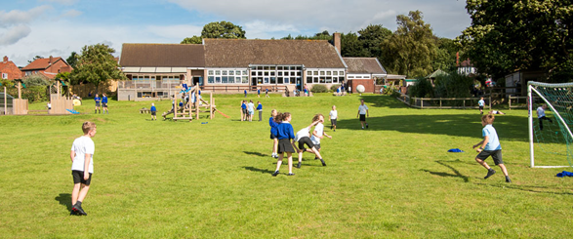

**Teams**

One of our incentives for children is in the school team system. Each child is a member of one of our four teams: Red, Yellow, Blue and Green. There is a mixture of each team in each class and lots of opportunities for children to collect team points during the week for good work, behaviour as well as for gestures of kindness and good manners. These are counted at the end of each week and the winning team is announced in our achievement assembly on Friday.

**Achievement Assembly**

This takes place on Fridays and is an opportunity for us to recognise the good work that has been done in school that week. Both parents and Governors are invited to attend on a class rota basis. Two children from each class are selected to be recognised for particularly impressive things and receive the “Star of the Week” award. We also encourage children to bring in certificates they may have been awarded in their other activities outside of school so that these can be recognised and celebrated by us all.

**HOMEWORK**

We want to strike a balance between keeping the core weekly homework that we set for the children and giving them an element of choice by suggesting a range of more practical activities, often related to the class topic, which we hope will extend and enrich their learning. The teachers have drawn up a grid of challenges for each year group from Class 1 onwards, which they will be sending out together with a homework book for each child to record what they have done. I know that when staff have set projects in the past the children have produced some amazingly good work and so I have high expectations that the homework books will be something that they can be proud of and that we can celebrate in school.

Please note however that this is meant to be something that the children do, so do give them help and support but don’t do the homework for them.

If the activity is a purely practical one we would love to see pictures in the book of the children doing it, or if that isn’t possible, a note from you to indicate that they have completed the activity.

I am hoping as well as making homework more enjoyable, the grid of challenges will also make you more aware of what your child is learning about in school.

I have outlined the homework for each year group below. If you have any questions about it please come and talk to myself or to your child’s teacher.  The shaded boxes contain essential homework, to be completed over the half term.  The remaining boxes are optional activities.

RECEPTION CLASS – Weekly sounds to practise, and reading to your child as much as possible.  Also the reading of key words and reading scheme books.

YEAR 1 – Reading each night, weekly spellings to learn, choose 1 activity each week from the new sheet

YEAR 2 – Reading each day, weekly spellings to learn, choose 1 activity each week from the new sheet

YEAR 3 – Reading each day (10 – 15 minutes), weekly number bonds or times tables practice, weekly spellings, choose one activity from the new sheet each week

YEAR 4 – Reading each day (15 – 20 minutes), weekly spellings, multiplication tables, choose 1 activity each week from the new sheet

YEAR 5 – Reading each day (20 – 25 minutes) weekly spellings, multiplication tables, maths activity, choose 1 activity each week from the new sheet

YEAR 6 – Reading each day (25 – 30 minutes), weekly spellings, multiplication tables, maths activity, choose 1 activity each week from the new sheet

Reading has always been the key activity in our homework policy and I cannot stress how vital it is that children continue to practice their reading at home whether they are in the Reception class or in Year 6. It really is the most important thing that you can do to help your child because so much depends on this skill and we greatly appreciate the time that parents spend reading to and with their child.

The support you offer your child with their homework is always much appreciated.

**COMPLAINTS**

If you have any problems or worries that concern your child and the school, please let us know straight away and we will do our best to resolve them. Most difficulties, which arise can be quickly resolved after discussion between the parents and the Headteacher and other staff of the school.

Routine concerns should be expressed to the class teacher, but where privacy is required, this can be arranged through the Headteacher. It is important that school hears parents’ views, otherwise issues may remain unsettled and children’s education and happiness may be at risk. Matters of immediate concern can usually be sorted out by a prompt phone call or a visit to the school. As always, informal visits by parents are always given a high priority.

Complaints about a member of staff may be made to the Headteacher and, thereafter, to the Chair of Governors and the Governing Body. Complaints about the Headteacher should be made to the Chair of Governors, who will decide whether to consult the Governing Body and/or the Local Authority.

**CHASA**

Crayke Home and School Association organises fundraising and social events for the school. A dedicated team of parents, friends and staff work together enthusiastically to provide a richer environment for the children. CHASA actively and continually seek the support of all parents to support their endeavours and if you would like to volunteer help in any form you will be warmly welcomed. Please speak to the Committee or class representatives if you are willing to help in any way with organising fund raising and/or social events.

**PARENT HELPERS**

Parents and friends of Crayke School are always welcome here and are encouraged to share their expertise by helping out in school. If you would like to help in school please contact your child's class teacher or the Headteacher. We need help in all sorts of areas including hearing readers; consolidating spellings; art activities; gardening; baking or cooking etc.

It is normal and necessary practice for all volunteer helpers to be checked and cleared by the Disclosure and Barring Service (DBS) prior to helping in school. We hope you will understand the need for us to ask you to take part in this.

*Thank you for taking the time to read this. I am very aware of the huge amount of detail contained in this prospectus. The most beneficial way of becoming acquainted with our school is to see it at work.*

*We look forward to welcoming you to Crayke School.*

**TRY YOUR BEST IN EVERYTHING YOU DO**

**CRAYKE CE PRIMARY SCHOOL**

**HOLIDAY DATES 2018/19**

**Autumn Term** Tuesday, 4th September to Thursday, 20th December, 2018

Half Term Monday, 29th October to return on Monday, 5th November

**Spring Term** Tuesday, 8th January to Friday, 12th April, 2019

Half Term Monday, 25th February to return on Monday, 4th March

**Summer Term** Tuesday, 30th April to Friday, 19th July, 2019

May Day Monday, 6th May

Half Term Monday, 27th May to return on Monday, 3rd June

**Teacher Training Days** –

Monday 3rd September 2018

Friday 21st December 2018

Monday 7th January 2019

Monday 29th April 2019

Monday 22nd July 2019