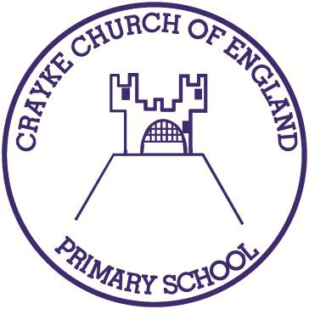

**Crayke Church of England Primary School**

**Easingwold Road**

**Crayke**

**North Yorkshire YO61 4TZ**

Tel/Fax: 01347 821767

E.mail: [admin@crayke.n-yorks.sch.uk](mailto:admin@crayke.n-yorks.sch.uk)

Website: craykeschool.org

**Headteacher – Mr. Andrew Buttery** BA (HONS), PGCE, NPQH

**Year 1 Phonics Screening Information**

**What is phonics?**

There has been a big shift in the past few years in how we teach reading in school. This is having a huge impact and helping many children learn to read and spell. Phonics is recommended as the first strategy that children should be taught in helping them learn to read. Phonics runs alongside other teaching methods to help children develop vital reading skills and give them a real love of reading.

**What is the phonics screening check?**

The national phonics screening check was introduced in 2012 to all Year 1 pupils. It is a short, statutory assessment to ensure that children are making sufficient progress in the phonics skills to read words and are on track to become fluent readers who can enjoy reading for pleasure and for learning.

The Department for Education defines the checks as “short, light-touch assessments” that take about four to nine minutes to complete.

Our results for 2017 showed that 100% of pupils at the end of Year 1 gained the required grade in the phonics tests (nationally it was 81%). All children who do not reach the required level have additional support to ensure that they are given every opportunity to develop their phonic skills and hence their ability to read.

**When does the Year 1 phonics screening check take place?**

All Year 1 pupils will take the phonics screening check during the week commencing 11th June 2018.

**How is the check structured?**

It comprises a list of 40 words and non-words, which the children know as ‘alien’ or ‘monster’ words. Your child will read one-to-one with their teacher. They will be asked to ‘sound out’ the word and blend the sounds together to read the word. The words will be presented as a booklet with up to 4 words per page. Non-words will be presented with a colourful picture of an alien. The children will be asked what the aliens name is by reading the pseudo word. This will make the check a bit more fun and provides the children with a context for these non-words. They are included because they will be new to all pupils, so there won’t be a bias to those with a good vocabulary knowledge or visual memory of words. Pupils who can read non-words should have the skills to decode almost any unfamiliar word.

**How will the results from the phonics screening check be used?**

Schools have to inform parents towards the end of the summer term in Year 1 of their child’s results. At Crayke Church of England Primary School the results form part of the end of year reporting. All of the children are individuals and develop at different stages. The results of the screening check will assist teachers to identify which children will need further support with decoding.

Yours sincerely,



Andrew Buttery

Headteacher