**Crayke Chronicle**

**Friday 27th April**

**Red Team**

**Mrs. Dobson**

On behalf of Mrs. Dobson I would like to thank the parents and carers in Class Two for her gifts.

We wish Mrs. Dobson all the best – we will keep you up-to-date with any announcements…

**York City Knights Touch Rugby Tournament**

Congratulations to the boys and girls from Class 4, who finished a gallant second in the York City Knights Touch Rugby Tournament. I was hugely impressed by the superb teamwork and commitment on show.

This was the first time Crayke had entered the aforementioned competition. To record four wins; one draw and one loss (conceding only one try in the process) was especially pleasing.

I would like to thank the parents and grandparents who attended/provided transport. Special thanks to Mr. Foster & Mr. Piercy for supporting Team B.

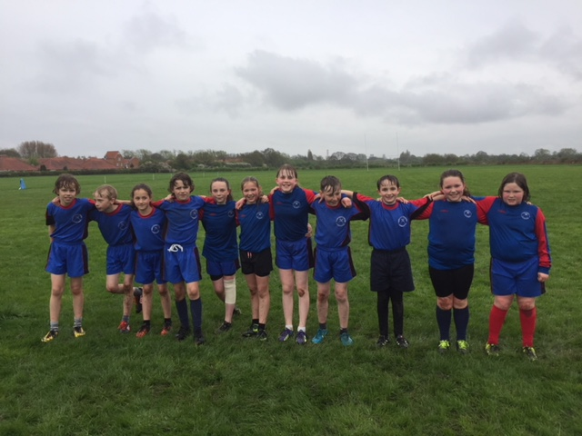

**Key Stage 1 Fun Run**

I would like to say a big well done to all the children in Class Two, who participated in the Fun Run on Wednesday. Each child showed great determination to complete the testing course.

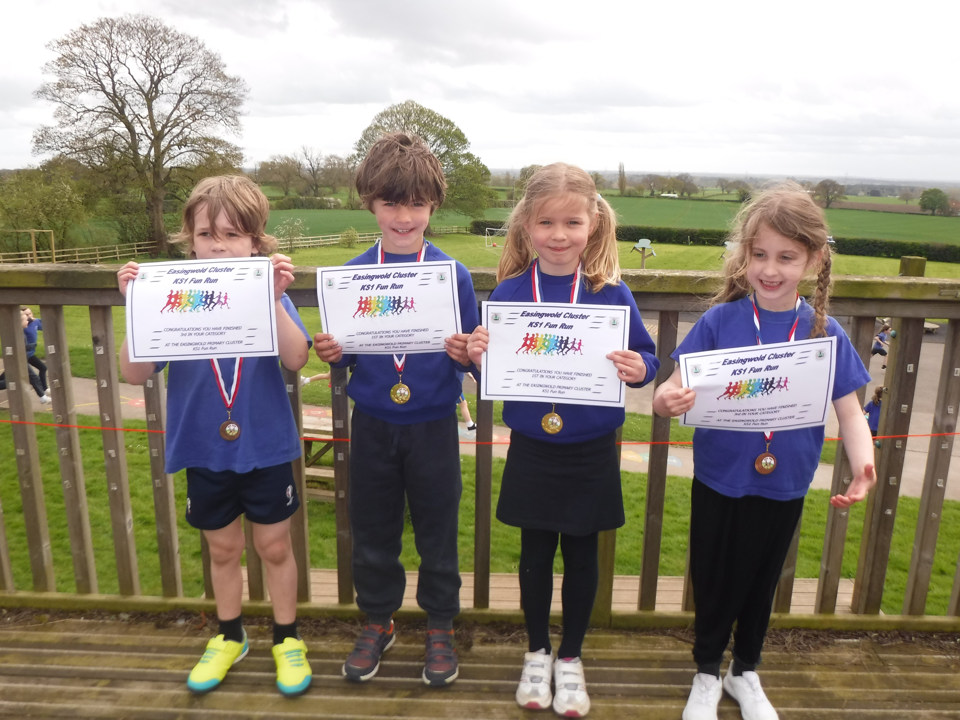

**Where's Church this week?**

**Sunday 29th April**

10.30am Holy Communion at Husthwaite. This is one of our joint services with all our churches together and we'll be having a bring and share lunch afterwards. I look forward to seeing you there. **Next week:** 6th May is Family Service week at Crayke.

Best wishes,

Revd Liz



In Class 1, the children will be able to be acknowledged as Whizz of the week...

**Whizz of the Week**

**Class 1 – Toby Seligman**

Each week a child will be selected from our classes to receive the title of *Maths Whizz* of the Week or *English Expert* of the Week. Congratulations to this week’s children...

**Maths Whizz of the Week**

**Class 2 – Maisy Emsley**

**Class 3 – Evie Marwood**

**Class 4 – Gaby Hollinrake**

**English Expert of the Week**

**Class 2 – Teddy Hill**

**Class 3 – Sam Pearce-Hogg**

**Class 4 – James Ritchie**

**Team Points**

This week’s winners are:





*At Crayke Church of England Primary School, we have our own news team, 'The Roving Reporters.' The team is made up of children from School Council. The Roving Reporter’s articles will be included in the Crayke Chronicle.*

**Roving Reporters**

We are excited to announce that our school has officially been awarded ‘Gold’ for the Woodland Trust’s ‘Green Tree Schools Award.’ The School Council from last year and our School Council this year have been leading the award and have really enjoyed helping us achieve this... we even have a plaque from the Woodland Trust, which is now on display in our entrance. Well done to everyone who has helped!

Our next plans are to work towards the final award of ‘platinum’ award and we are planning an exciting trip later in the summer term (more details nearer the time.)

***From School Council***

