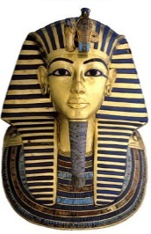
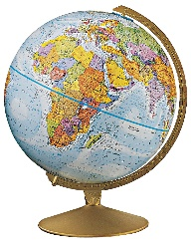
Class 3 Curriculum Letter
Summer Term

Dear Parent/Carers,  In this newsletter we hope to give you a brief outline to the content of our curriculum this term. | Timetable Reminders  Please note the change to the timetable: P.E. will take place on Wednesdays and Fridays. Please ensure that your child has their full P.E. kit including trainers, in school on these days.  Homework  Spellings – To encourage children to practise their spellings regularly, weekly spellings will now be sent home on a sheet on Fridays for the following week. These will often include words from the National Curriculum Year 3 and 4 spelling lists. There is also space for your child to put their own personal spellings on and practice at home. Children will be tested on Fridays. Children are expected to work on their Year 3/4 word list words throughout the year.  Reading – Pupils should read for 10-15 minutes each day. This is important even for confident readers to help improve speed, accuracy and comprehension. Please keep a record of your child’s reading in their reading record.  Maths – This will usually be based on the Maths work from either the previous or current weeks work. Maths homework is set on a Monday and due the following Monday.  In addition, there will be essential and optional homework choices on the homework menu. Could we also ask parents/carers to sign your child’s home/school record.  Achievement Assembly  Class 3’s achievement assembly will take place on Friday 11th May.  Please don’t hesitate to arrange an appointment via the schools office should you wish to discuss any aspect of your child’s education.  Mrs Rayner
Topics this Term

During the summer term, children will study:

English: The Egyptian Cinderella (text-focus,) mystery stories, scientific investigation writing, classic poetry for performance, reading comprehension and spelling, punctuation and grammar.

Maths: Measurement: time, mass and capacity, money, position and direction, written calculations, mental maths.

Science: Living things and their habitats, forces and magnets.

Computing: Games and information (Programming, handling data, technology in our lives)

R.E. – What is the importance of symbols in religious practice and thought?
When Jesus left, what was the impact of Pentecost?
What do Christians learn from the Creation story?
Does a beautiful world mean there is a wonderful God?

History – Early Ancient Civilisations (Egypt)
Geography – World map study
Art – Exploring cultural styles (Ancient Egypt)
DT – Food – healthy eating
Games – Rounders, Athletics
P.E. – Health-related fitness
Music – Theme-related songs and percussion
PHSCE – Relationships, Changes
French – Conversational French, grammar and ongoing skills

