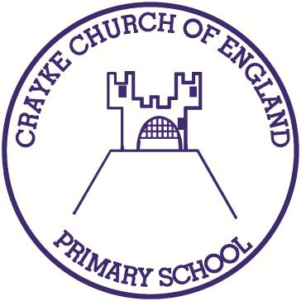

**Crayke Church of England Primary School**

**Easingwold Road**

**Crayke**

**North Yorkshire YO61 4TZ**

Tel/Fax: 01347 821767

E.mail: [admin@crayke.n-yorks.sch.uk](mailto:admin@crayke.n-yorks.sch.uk)

Website: craykeschool.org

**Headteacher – Mr. Andrew Buttery** BA (HONS), PGCE, NPQH

**Church School Inspection Notification**

Later this week, we will be having our ‘SIAMS’ Church School Inspection. This will take place on Thursday 1st March; there will be one inspector in school with us all day.

**Why are we having this Church School inspection?**

The very first schools in England were set up by the Church of England to serve the local community around 200 years ago. Currently, Voluntary Controlled Church of England Schools like Crayke are funded by the Government, but still have strong links to the Church traditions and base their values on ideas that come from the Bible. Church Schools are inspected, periodically, to check if this Christian Ethos is evident in the day to day experience of the children.

**What do they want to know?**

The inspector will ask questions such as… Do the children learn about values such as compassion, generosity and trust, using Bible stories as a springboard? Is this having an effect on them as young people? Does the school take part in a Collective Worship session each day? Are children encouraged to lead and interact in these sessions? What are RE lessons like? What impact do they have on the children? To what extent do the Church and School work together and serve the local community?

**What will happen on the day?**

The inspector will talk to me, members of staff and governors. They will also speak to a small sample of parents. They will chat with children and have a guided tour around the school. They will look at books and observe Collective Worship.

**Will my child be involved?**

Your child may be asked to talk to the inspector about their view of the school, or perhaps chat during a lesson. They may take part in leading the Collective Worship - their normal school day will not be disrupted.

**How can I help?**

Please think about these questions and how you might answer them, if you were asked:

- Are you aware this is a Church School?

- What does that mean to you?

The outcome of our SIAMS Church School inspection will be made public as soon as possible. In the meantime, I hope that this letter answers any immediate questions you may have. Please do contact me, however, if you have any further queries.

Yours sincerely,



Andrew Buttery

Headteacher