**Crayke Chronicle**

**Friday 9th February**

**Red Team**

**Scafell Pike**

After successfully climbing Mount Snowdon during the summer of 2016, and Ben Nevis last summer; the Buttery family are going to attempt to conquer Scafell Pike.

Any money raised will be donated to CHASA (Crayke Home and School Association). Your support will be greatly appreciated when we attempt this challenge in May 2018.

If you would like to make a donation please visit:

<https://www.justgiving.com/crowdfunding/andrew-buttery-2>

**Safer Internet Day 2018**

As part of Safer Internet Day (Tuesday 6th February) children throughout the school, thought about and investigated, how important it is to stay safe on-line. Children and young people spend a lot of time on-line; it can be a great way for them to socialise, explore and have fun. However, children do also face risks such as cyber bullying or seeing content that's inappropriate.

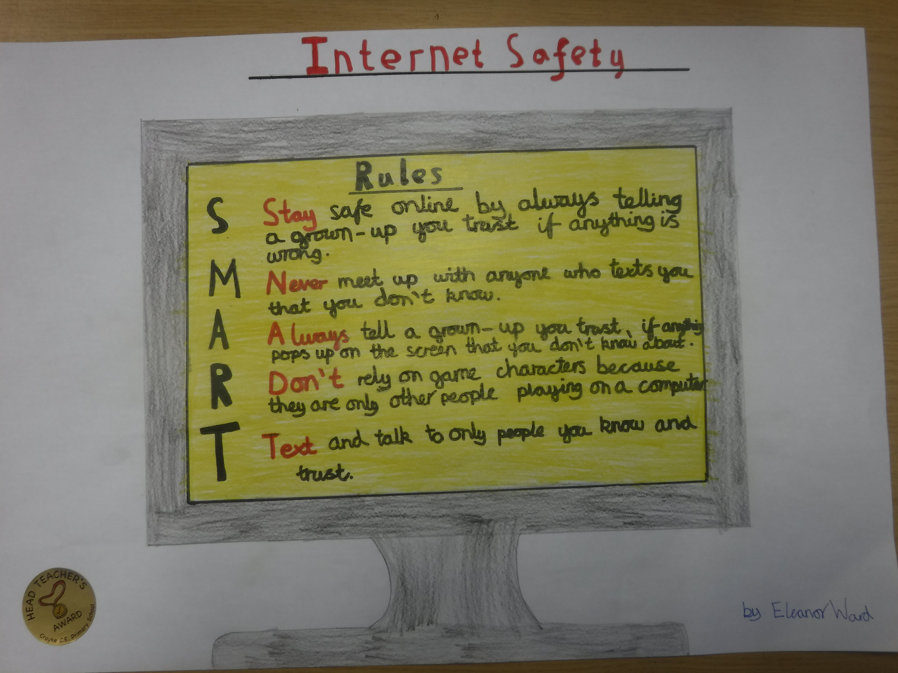

Eleanor Ward’s poster contains some really useful advice…

**Year Two Multi-skills**

On Wednesday, children from year two competed in an afternoon of multi-skills activities at Easingwold School. The children really enjoyed competing; congratulations to Isaac Waite who received a medal for ‘speed bounce’.

**Where's Church this week?**

**Sunday 11th February**

10.30am Holy Communion at Crayke

**Sunday 18th February**

10.30am Morning Service at Brandsby

There will also be a service on 14th February for Ash Wednesday at 6.30pm at Husthwaite church.

Everyone is very welcome. Have a good half term holiday.

Best wishes,

Revd Liz



In Class 1, the children will be able to be acknowledged as Whizz of the week...

**Whizz of the Week**

**Class 1 – Bertie Burnett Armstrong**

Each week a child will be selected from our classes to receive the title of *Maths Whizz* of the Week or *English Expert* of the Week. Congratulations to this week’s children...

**Maths Whizz of the Week**

**Class 2 – Tom Ward**

**Class 3 – Charlotte Furnass**

**Class 4 – Alex Gilleard**

**English Expert of the Week**

**Class 2 – Betty Strong**

**Class 3 – Sam Noy Scott**

**Class 4 – Toby Helfferich**

**Team Points**

This week’s winners are:





*At Crayke Church of England Primary School, we have our own news team, 'The Roving Reporters.' The team is made up of children from School Council. The Roving Reporter’s articles will be included in the Crayke Chronicle.*

**Roving Reporters**

**R.E. Day**

Last Friday was a special day for Crayke C of E Primary School because we had an R.E. day and it lasted the whole day. We had four activities and they were: painting memories on stones with Mrs Dobson, outdoor tree dressing our hopes for the future with Mrs Rayner, making Christingles with Mrs Chandler and finally we talked to four special visitors  who were two Muslim ladies, a Christian and a Humanist (who was Mr Buttery`s old English teacher!)

We finished off our amazing day with a Christingle service with Mrs Sheppard and Rev. Liz and all of the staff. We each lit our Christingles, which was magical! We all really enjoyed the special day and love that we get to see our memory pebbles and our hopes on the tree in our playground.

**By Olivia and Lizzie**



