**Crayke Chronicle**

**Friday 12th January**

**Blue Team**

**Welcome back…**

I hope everyone had an enjoyable Christmas break and have had a great start to 2018.

Please look out for curriculum letters and updated homework grids on our website.

**Pregnancy Announcement**

I am pleased to inform you that Mrs. Dobson and Mrs. Rayner are both expecting.

Mrs. Dobson’s first child is due in May, while Mrs. Rayner is expecting her second child in June.

We will be advertising both maternity positions shortly, and will obviously keep you up to date with this process.

**Top of the Class**

I was informed yesterday that our school will once again be included in The Yorkshire Post. The feature is scheduled to run in Thursday 25th January's Yorkshire Post entitled 'Top of the Class'. The feature highlights the top performing schools in the region.

This is a wonderful acknowledgment of the hard work that all those associated with Crayke put in to the successful running of our school.



**Young Voices**

It will be hard not to feel more than a little musical next week as Young Voices will be taking place. Nothing can prepare you for the sound of thousands of children singing in harmony. Young Voices combines the power of singing together as one, with accompaniment from a wide range of musicians and artists, to create an amazing performance.

Look out for a review of this event in next week’s Chronicle…

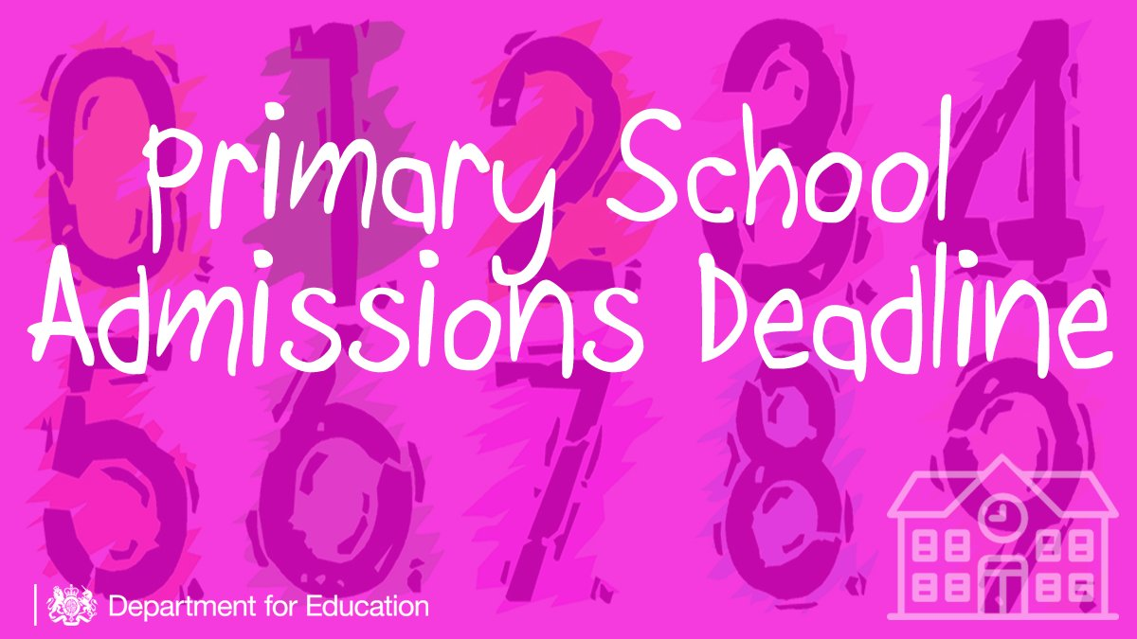

**School Admissions - Final Reminder**

If you have a child who is due to start school next academic year (i.e. who will be four years old before 1st September 2018) please ensure you have applied for a school place in time. The closing date for first time admission applications is the **15th January 2018** for the September 2018 intake.

All applications are made to the Local Authority; you can apply online at [www.northyorks.gov.uk/apply-primary-or-junior-school-place](http://www.northyorks.gov.uk/apply-primary-or-junior-school-place)

If the aforementioned does not apply to you, please feel to forward this document to anyone you believe could find this information useful.

**Where's Church this Week?**

**Sunday January 14th**

10.30am Holy Communion at Crayke

All welcome. I look forward to seeing many of you there.

With best wishes for the New Year,

Revd Liz

**Team Points**

This week’s winners are:

