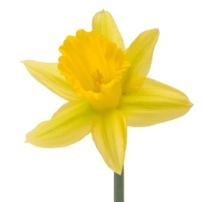
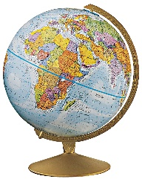
Class 3 Curriculum Letter
Spring Term
Dear Parent/Carers,  In this newsletter we hope to give you a brief outline to the content of our curriculum this term. | Timetable Reminders  P.E. will take place on Wednesdays and Thursdays. Please ensure that your child has their full P.E. kit including trainers, in school on these days.  Ukulele lessons will continue every other Tuesday.  Homework  Spellings – Weekly spellings will be sent home on a sheet on Monday. These will often include words from the National Curriculum Year 3 and 4 spelling lists. There is also space for your child to put their own personal spellings on and practice at home. Children will be tested on Fridays.  Reading – Pupils should read for 10-15 minutes each day. This is important even for confident readers to help improve speed, accuracy and comprehension. Please keep a record of your child’s reading in their home/school record.  Maths – This will usually be based on the Maths work from either the previous or current weeks work. Maths homework is set on a Monday and due the following Monday. Times tables are usually tested on a Tuesday and Mental Maths on a Friday.  In addition, there will be essential and optional homework choices on the homework menu.  Could we also ask parents/carers to sign your child’s home/school record.  Achievement Assembly  Class 3’s achievement assembly will take place on Friday 27th January.  Please don’t hesitate to arrange an appointment via the schools office should you wish to discuss any aspect of your child’s education.  Mrs Rayner
Topics this Term
During the Spring term, children will study:

English – Recounts: Newspapers, fantasy stories, persuasive adverts, traditional folk/fairy tales and Spelling, Punctuation and Grammar.
Maths – Position and direction, time, place value (including Roman numerals for Year 4,) properties of shape, fractions, measurement, written methods and mental maths skills.
Science – Scientists & inventors and Electricity.
Computing – ‘Move It and Sort It!’ (Programming, Handling Data, Technology in our Lives.)
History – Inventors that have shaped Great Britain (Victorian focus.)
Geography – Resources around the world, atlas skills and place knowledge.
R.E. – Islam and the first Easter.
Art – Artists, architects and designers in history.
DT – Mechanical systems.
Games – Netball
P.E. – Dance
Music – Learning to play a pitched instrument – ukulele (moving onto different notes and reading musical notation.)
PHSCE – ‘Going for goals’ and ‘Good to be me.’
French – Speaking, reading and writing including French grammar skills.

