07 November 2016

Dear Parent / Carer

I have asked the primary schools to send out this letter to keep you informed about the situation at Easingwold School.

I am sure that you are aware that in September the school was placed in a category of concern by OfSTED. Mr Benaiges has left the school and we now have myself as Interim Executive Headteacher and Mr Brockwell as Interim Headteacher. We are working with the leadership team, staff and students to rapidly improve the situation and address the issues raised by the OfSTED team.

In the medium term the school will have to convert to an academy. A multi academy trust will sponsor the school and they will take over the leadership arrangements. As a result, my role will be ‘Interim’, but be assured I will be working with the new sponsor to ensure a smooth transition and continue the improvements.

We have had two public meetings to explain why the school is in this position. I believe that we are now in a position to look ahead and make rapid and sustained progress. There are areas to improve, but there are also many strengths which we wish to build upon.

I am sure that you will be anxious about the future, but be assured that we have the experience and capacity to improve the situation. We accepted these positions because the school needed support, and we were confident we had the skills to make the necessary changes.

The sponsor will be confirmed in a few weeks time. They will then look to work with the school before Christmas with the legal conversion to follow. It will be a quick process, because it is recognised time cannot be wasted.

We will continue to communicate with you, and when there is any further news we will be in touch.

Yours sincerely

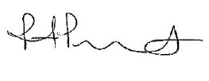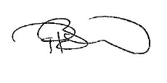
R Pritchard P Brockwell
Interim Executive Headteacher Interim Headteacher

