SMSC and Fundamental British Values evidence for Crayke Church of England Primary School 2016–17
Event, details & photographs… | SOCIAL |  |  |  | MORAL |  |  |  |  | SPIRITUAL |  |  |  |  | CULTURAL
 | Developing personal qualities & using social skills | Participating, co-operating and resolving conflicts | Understanding how communities and societies function | Develop an understanding of the Fundamental British Values of democracy and the rule of law. | Developing and expressing personal views or values | Moral codes and models of moral virtue | Recognising right and wrong and applying it | Understanding the consequences of actions | Investigating moral values and ethical issues | Developing personal values and beliefs | Experiencing fascination, awe and wonder | Exploring and respecting the values and beliefs of others | Understanding human emotions and feelings | Using imagination and creativity in learning | Exploring, understanding and respecting diversity | Participating in and responding to cultural activities | Understanding and appreciating personal influences
Jeans for Genes day – charity fundraising wearing jeans to school.  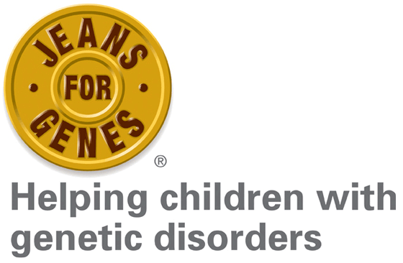 | * | * | * |  | * |  |  |  |  | * |  | * | * |  | *
Church Service: Harvest Festival -  Pupils looked at a range of different issues effecting people in our local area and brought food based donations into school to support our local food bank. |  | * |  |  |  | * |  |  | * | * | * | * |  | * | * | *
NSPCC Whole School Assemblies and Workshops – As part of anti-bullying week, the NSPCC came into school to discuss their Speak out Stay safe programme. This ensured that all our pupils learned essential safeguarding information in a lively, interactive and memorable way.  With the help of their mascot Buddy, the programme provided child-friendly, interactive assemblies and workshops to help children:  - understand abuse in all its forms and recognise the signs of abuse  - know how to protect themselves from all forms of abuse  - know how to get help, and the sources of help available to them. | * | * | * | * | * | * | * | * | * |  | * | * | * | * | * | * | *
Autumn Term RE – What and how do we celebrate? Pupils discussed celebrations and traditions that were meaningful to them and we held our own class celebration. We visited the local church to witness a ‘baptism ‘ and compared it to a Sikh naming ceremony. |  |  | * |  | * |  |  |  |  | * |  | * | * |  | * | * | *
Remembrance day Pupils made poppies and participated in the school’s two minutes silence.  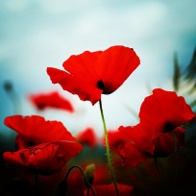 |  |  |  | * |  |  |  |  |  |  |  | * | * |  |  | *
Forest Schools In Forest Schools activities pupils are required to cooperate and abide by simple safety rules. Our beautiful school grounds and setting help them to be inspired by the natural world.  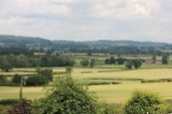 | * | * |  | * |  |  | * | * |  |  | * |  |  | *
EYFS Curriculum Expressive Arts and Design Pupils are given opportunities to respond imaginatively and creatively to a range of activities and experiences  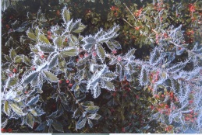 |  |  |  |  | * |  |  |  |  |  | * |  | * | *
Church Service: Christmas  All children celebrated Christmas through performing poems and singing carols at the Church of St Cuthbert in Crayke.  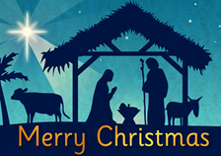 |  |  |  |  | * |  |  |  |  | * | * |  | * | *
Minster FM Toy Appeal  Please see website for more information.  http://www.craykeschool.org/2016/minster-fm-toy-appeal-2/ | * | * |  |  | * | * |  | * |  |  | * |  |  | *
EYFS Curriculum Personal, social and emotional awareness Developing pupils’ sense of themselves and others as moral and responsible people runs through all learning and relationships in Class 1. No opportunity is wasted.  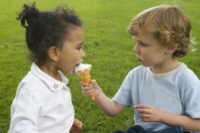 | * | * | * | * | * | * | * | * | * | * |  | * | * | * | * | * | *
Christmas nativity Classes 1 and 2 joined together to perform the school’s nativity.  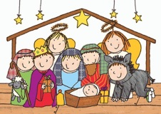 | * | * |  |  |  |  |  |  |  |  |  | * | * | * | * | *
Spring Term RE What makes a place special? Starting with our own special places we thought of what makes religious buildings special to people of all faiths.  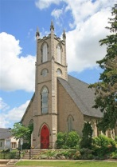 |  |  | * |  | * |  |  |  |  |  |  | * |  |  | *
Class 2 R.E Topic – Special Places  We discussed where our special places are and why they are special to us. We explored how a church, mosque and synagogue are special places to people. We discussed similarities and differences between the different places of worship. |  |  | * |  |  |  |  |  |  | * |  | * | * | * | * | * | *
School Council – Playground Games  School Councillors discussed how they wanted to learn some new playground games and give others the opportunity to learn them, too. They came up with the idea of having a ‘School Council Zone’ every morning break time, to take it in turns teaching different games. They now lead other children who are interested, explaining how the game works and then demonstrating it.  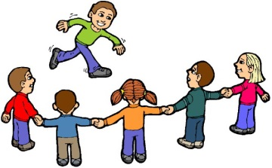 | * | * | *
School Council – Woodland Trust Tree Planting  School Council are involved in leading our progress towards the Woodland Trust ‘Green Tree Schools Award’ and as part of this, applied for 60 free saplings for the school field. They discussed the environment and their duty to protect the environment and enhance our school environment for everyone, including wildlife. They then worked as a team to plant the trees along the school field.  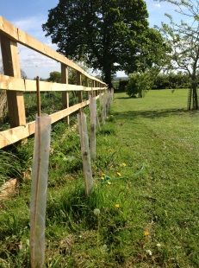 |  |  |  |  | * | * | * | * | *
Class 2 R.E Topic – Whole School Religion – Islam  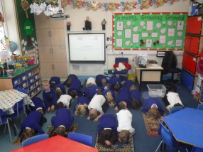  Children enjoyed learning about Islam. We looked at a mosque and how it differed from a church. We looked at their rituals and prayers. We looked closely at prayer mats and their design. We completed our own prayer ritual using the prayer mats Mrs Pegram brought in to show us. |  |  | * |  | * |  |  |  |  |  |  | * | * |  | * | * | *
Church Service: Easter  Crayke pupils celebrated the resurrection of Jesus through exploring bible readings, poems, prayer and song.  Children from Class 4 also rewrote the Easter Story for younger readers.  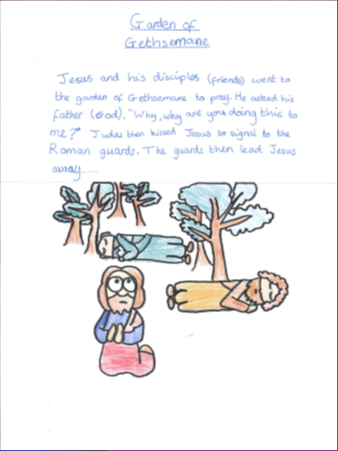 | * |  |  |  | * | * | * | * | * | * | * | * | * | * | *
Participating in the school’s Lent and Easter celebrations These include Collective Worship, class RE lessons, whole school fun activities. Children learn that Easter means different things to different people and each person’s opinions are to be respected.  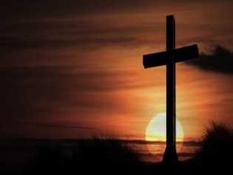 | * |  | * |  | * | * |  |  | * | * | * | * | * | * | * | * | *
Summer Term RE  Old and New Testament stories  The children hear these stories and think about how they might apply to them. |  |  |  |  | * | * | * | * |  | * |  | *
Whole school visit to Beamish  This was chosen by the school council and enjoyed by the whole school.  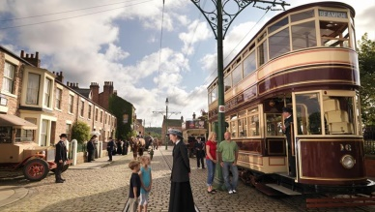 |  |  |  | * | * |  |  |  |  |  | * |  |  |  | *
Class 3: General Election Week  During the week of the 2017 general election, Class 3created their own mini ‘political parties.’ They elected a candidate. Within their parties, they then created their own manifesto, with some party pledges on what they would do to improve school, and some that would be national pledges.  They learnt about the democratic system in Britain and how the voting process worked. Each party held a campaign involving posters, leaflets, persuasive e-mails and finished off with a political speech from each candidate before children in Class 3 and 4 held a secret vote. This was done in a similar process to real voting, with an electoral register, polling cards, ballot papers and a ballot box.  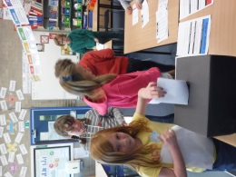 | * | * | * | * | * | * | * | * | * | * |  | * | * | *
School Council – New Play Shed  School council were offered the opportunity to run the new play shed. They discussed and voted on how best to run it and created timetables for each councillor and class to have a turn. They explored how to care for the equipment and their role as leaders and carers of the equipment.  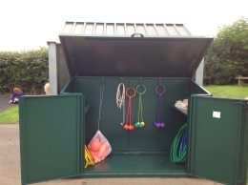 | * | * | * | * | * | * | * | * |  |  |  | *
Class 2 R.E Topic – Big Questions  We thought about the different types of questions we can ask. Some questions can be answered easily, others might have different answers and others we may not be able to answer at all. We thought about questions we could ask God and how he might answer them.  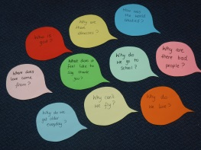 | * |  | * |  | * |  |  |  |  | * |  | * | *
Class 2 R.E Topic – Where do I belong?  We discussed different groups we belong to including family, friends and clubs. We thought about belonging to the church and how people are welcomed in to church through a baptism. We discussed godparents and how they support us. We thought about the roles of children, parents, godparents and God.  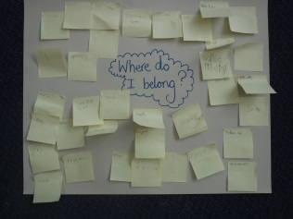 | * |  | * |  | * |  |  |  |  | * |  | * | *
Class 4 RE Topic: How do people express their ideas about God?  The class explored emotions, images of God, the Apostles Creed, colours of the church year and using the arts to express ideas about God. | * | * |  |  | * | * |  |  |  | * | * | * | * | * | * | * | *
Class 4 RE Topic: What is the Quran?  This unit enabled the children to deepen their knowledge and understanding of the Qur’an and appreciate its significance for Muslims.  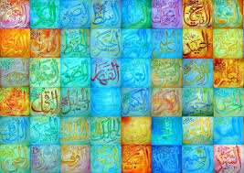 | * | * | * |  | * |  |  |  | * | * | * | * | * | * | * | * | *
Class 4 RE Topic: Christian Aid and Islamic Relief – can they change the world?  This unit enabled the children to deepen their knowledge and understanding of Christian Aid and Islamic Relief and appreciate each charities significance. | * |  | * |  | * | * | * | * | * | * |  | * | * |  | * |  | *
KS2 TRIP TO MOSQUE – BRADFORD.  We visited the mosque as part of our whole school study of the religion of Islam.  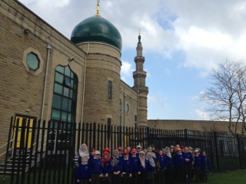 | * | * | * | * | * | * |  |  | * | * | * | * | * | * | * | * | *
Class 4 PHSE Topic: British Values  All of you will:  Begin to understand what it means to be British.  Most of you will:  Debate and discuss what makes us British.  Some of you will:  Understand how to justify your opinion on what it is to be British! | * | * | * | * | * | * | * | * | * | * |  | * | * |  | * |  | *
Class 4: PHSE topic: Living and Growing (Changes)  This unit enabled the children to deepen their knowledge and understanding of the changes that will happen during puberty.                                    

