SMSC and Fundamental British Values evidence for Crayke Church of England Primary School 2015–16
Event, details & photographs… | SOCIAL |  |  |  | MORAL |  |  |  |  | SPIRITUAL |  |  |  |  | CULTURAL
 | Developing personal qualities & using social skills | Participating, co-operating and resolving conflicts | Understanding how communities and societies function | Develop an understanding of the Fundamental British Values of democracy and the rule of law. | Developing and expressing personal views or values | Moral codes and models of moral virtue | Recognising right and wrong and applying it | Understanding the consequences of actions | Investigating moral values and ethical issues | Developing personal values and beliefs | Experiencing fascination, awe and wonder | Exploring and respecting the values and beliefs of others | Understanding human emotions and feelings | Using imagination and creativity in learning | Exploring, understanding and respecting diversity | Participating in and responding to cultural activities | Understanding and appreciating personal influences
Jeans for Genes day – charity fundraising wearing jeans to school.  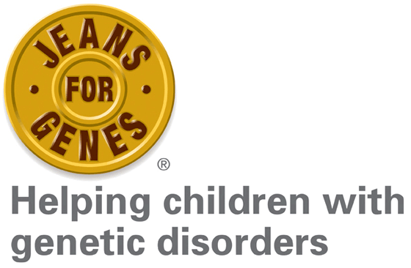 | * | * | * |  | * |  |  |  |  | * |  | * | * |  | *
Church Service: Harvest Festival  Pupils looked at a range of different issues effecting people around the world and raised money for the charity Send a Cow.  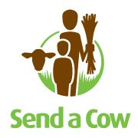 |  | * |  |  |  | * |  |  | * | * | * | * |  |  | * | *
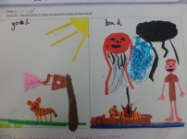  Class 2 R.E Topic: Creation.  This included discussing our favourite creations in the world, sharing our own creations, the creation story and comparing a good and bad world through collage. |  |  |  |  | * |  |  |  |  | * | * | * | * | *
School Council – ‘Anti-Bullying Council’  The school council discussed bullying in anti-bullying week and how they could help to tackle any situations that may be seen as bullying.  They implemented a red ‘ABC’ (anti-bullying council) box with a form for children to fill in if they felt that they (or someone they know,) was being bullied.  If any slips are completed, one of the pupils from the ‘ABC’ from the year group affected, would talk to the child who had completed the form to ascertain whether it was bullying or not and suggested ways of resolving the situation.  The anti-bullying council wrote a script and recorded information to go on the school website, to inform everyone of the ‘ABC’ box. | * | * | * |  |  | * | * | * | * | * |  |  | * |  | *
Class 3 Anti-Bullying Week  In anti-bullying week, Class 3 looked at the story of ‘how to fill a bucket.’ They discussed how everyone has feelings and how being kind to others not only makes someone else feel good, but makes you feel good, too. The children wrote ideas of how to ‘fill a bucket’ and discussed how bullies can’t fill their own ‘buckets’ by being unkind to others. They talked about what to do if they felt that they, or someone they know, was being bullied. | * | * |  |  | * | * | * | * | * |  |  |  | *
Class 4 Young Leaders Award –  Through studying a number of people of faith who have helped change the world for the better, pupils reflected on how belief informs a person’s perspective on life and how it can inspire them to action. Students continually learnt about themselves through the award, identifying strengths and weaknesses and increasing their personal development as they grow in leadership skills through Archie’s challenges.  Pupils learnt about their local community and the world around them and were encouraged to be creative and imaginative in the ways in which they completed Archie’s challenges – thinking about how they can serve their community and bring about change for the better. Through their evidence scrap book the students reflect on their experiences, in particular the active citizenship aspect of the award.  Through researching a number of people of faith and charitable organisations who stand up against injustice in the world, students learn about issues of right and wrong and are able to think about this in relation to their own lives. Furthermore, the pupils become ambassadors for local charities and inevitably investigate moral and ethical issues relating to their work, in turn applying these issues of justice to their own thoughts and decisions. Through Archie’s challenges the pupils learn to work in teams, dealing with any mistakes and understanding the consequences of their actions. | * | * | * | * | * | * | * | * | * | * | * | * | * | * | * | * | *
As schools and students take on the community action projects involved in the award, opportunities can arise for them to work with people and pupils from different religious, ethnic and socio-economic backgrounds. Students learn to cooperate well with others and come up with ideas for serving the various communities in their local area.

The award explores the varying levels of community in our lives and includes case studies and practical tasks, through Archie’s challenges, relating to each one. Throughout the award the pupils are involved in community projects which function on a school, local, national and even international level, to help bring about change for the better.

The Awards focus on exploring and understanding community at a local, national and international level and encourages students to engage in community action projects. As they do this they celebrate diversity in the way they serve people from different religious, ethnic and socio-economic backgrounds.

Church Service: Christmas  All children celebrated Christmas through performing poems and singing carols at the Church of St Cuthbert in Crayke.  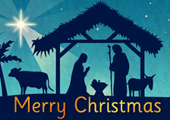 |  |  |  |  | * |  |  |  |  | * | * |  | * | *
Class 3 – John Lewis Competition Entry  As part of John Lewis’s Christmas campaign with Help the Aged, Class 3 entered the John Lewis competition to write about someone elderly who is special to them, or to write about caring for older people.  Every pupil wrote either a poem or memory about someone elderly and discussed how many people can be alone at Christmas. They watched the ‘man on the moon’ advert and thought of ways in which they could help older people; by visiting with an adult, entertaining them with music or dance, baking them a cake etc. All entries were submitted to John Lewis and displayed on their competition website.  Many children returned from the Christmas holidays saying how they had helped an older person over the festive period.  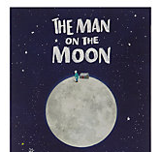 | * |  | * |  | * | * |  |  |  |  |  |  | * | *
Class 4 History Topic: Ancient Greece  The class discussed the differences between democracy now and in ancient  Athens. They explored the concept of whether Athens really was a democracy since so many people were excluded from the vote.  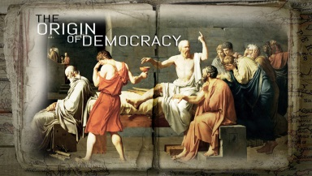 | * | * | * | * | * | * |  |  | * | * |  | * | * |  | *
Church Service: Easter  Crayke pupils celebrated the resurrection of Jesus through exploring bible readings, poems, prayer and song.  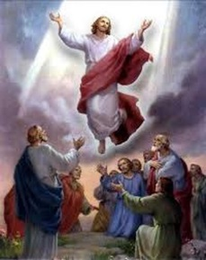 |  |  |  |  | * | * | * | * | * | * | * | * | * | * | *
Participating in the school’s Lent and Easter celebrations These include Collective Worship, class RE lessons, whole school fun activities. Children learn that Easter means different things to different people and each person’s opinions are to be respected.  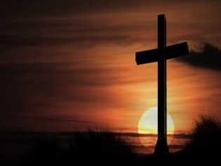 | * |  | * |  | * | * |  |  | * | * | * | * | * | * | * | * | *
Class 4 RE Topic: How do people express their ideas about God?  The class explored emotions, images of God, the Apostles Creed, colours of the church year and using the arts to express ideas about God.  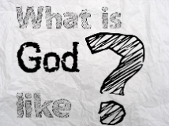 | * | * |  |  | * | * |  |  |  | * | * | * | * | * | * | * | *
Class 2 R.E Topic: Gifts  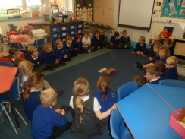  We looked at 2 different presents. One was small and wrapped in newspaper and the other was big and wrapped in colourful paper. Most children decided they would like to open the bigger, more colourful present. However when we opened the present there was only a cardboard box inside. The smaller present had a small book and colouring pencils inside. We all agreed this present was much better. We all decided it was important not to judge something by its outside wrapper. | * |  |  |  | * | * |  |  |  | *
Class 2 School Value: Service  We discussed as a class different people who provide a service to us. We looked at 3 different areas – at home, at school and at a club. We thought of lots of ideas for each area and then chose our favourite from each to create a collage for the display. We chose Mum, School Cook and Lifeguard. | * | * | * |  |  | * |  |  |  | *
Class 2 R.E: Emotions in the Easter Story  We thought about the different emotions in the Easter story. We thought about feeling, excited, worried, mystified, very upset and then thought of one of our own. We linked these feelings to our own emotions and thought about times in our lives when we have felt like that.  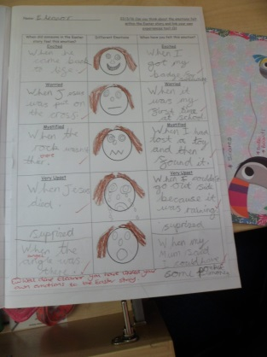 | * |  |  |  | * |  |  |  |  | * |  |  | * | *
Class 2 R.E: Can we show acts of kindness?  We thought about different ‘acts of kindness’ we could carry out. We worked in small groups to record ‘acts of kindness’ we had already carried out or could carry out in the future.  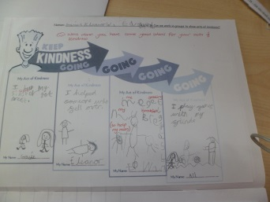 | * | * | * |  | * |  |  | * |  |  |  |  | *
Class 1 Autumn Term RE – What and how do we celebrate? Pupils discussed celebrations and traditions that were meaningful to them and we held our own class celebration. We visited the local church to witness a ‘baptism ‘ and compared it to a Sikh naming ceremony. |  |  | * |  | * |  |  |  |  | * |  | * | * |  | * | * | *
Class 1 Forest Schools In Forest Schools activities pupils are required to cooperate and abide by simple safety rules. Our beautiful school grounds and setting help them to be inspired by the natural world.  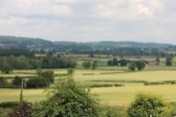 | * | * |  | * |  |  | * | * |  |  | * |  |  | *
EYFS Curriculum Expressive Arts and Design Pupils are given opportunities to respond imaginatively and creatively to a range of activities and experiences  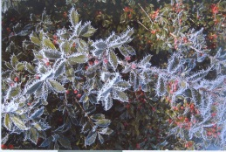 |  |  |  |  | * |  |  |  |  |  | * |  | * | *
Class 4 RE Topic: How and why do Christians, Muslims and Hindus see life like a journey?  KEY QUESTION: What does a journey mean to us?  Can I identify a way in which life is like a journey?  Can I begin to identify the impact chosen journeys have on ourselves and others?  KEY QUESTION: What journey will a Muslim like to take once in his / her lifetime??  Can I suggest simple meanings for the Five Pillars for Muslim believers?  Can I retell events of the Aqiqah ceremony?  KEY QUESTION: What journey will a Muslim like to take once in his / her lifetime??  Can I ask important questions about the joining of two people and their families in marriage?  KEY QUESTION: What journey will a Hindu take in his/her lifetime?  Can I ask questions and suggest answers about the beliefs of life for Hindus?  Can I describe the concept of a person being reincarnated?  KEY QUESTION: What 4 stages of life do Hindu people remember and celebrate?  Can I identify that there are 4 ‘Ashramas’ throughout a Hindu life?  Can I understand the role of the family in Hindu life and daily worship? | * |  | * |  | * |  |  | * | * | * | * | * | * | * | * | * | *
Class 4 PHSE topic: DEMOCRACY  The class explored fundamental British Values of democracy through discussion, research and information sharing. Also through practical experience such as school council elections.  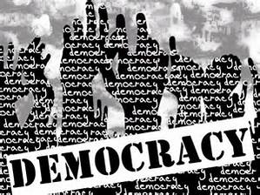 | * | * | * | * | * |  |  |  |  | * |  | * |  |  |  |  | *
EYFS Curriculum Personal, social and emotional awareness Developing pupils’ sense of themselves and others as moral and responsible people runs through all learning and relationships in Class 1. No opportunity is wasted.  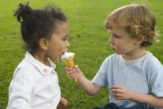 | * | * | * | * | * | * | * | * | * | * |  | * | * | * | * | * | *
Class 1 Spring Term RE What makes a place special? Starting with our own special places we thought of what makes religious buildings special to people of all faiths.  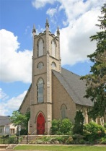 |  |  | * |  | * |  |  |  |  |  |  | * |  |  | *
Sports Relief The children were involved in raising money for others by participating in the school’s mudstacle course.  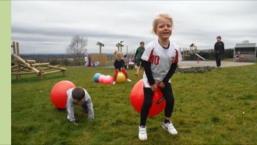 | * |  | * |  |  | * | * |  | * | * |  |  | *
Class 3 & 4 – Fundamental British Values  One of the tasks set on the Summer 1 homework grid, has been to design an image representing one of the fundamental British Values. This was a compulsory homework and we held a class discussion during our class assembly, about the fundamental British values and what each of them mean. A selection of this work is on display in the hall. |  |  |  | * | * | * |  |  |  | * |  | *
School Council – Whole School Trip to The Deep  The School Council were asked to choose somewhere suitable for a whole-school visit, entirely funded by a member of the local community.  They chose ‘The Deep’ and voted on a different workshop for each class.  Children got to explore The Deep, take part in their workshop activity and also see a dive presentation, witnessing sharks and other fish being fed.  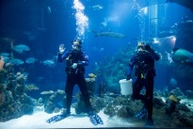 | * | * | * | * | * |  |  |  |  |  | * |  | * | *
School Council – A postcard about Archbishop Sentamu’s visit to our school.  The school council were invited to write a short entry as a postcard, for the Archbishop’s website, about his visit as part of his pilgrimage. The children discussed his visit and collectively wrote a postcard entry.  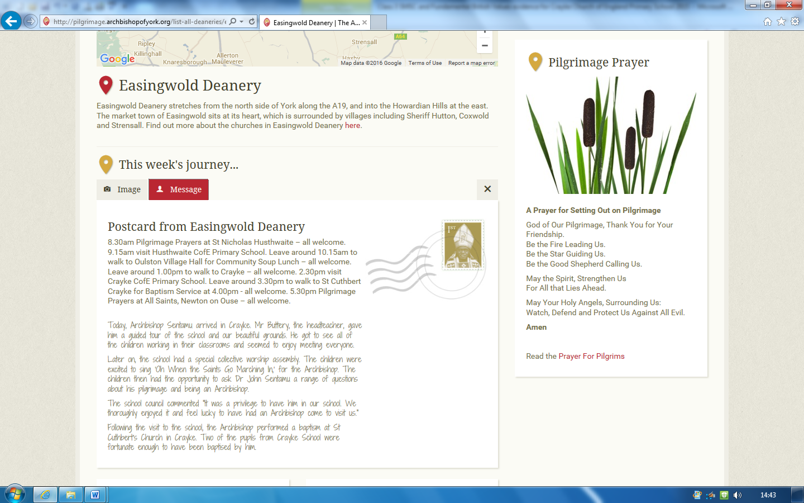 | * | * |  | * | * |  |  |  |  | * | * | * | * |  | * | *
Class 3 – Joseph Rowntree Project  As part of Class 3’s history topic ‘York’s Chocolate History,’ the children have been researching one of York’s founding chocolatiers, Joseph Rowntree. They learnt about his Quaker faith, how he bought land for New Earswick to be built for his workers and was one of the first to provide health care and pensions for his employees. They researched his development of a community in New Earswick, building schools, communal meeting places and protected green spaces.  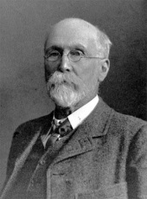 |  |  | * | * |  | * |  |  | * |  |  | * | * | * | *
Class 3 – Use of Forums on online learning platform ‘DB Primary.’  Children have been using the forum function on our online learning platform, ‘DB Primary.’ They have learnt the importance of writing appropriate comments to one another and what the consequences can be for inappropriate online forum replies, in the real world. They frequently write polite, respectful and purposeful responses to one another, engaging in an online collaborative community.  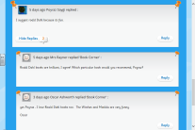 | * | * | * | * | * |  | * | * |  | * |  | * | * |  |  |  | *
Class 2 R.E: Creating our own stories based on ‘The Good Samaritan’.  We studied the story of ‘The Good Samaritan’ as a class and discussed how it made us feel. We tried to think of scenarios we could be in for example in the playground when similar things have happened to us. We created our own storyboard based on ‘The Good Samaritan’ but linked with a situation you could find yourself in at school or home. | * | * |  |  | * | * | * | * |  | * |  | *
Class 2 Circle Time: Getting on and Falling out  Over the year we have had a variety of different circle times based on ‘Getting on and Falling out’. We have discussed what makes a good friend and how we expect others to act towards us. We have role played different scenarios and discussed what the different outcomes of certain ‘fall outs’ should be. | * | * | * |  | * |  | * | * |  | * |  |  | *
Class 1 Summer Term RE  Old and New Testament stories.  The children hear these stories and think about how they might apply to them. |  |  |  |  | * | * | * | * |  | * |  | *
Years 3, 4 and 5 – Letters to Zimbabwe  As part of an ongoing link between pupils currently in Year 4 and 5, the children received letters from pupils in Zimbabwe, personally addressed to them. The whole school had an assembly about the school and have brought in school shoes to be sent over to the school in Zimbabwe. Children in Years 4 and 5 replied back to their ‘pen-pal’ and children in Year 3 wrote letters to different children, to begin new links. In their letters, they explore the cultural differences and similarities, as well as explaining more about their life, hobbies and interests.  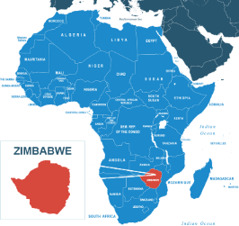 | * |  | * |  | * |  |  |  |  |  | * | * | * | * | * | * | *
Whole School - EU Referendum Assembly  All schools are obliged to include citizenship in their curriculum, and following lots of questions from children to their teachers about the EU Referendum we decided to use this as an opportunity to teach them about elections and how they work. We explained the mechanics of elections and voting - this was completely neutral with no political content. As the adults of the future, teaching children about the importance of democracy and freedom of choice is a positive.  The children were all really interested in the session and very much enjoyed it. | * | * | * | * | * | * |  | * | * | * | * | * | * | * | * | * | *
Whole School: Queen’s 90th Birthday Celebrations  All children participated in a morning of activities to celebrate the Queen’s 90th Birthday. Art and craft alongside baking activities took place leading to a whole school street party in the afternoon where we ate, sang and celebrated together.  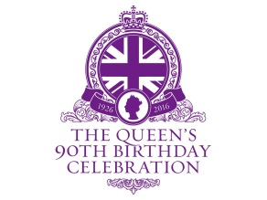 | * | * | * |  | * |  |  |  |  | * | * | * | * | * | * | * | *
Class 4: PHSE topic: Living and Growing (Changes)  This unit enabled the children to deepen their knowledge and understanding of the changes that will happen during puberty.  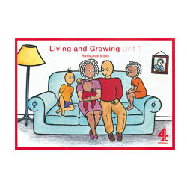 | * | * |  |  | * | * | * | * | * | * |  | * | * |  |  |  | *
Class 4 RE Topic: What is the Quran?  This unit enabled the children to deepen their knowledge and understanding of the Qur’an and appreciate its significance for Muslims.                                    

