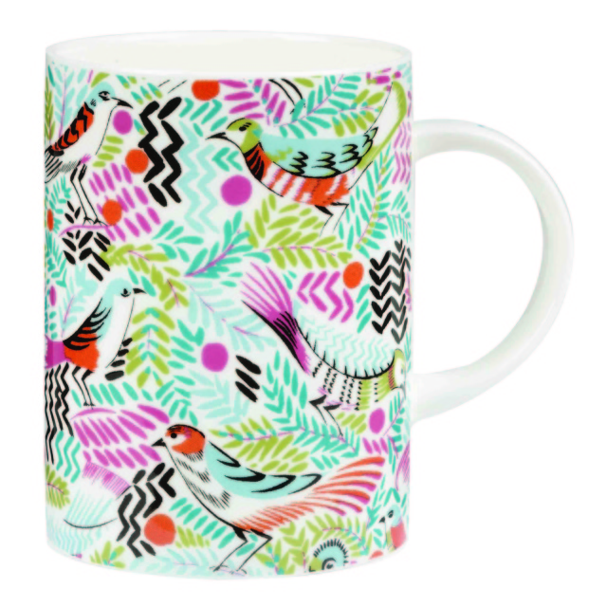
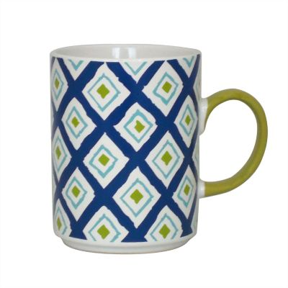
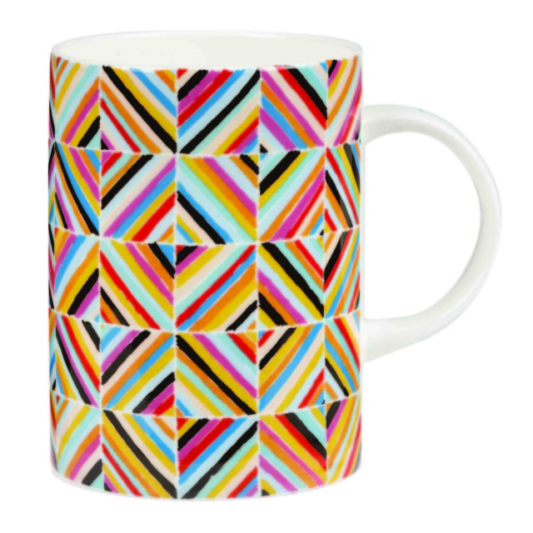
Fairtrade Fortnight Mug Challenge
Can you rise to the Fairtrade Fortnight Challenge and design a bright and attractive pattern for a mug to use for your Fairtrade drinks?
Your design could include the Fairtrade logo, some of the products that Fairtrade produce or it could just be very beautiful!
To enter ask your class teacher for a template and return your design to Mrs. Cotterill in time for Monday 9th March.
A delicious Fairtrade Easter Egg is waiting to be awarded to a KS1 winner and a KS2 winner in time for Easter.

