**Crayke Chronicle**

**Friday 19th December**

**Happy Christmas**

I would like to wish all our pupils, parents, carers and staff a very Merry Christmas and a Peaceful New Year!

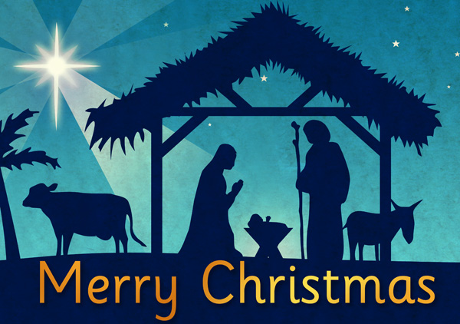

We look forward to starting a successful 2015 when we return for the new term on 6th January.

**Where's Church this Christmas?**

**Sunday 21st**: 6.30pm 9 lessons and Carols at Crayke

**Christmas Eve**: 4pm Nativity at Crayke

11.30pm Holy Communion (aka Midnight Mass) at Crayke

**Christmas Day**: 9am Family Communion at Yearsley

10.30am Family Communion at Brandsby

For services between Christmas and the beginning of term, please see [www.achurchnearyou.com](http://www.achurchnearyou.com) and search for the name of the village.

Best wishes for a very happy Christmas,

Revd Liz

**Easingwold District Lions invite you to…**

Carols in the Market Place (in the Galtres Centre if the weather is bad), tomorrow at 4.00 p.m.. Celebrate the festive season with carols in the Market Place accompanied by the Easingwold Town Band and Jess Liversidge’s community choirs.



In Class 1, the children will be able to be acknowledged as either *Thinker* or *Friend* of the Week. Congratulations to this week’s children...

**In Class 1, Mrs. Sheppard and Mrs. Forshaw are delighted to say that everyone has been a good friend and thinker during this half term.**

Each week a child will be selected from our classes to receive the title of *Maths Whizz* of the Week or *Wonderful Writer* of the Week. Congratulations to this week’s children...

**Maths Whizz of the Week**

**Class 2 – Charlotte Furnass**

**Class 3 – Alex Gilleard**

**Class 4 – Alex Lynas**

**Wonderful Writer of the Week**

**Class 2 – Poyraz Saygi**

**Class 3 – Martha Lowther**

**Class 4 – Ben Forshaw**