**Crayke Chronicle**

**Friday 12th December**

**A Midwife Crisis**

I am very proud of all the children in Reception, Year 1 and Year 2. Despite illness and end of term tiredness they managed to perform “A Midwife Crisis” three times this week.

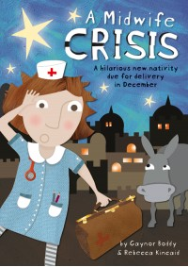

For those of you who didn’t see it; the play showed how with the help of a very flustered midwife and her put-upon donkey Steve, the Nativity story unfolded.

Please can I remind everyone that any photos/video taken should not appear on social media. Thank you for your assistance.

**Where's Church this week?**

The season of Carol Services has begun! This week you are invited to join us at All Saints' Brandsby for Carols, drama and mince pies at 4pm on Sunday 14th.

The morning service is at Crayke at 10.30am

You can still follow the progress of Mary and Joseph around the village by clicking here [**https://twitter.com/search?f=realtime&q=craykeposada&src=typd**](https://twitter.com/search?f=realtime&q=craykeposada&src=typd)

If you host them at your house, please email a picture to me (details on the instruction sheet with the bag) so I can add it to the journey.

Revd Liz



In Class 1, the children will be able to be acknowledged as either *Thinker* or *Friend* of the Week. Congratulations to this week’s children...

**Thinker of the Week**

**Class 1 – George Clarke**

**Friend of the Week**

**Class 1 – Dominic Dawson**

Each week a child will be selected from our classes to receive the title of *Maths Whizz* of the Week or *Wonderful Writer* of the Week. Congratulations to this week’s children...

**Maths Whizz of the Week**

**Class 2 – Sam Pearce-Hogg**

**Class 3 – Ruby Hamill**

**Class 4 – Charlize Craggs**

**Wonderful Writer of the Week**

**Class 2 – Olivia Tweddle**

**Class 3 – Pia Emsley**

**Class 4 – Maisy Kraemer**