**Crayke Chronicle**

**Friday 21st November**

**Homework Questionnaire Feedback**

I would like thank the parents/carers who returned their comments to school. I’m really pleased by the overwhelmingly positive feedback the homework grids have received. Your views are exceptionally important to me and the rest of the staff, so please don’t hesitate to get in touch with any further suggestions/comments. If there is anything you would like to discuss with me, please call the school, or alternatively I can be reached by email on [headteacher@crayke.n-yorks.sch.uk](mailto:headteacher@crayke.n-yorks.sch.uk).

**CHASA’s Invaluable Support**

Following CHASA’s generous support, ten Franklin Electronic Dictionaries have been purchased for use in Classes Three and Four.

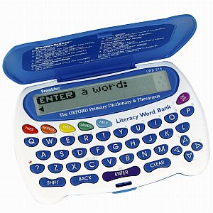

The dictionaries will enable children to independently check the spelling and meaning of words. In addition they also feature a thesaurus function, which will facilitate improved vocabulary. Here’s what Martha and Annabel had to say about using them in class: “We needed to find a different adjective for *vicious*. So we put it in and used the thesaurus. We found the word *aggressive*! They are good because they save time, you become quicker on a keyboard and you can find more grown up words”.

**Children in Need**

A grand total of £240.52 was raised for Children in Need. Thank you for your generous support.

Children in Need Action at Crayke School

I would like to highlight the role children in Class 4 played in this fundraising. The children successfully ran a number of stalls and raised a total of £145.52, an outstanding achievement, I’m sure you’ll agree.

**“Nativity”**

The children and staff are busily rehearsing for our Nativity. This year we are performing ‘A Midwife Crisis’.

In order that all parents will be able to attend, the children will perform on two occasions:

Tuesday 9th December 2.30pm

Wednesday 10th December 6.00pm

Information relating to the performance will be distributed next week.

**Durham Ox**

The winners of the art competition were due to be announced this Sunday, but this has had to be re-arranged as some children are not available. This will now take place during an Achievement Assembly at a later date.

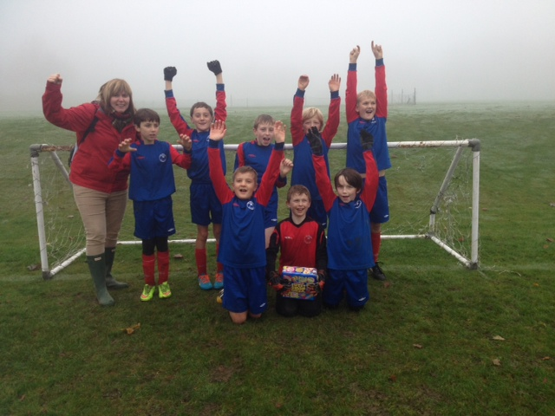



In Class 1, the children will be able to be acknowledged as either *Thinker* or *Friend* of the Week. Congratulations to this week’s children...

**Thinker of the Week**

**Class 1 – Mani Brown**

**Friend of the Week**

**Class 1 – Florence Ritchie**

Each week a child will be selected from our classes to receive the title of *Maths Whizz* of the Week or *Wonderful Writer* of the Week. Congratulations to this week’s children...

**Maths Whizz of the Week**

**Class 2 – Charlie McAdoo**

**Class 3 – Olivia Piercy**

**Class 4 – Abigail Mears**

**Wonderful Writer of the Week**

**Class 2 – Rupert Curtois**

**Class 3 – Kathryn Featherstone**

**Class 4 – Luke Forshaw**

**Football**

Well done to the football team for once again achieving great success. They won the Football Competition at St. Martins (Ampleforth) and finished 4th out of 68 schools in the Thirsk football finals. Thank you to Miss Henn and all parents for supporting the team and giving up their own time.

**Consultation on Local Library Provision**

Part of the aforementioned proposals is for Easingwold to become a community/volunteer-run library. You can share your views by accessing this link: <http://www.northyorks.gov.uk/article/29733/Library-consultation---your-views-matter>

**Where’s Church this week?**

10.30 a.m. Holy Communion at Holy Trinity, Yearsley.

6.30 p.m. Evensong at St. Cuthbert’s, Crayke

Crayke Church will be holding a Christingle Service at 4 p.m. on 7th December. All welcome. Details will be coming shortly about the village Nativity play on Christmas Eve at 4 p.m. It would be lovely to have lots of people involved in this – a real highlight of Christmas!

Rev. Liz