Enrichment Week in Class 3

On Monday a man called Peter came to Crayke School to teach us about art. First we looked at some paintings and had a quiz with clues about the different ones. We had a discussion about the artist Piet Mondrian who was born in 1872 and died in 1944.He was very strict about his art and he only painted straight vertical and horizontal lines on his pictures. He had a friend for 16 years who he painted with, but never spoke to him again after his friend painted a diagonal line! Finally we had a go at making our own ‘Mondrian’ using glue, scissors, ribbon and paper. We could do any design as long as it had horizontal and vertical lines and at the end they all looked great.
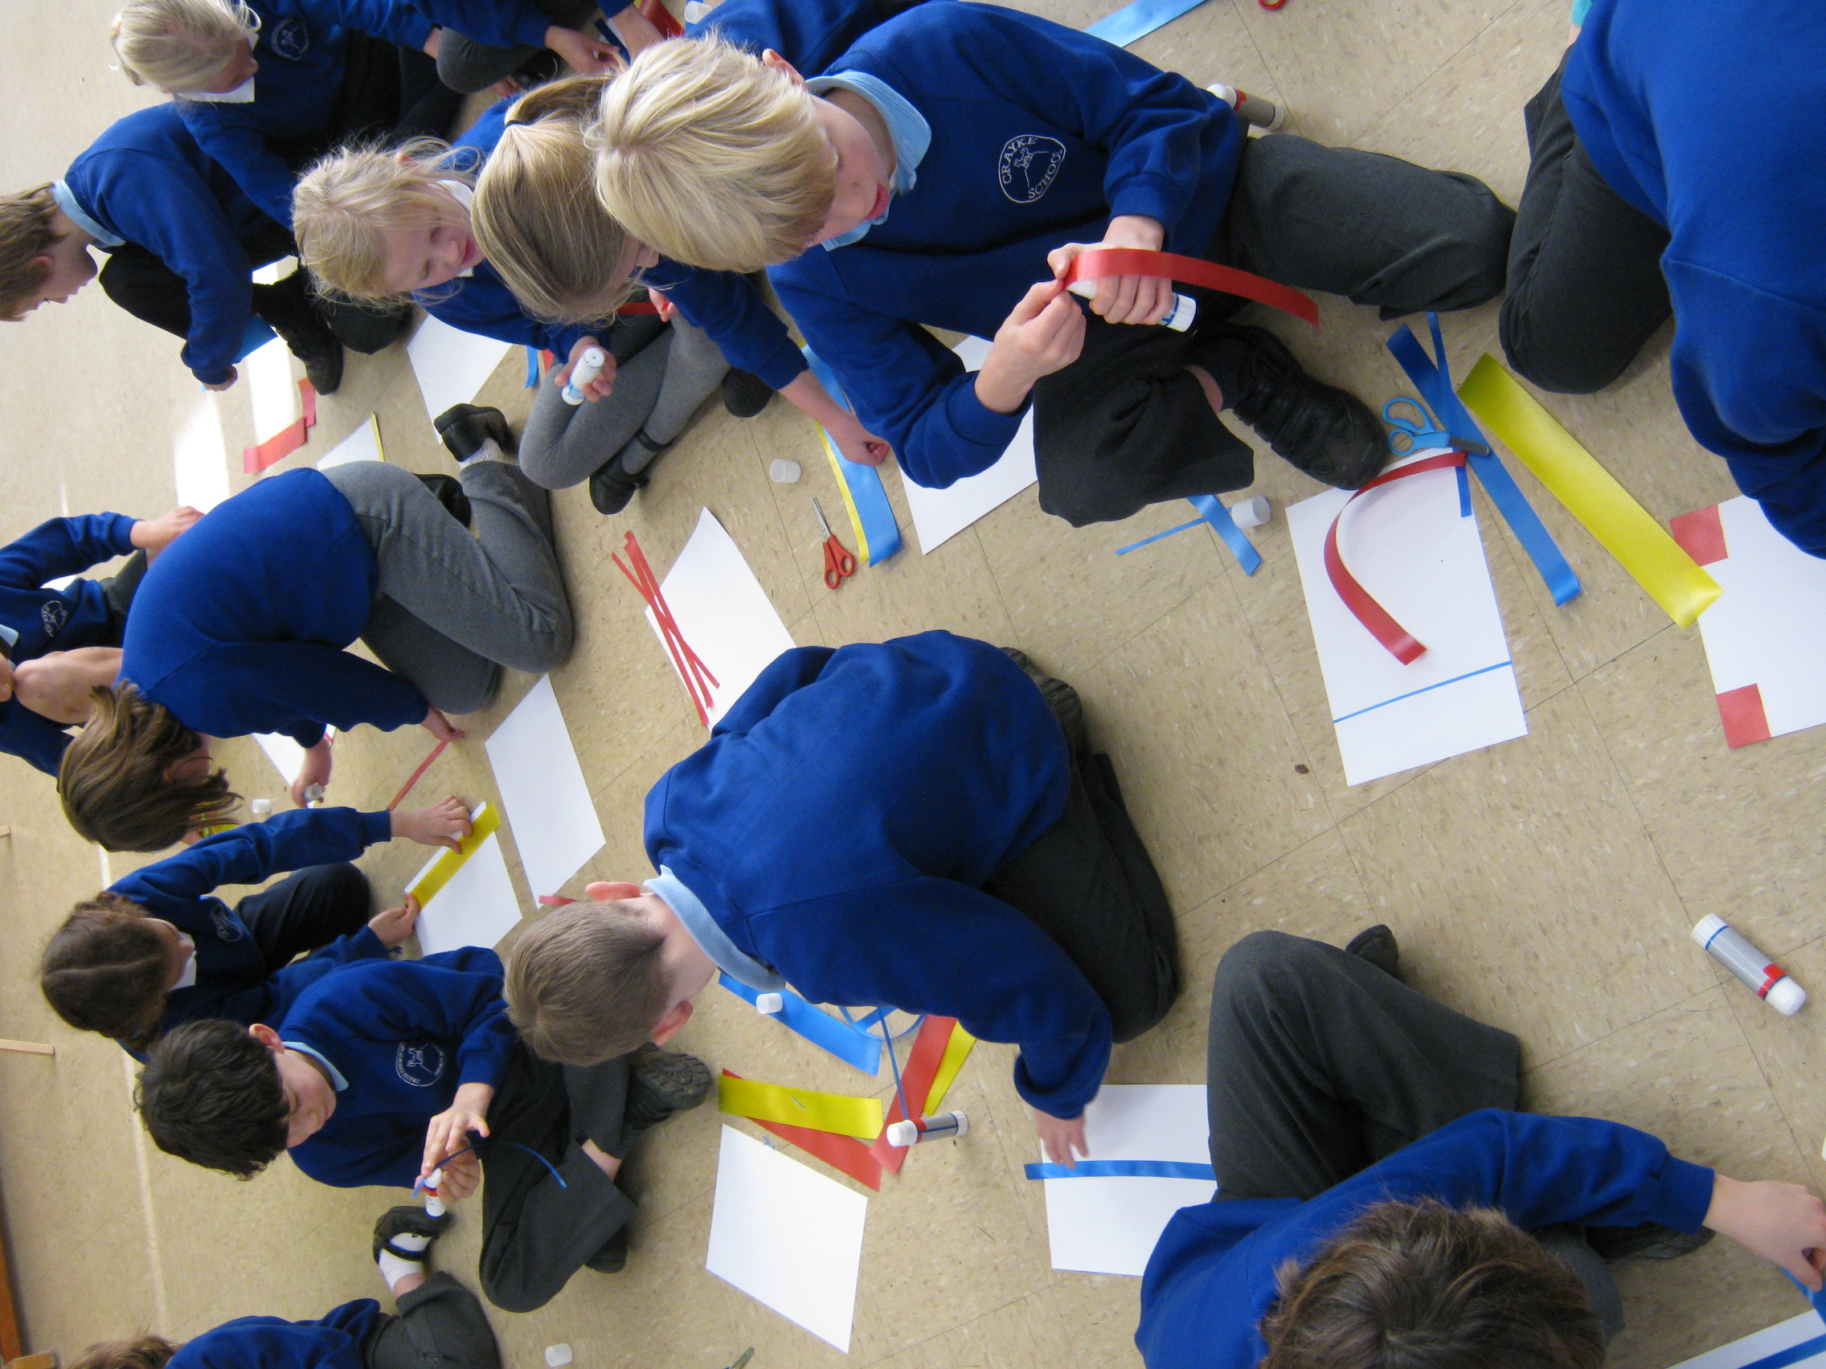

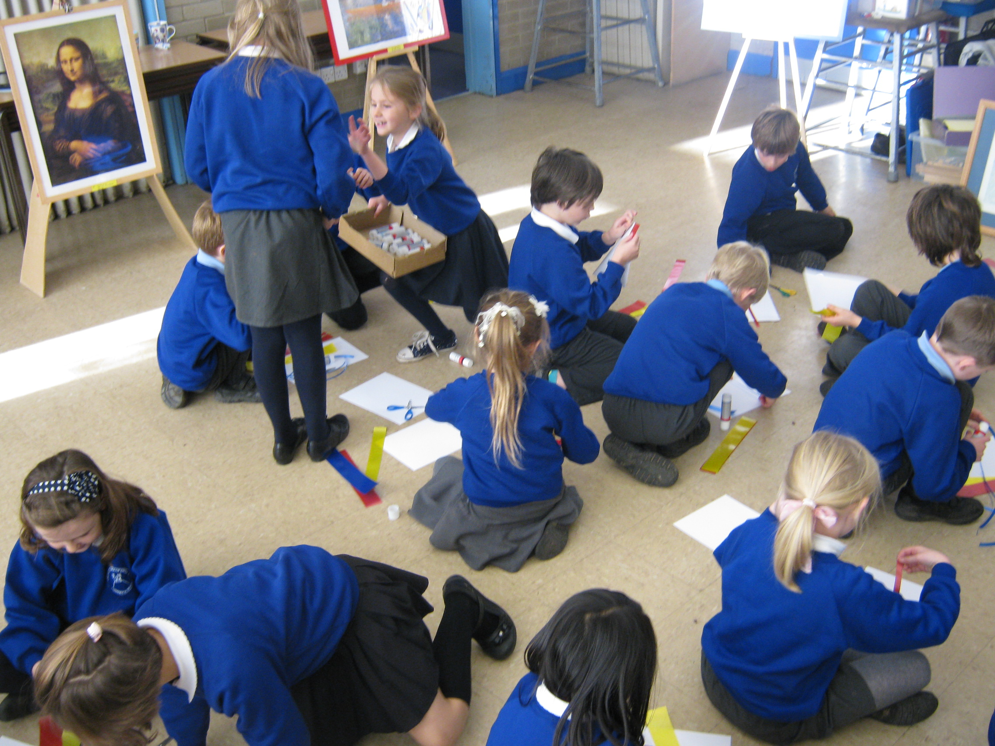

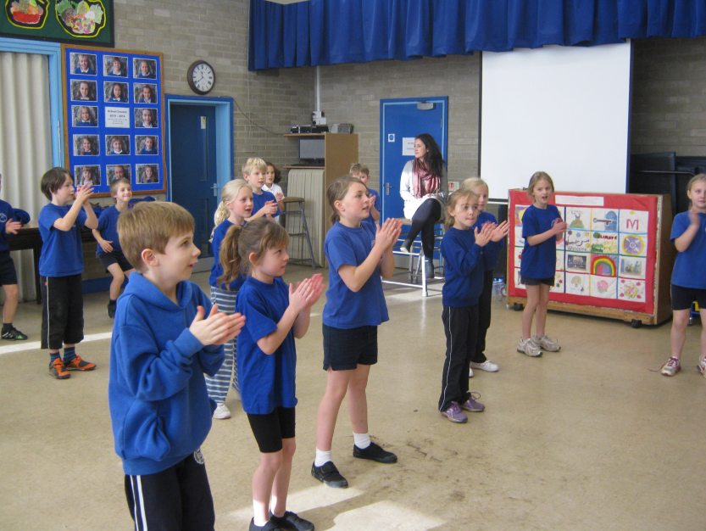
On Tuesday Pete, who was from the stage show Stomp, came and taught us dance. We had groups of 4 or 5 children and made up our own dances. We had to use stamping, clapping and anything else we wanted to do but we didn’t sing. Pete said that he had to think a lot to make our dance harder for us because we were so good! We practised and practised and at the end of the day we performed to the rest of the school. It was nerve racking.

On Wednesday the Year 3 group went with Class 2 to Fountains Abbey where we made mosaics. First we went to St. Mary’s Church which was a long, long way away. It was built 140 years ago and there were beautiful mosaics on the floor. Some people sketched and others were looking around at things like stained glass windows. The first thing we did when we got to the workshop was to look at mosaics that other people had done which were really good, then we made sketches of our own design, and finally we placed the tiles where they needed to go. It took a long time to lay all the tiles in straight lines with a little gap between each tile for the grout. The teacher did the tip test to make sure the pieces didn’t fall off when we put them on the wall. At the end we put grout on the mosaics which was great because we got dirty. The best bit was sticking the tiles onto the board to make the pattern, but all of it was fun.
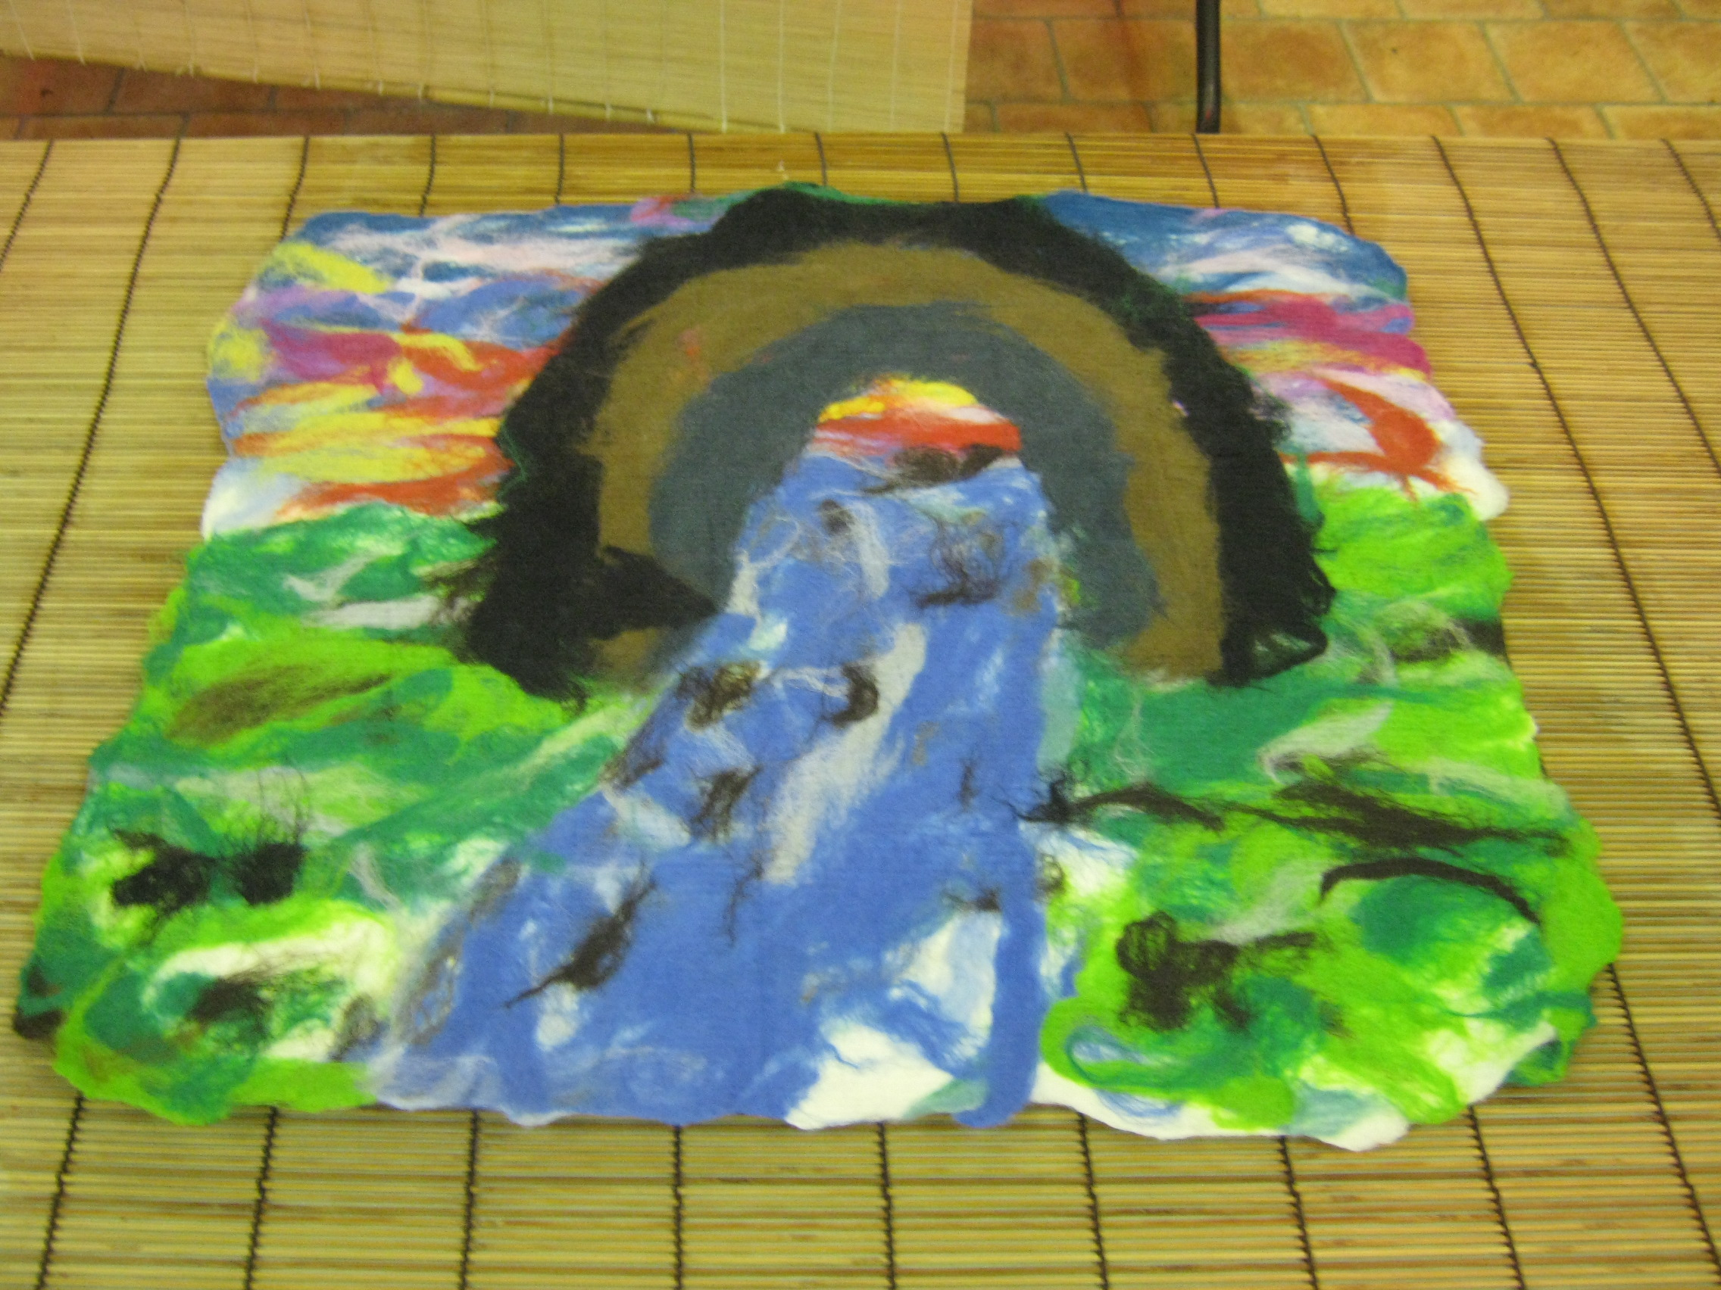

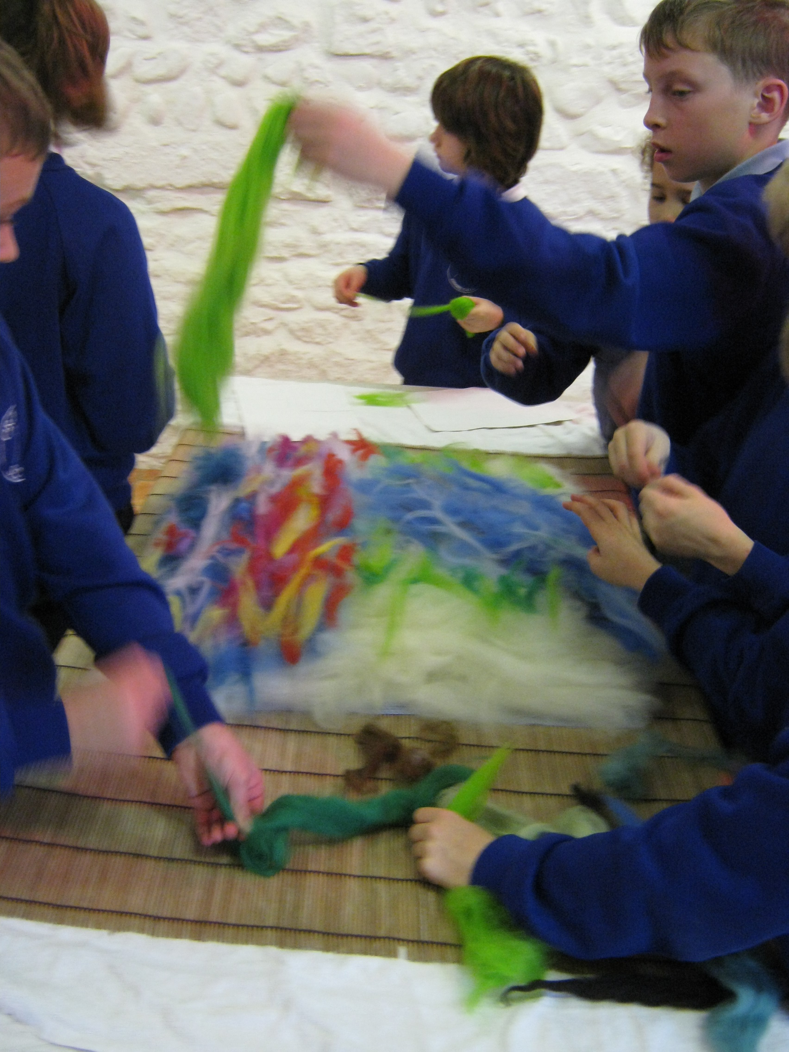

On Thursday the Year 4 group went with Class 4 to Fountains Abbey to meet a lady called Emma. She told us about monks in the olden days having 1,500 sheep and they sold their wool until they had enough money to build Fountains Abbey. In our workshop we were going to use wool to make felt.
It was a cold day but we went out looking at Fountains Abbey to get ideas for our art work. It was quite challenging because you had to draw and look at the same time. We had to design our own felt picture by using ideas from our sketches. We made the pictures by first laying layers of plain wool onto a Jay cloth, then laying coloured wool on top for the background and then building a picture out of coloured wool on the last layer. We added all kinds of colours: red, blue, green and many more. We put another Jay cloth on top of our design and poured water and Fairy liquid on top. After that we rolled it in a window blind 1,000 times to get the water out, flipping and rotating it as we went. It wasn’t easy but it was worth all the hard work. The finished product looked very different from when it started!

By all of Class 3

